
Edvard Grieg Lodge 657 District 5
Cincinnati-Dayton, Ohio

The First Lodge in Ohio
Sons, Daughters and Friends of Norway
February 2008

Future events
Saturday, February 16th 10:00AM
A day at Perfect North Slopes.
Saturday,March 15th at 4:00PM
Building and sailing Hjemkomst at New England
Club
April 19th, White Elephant Sale, at Mikaloff’s home.
May 17th at Kari Poe’s home

Ord fra presidenten..
Godt Nyttar (Happy New Year)
I hope you all had a great holiday and are ready to begin a New Year .
We finished the year 2007 with 106 members and that is great. We have had many programs that are outstanding in the course of the year. Those of us who participated in the Rosemalling had a great time and have continued to do some painting, at least until the holidays got the better of us. We will start again in this New Year.
I am saddened to report that our Vice President Carol Stone had to resign due to moving to Kentucky and her job which takes her out of town. Also on another sad note, our secretary Rosalie Wingler felt it necessary to resign to return to school and work full time. Mange tussen takk to both of them for all their hard work.
Now the good news!! I am pleased to report that Nina Downs has agreed to take on the Vice president position while maintaining her job as Social Director. Secondly, I am also pleased to report that Tillie Elvrum, a new member, has agreed to become our secretary.
These will not be official until the next business

meeting where the membership can vote them into office.
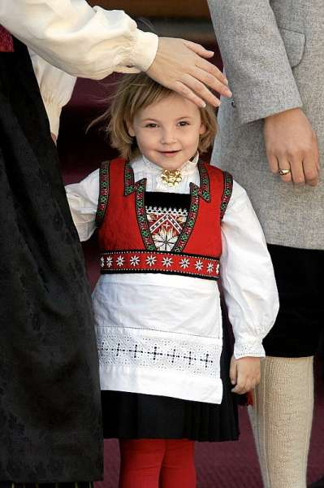
Little Princess, Ingrid Alexandra just turned 4 on January 21st. This picture from last 17th of May was taken by Erlend Aas. Ingrid is third in line to the throne, after her grandfather and father. From Aftenposten.

We will be making our annual report for the 2007 year and to do that we need any volunteer hours you had during the year. That could include going to a school and talking about Norway and its customs. If you did any other activity, ie. going to the Viking Festival or to the Flee Market to help or anything like that, please let me know so we can add that to our report. We have all of the meeting hours (that is the paper you signed with the time it took you to get to the meeting). We will be doing the report very soon.
Another sad note was the need to cancel our Jultrefest in December due to the weather. However, we had a great Meatball dinner in January. We started the year with a wonderful meeting. Our market did very well, we had our historical items out for display as well as the books in our library. The books can be checked out through Esther. Call or email her to arrange to borrow one of the books. If you didn’t see them at the dinner she can tell you what is available when you contact her. Her contact info is located in the newsletter with all the officers and committee chairs.
The District 5 Convention will be held in Madison, Wisconsin on June 11-14. We are allowed 3 delegates and 3 alternates. It was moved and passed by the board to pay the $51.00 registration for 3 delegates to attend this convention. They will take care of the remainder of their expenses. At this time Nelda Chandler, Carol Luiso, Esther Charlton, and Nina Downs have expressed interest in attending.
I am looking forward to another great year and with everyone’s help, it will be a great year. If you have suggestions for programs or any other activities please feel free to contact myself or any of the other officers or committee chairs. If you are willing to help with any of the committees please contact that chair and offer your help. This Lodge can only be as good as we make it by all working together.
See you at the next meeting (info inside).
Beste Hilsen
Nelda Chandler

Tubfrim
Tubfrim will now accept stamps that were previously unacceptable. Tubfrim can now use stamps that are in a row, but there must be a ½” border so they can be trimmed. To restate the rules: Clip canceled stamps from envelopes, leaving ½”

around the edge. Stamps cannot be damaged, nor should there be more than one layer of envelope behind them.
Tubfrim is a worthy charity that took in $80,000 last year, that was distributed to disabled and needy children. Go to www.tubfrim.no to learn more, or talk to our Tubfrim officer: Alene Rice

Facts (and fiction) from Nordic Mythology and Norwegian History
From Anders Marstrander
This time I will shed a little light on how Norway was settled, and the early years of human inhabitation.
Approximately 12,000 years ago the first settlers arrived to Norway. They came from the south east crossing over what was then a large glacier covering most of Scandinavia, Finland and western Russia. They probably followed the reindeer which is known to migrate to the coastline in the summer. They found a coast full of the reindeer they were seeking, but also lots of birds and fish. This probably let them to believe that this was a land they could settle and live in. The land they found is in the northern most region of Norway; Finnmark.

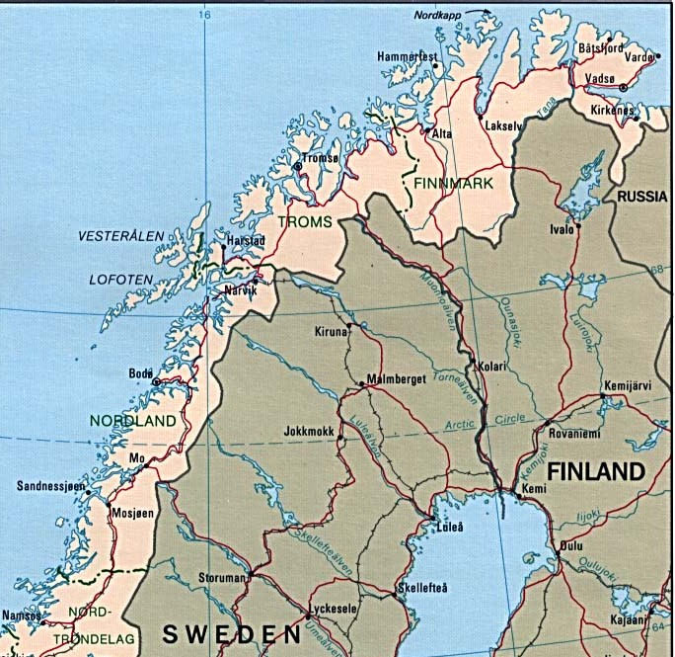

The oldest verified traces of human habitation was found at the island Magerøya in Finnmark. The arrowheads, stone knives etc. date back to about 9,500 B.C. Exactly where they came from can not be determined, but one theory is that the came from

the south, or south east over the ice from Finland or Russia. Another theory is that they came along the coast from the southern parts of Norway. Which ever is correct, the oldest remnants are found all the way up on the northern end of Norway.
When these people came, it was cold in Europe. The large glaciers covered large parts of the northern section of the continent, and the people who traveled north did so only to follow the game for the season. Most of the hunting people lived in central and southern Europe. Over the next few thousand years the climate got warmer and the glaciers slowly withdrew. This led to new trees and other plants starting to grow in the northern parts of Europe. The people developed, and under influence from the rest of Europe, the people in Norway took up farming and crafts. They settled and formed societies. For the most parts they were ignored by the rest of the continent until the Viking era started.
The Phoenicians were the dominating traders in the Pre Roman age. They were based in the Mediterranean Sea, but traveled along the African Atlantic coast and also all the way to the Baltic countries. To get to the Baltic area they had to pass between Norway and Denmark, and it is believed that they named the land to the north “The way to the North – Norway. The name is spelled differently in many languages, but they all mean the same – the way to the north.
Next time I will jump ahead several hundred years and catch up with Harald the Fairhair who won over all the local kings and rulers and united Norway under one king.

Norwegian Lady Statues
In 1962 Norwegian sculptor Ørnulf Bast was commissioned to create two 9’ bronze replicas of the original figurehead from the Norwegian barque DICTATOR which floundered off the coast near Virginia Beach in 1891. One is in Moss, the home port of the barque, and the other is in Norfolk, Virginia each facing each other. The pregnant young wife (Johanne Jørgensen) of the captain (Jørgen), and their 4 year old son perished in the wreck.

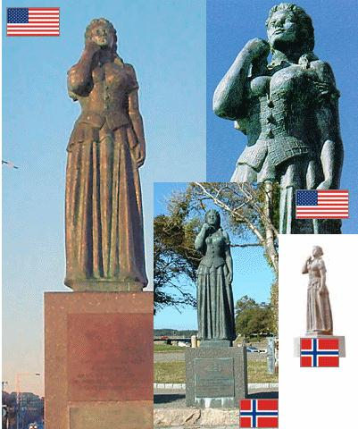
The original figurehead washed ashore and was placed facing the ocean as a memorial to those who lost their lives in the shipwreck. Known as “The Norwegian Lady”, it was a landmark for more than 60 years until 1953 when Hurricane Barbara significantly damaged the figurehead, and the city removed it for safe keeping.
There is much more to this story available on the internet by going to Google, and inquiring about Norwegian Lady, Virginia Beach.
Author William O. Foss wrote a book in 2002 titled “The Norwegian Lady and the Wreck of the Dictator”, published by Noreg Books, ISBN 0-9721989-0-3.

Membership
We are delighted to introduce several new members to the lodge.
For her many contributions to our lodge, we have given a one-year gift of membership to Sissel Rasdal Unneland. Sissel is Linda Burge’s cousin and lives in Bergen. Some of you may remember Sissel and her husband when Linda had an open house for them on their last visit here

Jerry and Tillie Elvrum have joined our lodge. They saw the publicity about our November meeting (thanks, Siri) and Tille and their son J.D. came to the meeting. Tillie has stepped forward to be the lodge secretary.
More good news, we signed up three new Heritage Members at our Meatball Dinner. Kari Poe’s grandchildren Braden and Kari Watts are new heritage members. Jerry and Tillie Elvrum signed up their son J.D. as a heritage member.
It was a joy to present service pins to members for their years in Sons of Norway. Service pins are available for every five years. We honored Robert Price for his 20 years as a member of Sons of Norway. Anders Marstrander and Margie Mays both received 5-year pins.
If you know of someone that may be interested in our lodge, please pass along their name to me. Or if you should have any questions about the membership process contact me.
Esther Charlton, Membership Secretary
Future Meetings:
Our Lodge meeting on February 16, 2008 will be A Day at the Slopes! Come join us at 10:00 AM at Perfect North slopes, 19074 Perfect Place Lane, Lawrenceburg, IN 47025. For details go to www.perfectnorth.com or call 812.537.3754. Group rates will apply if we have 15 or more participants. If you don't want to battle the slopes, come join us for card games and coffee in the Lodge! RSVP to Nina at ninatdowns@fuse.net or 513.608.0364.
On March 15, 2008 at 4:00. Come watch an amazing video on the building and sailing of the Hjemkomst. We will be meeting at the New England Club Upper Lounge, 8135 Beechmont Ave., 45255. Please bring $5.00 per person for pizza dinner. RSVP to Nina at ninatdowns@fuse.net or 513.608.0364.
April 19, 2008 at 4:00 PM is our Annual White Elephant Auction! Bring items to donate for this fundraiser for our Lodge. Auctioneer extraordinare Glenn Mikaloff and his lovely assistant Susie are sure to make this an enjoyable afternoon for all! This is a Potluck Dinner, please bring a dish to share. Meeting at the home of Glenn and Susie Mikaloff, 7472 Stone Ridge Drive, Springboro, OH 45066. Please RSVP to Susie at 937.748.8121.
Come celebrate 17 Mai, 2008 at the home of Kari Poe! 579 Belle Meade Farm Drive, Loveland, OH 45140. Children's activities will start at 3:00 PM, ending with a parade around 4:00 PM. Please bring a dish to share for a Potluck dinner. RSVP to Kari at 513.697.7142, or Nina at ninatdowns@fuse.net.
June 21, 2008 at 4:00 PM. is our 9th Annual Summer Solstice Pool Party at the home of Susie and Glenn Mikaloff, 7472 Stone Ridge Drive, Springboro, OH 45066. Bring your bathing suit and enjoy the day around the pool! Please bring a dish to share for dinner. RSVP to Susie at 937.748.8121.



Picture of existing embassy. Picture and article from Aftenposten, picture by Jan Tomas Espedal.

New US embassy on ice
Plans to build a new, more secure, US embassy on open space northwest of downtown Oslo are back on hold, after city politicians voted against issuing a building permit. The US ambassador to Norway is disappointed.
So are neighbors of the existing embassy, which has stirred controversy for years for being a terrorist target just across the street from the Royal Palace. Residents and businesses located near the US embassy have long wanted it to move out of its prime downtown location.
Few dispute relocation, but the site finally chosen for a new embassy has sparked the ire of its prospective neighbors. They are carrying on a legal battle to prevent its construction on one of the city's last remaining areas of open space at Huseby, not far from the busy Smedstad intersection.


Proposed embassy, picture by Einhorn Yaffee Prescott/Runnar Kolnes. City officials opted this week to wait until the legal battle is over. No building permits will be granted until a final decision is made on the Huseby site.
Barnebirkie
This year’s Barnebirkie will be held on Thursday, February 21 in Hayward Wisconsin. This annual event is a big favorite for many Norwegian families in the mid-west. Last year there was a definite lack of adequate snow, but right now that doesn’t look like it will be a problem this year. Go to www.birke.com for an entry form, and further information. Volunteers and cookie bakers are also being sought to help put on the event. Contact Darlene Arneson at 608-873-7209 or arnesn@chorus.net if you are interested in being a part of this event.
Moose problems
More moose and deer are being hit by motorists than ever before, and with each collision costing at least NOK 200,000, it's become an extremely expensive problem as well as traumatic for both animal and driver.
Trond Kjetil Kværnå survived a collision with a moose in 2006, and can attest to the costs involved, both physical and financial. "I was driving about 100 kilometers an hour (60 mph) and it was dark," Kværnå told Aftenposten, recalling the night he was driving on the main E-18 highway between Oslo and Sydeberg.
Suddenly a moose darted into my lane, it came from the left and ran between cars in the oncoming lane," said Kværnå, an experienced motorist who drives a truck for a living. He said that everything happened so fast that he didn't have time to react, and ended up with the moose coming right through his windshield.
The huge moose are especially dangerous because their legs are so long and their trunks so heavy. Cars normally hit them in the legs, hurling the animal onto the vehicle.
Kværnå said he remembers waking up in a field about 150 meters from the road. His injuries kept him away from work for three months. Emergency crews said that from the looks of his ruined car, a passenger in the car would have been killed.
State highway officials are stepping up measures to keep moose and other wildlife off Norwegian roads, especially in Hedmark County, where the accident rate is the highest. They're setting up winter feeding stations away from the road, and cutting back vegetation near the road, to allow motorists a better overview and reduce the possibility of wildlife suddenly darting out of the bush. From Aftenposten

Birthdays:
February
Luke Suthin[1], Tillie Elvrum[5], Jan Garnaes-Johnson[6], Patsy Bannick[6], Sylvia Casas[15], Linda Burge[17], Cassi Rice[19], Mark Kosobud[20].

March
Kari Watts[2], Robert Charlton[11], Robert Hippert[13], Larry Banick[17], Alene Rice[23], Alex Crocker-Lakness[24].

April
Sonja Kinney[1], Katherine Sanders[2], Braden Watts[8], Robert Price, Jr.[18], Donna Kent[25], Robert Price, Sr.[26], Walter Varland[27]

Remember to go to:
website: www.evensens.net/sons/sons.html

President Vice-President
Nelda Chandler Nina Downs(tentative)
11409 Geneva Rd. 1478 Montegor Dr.
Forest Park, OH 45440 Cincinnati,OH 45230
513-742-9540 513-561-1759
nelda1961@Cinci.rr.com Ninatdowns@fuse.net

Secretary Treasurer
Tillie Elvrum(tentative) Carol Luiso
6724 Trillium Ct. 1006 Paxton Lake Dr
Maineville, Oh 45039 Loveland, Oh 45140
513-683-5826 513-683-3631
Elvrumjtj@aol.com Chluiso@aol.com

Social Director Webmaster
Nina T. Downs Lois Evensen
1478 Montegor Dr. P.O.Box 9450
Cincinnati, OH 45230 Cincinnati,OH 45209
513-561-1759 513-281-8408
Ninatdowns@fuse.net Lois@evensens.net

Edvard Grieg Lodge 657 District 5
Cincinnati-Dayton, Ohio
C/O Esther Charlton
3798 Susanna Dr.
Cincinnati, OH 45251

Adopt-A-School Tubfrim
Donna Marstrander Alene Rice
5527 Woodvalley Ct. 2 Forest Pl.
Mason, Ohio 45040-2622 Glendale, OH 45246
513-398-4285 513-771-4378
dmarstrander@gmail.com Clocks@usadatanet.net

Membership Newsletter
Esther Charlton Per Flem
3798 Susanna Dr. 4269 Berryhill Ln.
Cincinnati, OH 45254 Blue Ash, OH 45242
513-923-3798 513-791-8942
Esthersofn@aol.com Perflem@rectomolded.com

Publicity Foundation

Siri Timo Anders Marstrander
6873 Rosetree Pl. 5527 Woodbury Ct
Mason, OH 45040 Mason, OH 45040-2622
513-398-4285 513-398-4285
Siri@Cinci.rr.com Anders@Marstrander.com

