
Edvard Grieg Lodge 657 District 5
Cincinnati-Dayton, Ohio & Kentucky

The First Lodge in Ohio
Sons, Daughters and Friends of Norway
February 2009

SAMMENKOMSTEN (MEETINGS) PLEASE NOTE DATE, TIME AND LOCATION CHANGES!!!
February Meeting: February 14, 2009 at 12:30 KRAZY BINGO!! This is a popular game and crowd pleaser with other Sons of Norway Lodges.The meeting will be held at the home of Glenn and Susie Mikaloff, 7472 Stoneridge Drive, Springboro, OH 45066. Come and warm up with a bowl of Red and /or White Chili (provided by the Mikaloff's). We will begin with a brief business session followed by lunch and the Bingo game. Also-don't dig too deep into your White Elephant Donations, but if you have a small treasure you could dust off and donate as a prize, that would be great! We will need some members to bring a salad or a dessert. Please let Susie know what you intend to bring when you RSVP to her at 937.748.8121. We look forward to sharing this fun afternoon with you.
March Meeting: March 21, 2009 at 3:00 VIS og FORTELL (Show and Tell). Come join us at the home of Jerry and Tillie Elvrum, 6724 Trillium Court, Maineville, OH. Bring something that you love about or from Norway to share with everyone. We will order pizza, have our brief business session, Vis of Fortell and then eat dinner and socialize. Please bring $5.00 per person for the pizza. If anyone would like to bring a salad or dessert please let Tillie know when you RSVP. In an effort to start giving back more to our community please bring a non-perishable item to donate to a
local food pantry, (TBA). RSVP to Tillie at 513.683.5826 or Elvrumtjt@aol.com
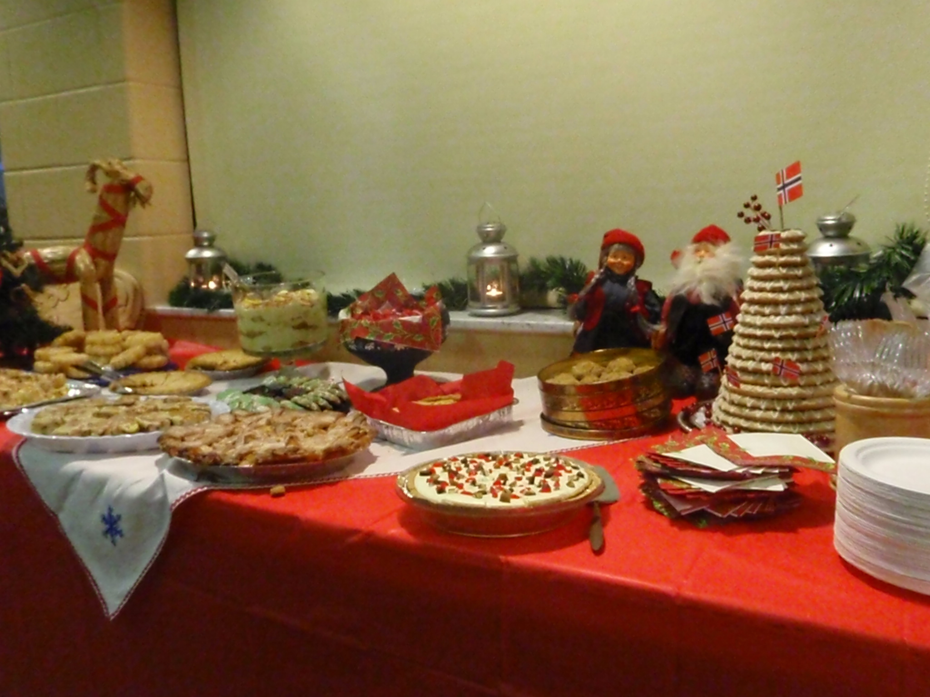
Picture from Nina, to remind those of the good stuff from Jultrefest. Envy to those who didn’t make it.

Fra Presidenten
Dear fellow Members and Friends,
Godt nyttår! I hope this message finds you all warm and ready for a great time in 2009. It is with great honor and enthusiasm that I write you my first message as President of our Lodge.
First, I would like to thank all of you who helped to make our Juletrefest the success that it was: Tillie Elvrum, for putting together the table setting/party favors with the Norwegian table prayer, for shopping with me for the food and other supplies, helping in the kitchen, serving the food, and enduring countless phone calls from me about all the little “details”. (You rock! ) Jerry, and JD Elvrum, for setting the tables, preparing and serving the food and cleaning the kitchen up! Anders Marstrander for greeting guests, cooking, and for being the Julenisse! Carol Luiso for manning the registration table. Carol Stone for being our photographer (Great pics Carol!!!) Beth Monson for playing the piano during our dances around the tree. (Clap, clap, clap!!!) Esther Charlton for fine tuning matters at her church, taking reservations and performing other administrative details. Nelda Chandler, for filling in all the needed blanks.(Thanks!) To Kari Poe, Susie Mikaloff, Donna Marstrander, Nelda Chandler, Sandy Nelson, Diane Person and Tillie Elvrum for donating homemade, Norwegian baked goods. (Yum, yum!) And last, but certainly not least, to Sandy Nelson, Diane Person, and Linda Burge for all their hard work on the fabulous Norsk Buttik ! All of their time, great energy, wonderful ideas and personal donations really contributed to the success of our Juletrefest. Tusen, tusen takk allesammen !!!
Second, I would like to thank Burt Bittner (our District Vice President) and his wife Jean for joining us at IKEA in January for our Officer Installation Dinner. They provided us with a lot of information and encouraged us to work on our Cultural pins. We will be discussing more of this at our meetings as it is our goal to begin receiving many of them!

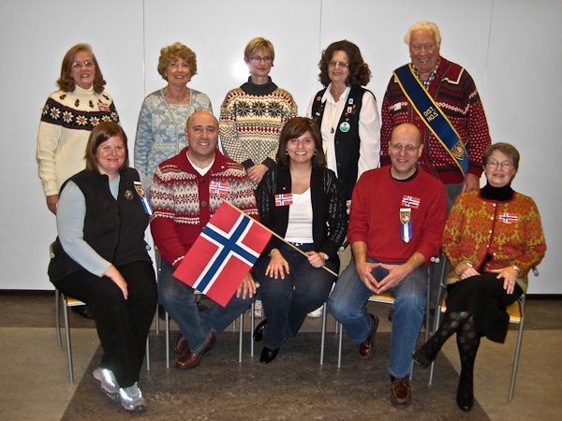
From the January meeting: From front left to right, new officers Nina Downs(President), JerryElvrum(Vice-President),Tillie Elvrum(Secretary), Anders Marstrander, Sandy Nelson(go to person). Top, left to right Lois Evensen(webmaster), Carol Luiso(happy former treasurer), Siri Timo , Esther Charlton(Membership, former President), Burt Bitner(from Indianapolis representing District 5) who inducted new officers into office.

I love Norway and am deeply passionate about my Norwegian roots. For those who do not know me I felt a little background may be necessary. My father was American and my mother was Norwegian, born and raised in Østerås,Oslo. (I say “was” as they have both passed away way too early, in the past 5 years). My father was in the Army, therefore I was born in Germany, went to a French Preschool, lived in Iran, in Germany, several places in the United States and spent 3 months every summer in Norway.
I have been back about 10 times since high school including the Winter Olympics in 1994 and for a winter honeymoon. My two sons and I will be traveling to Norway for the month of July. It is my plan to go every other summer with them.
My Norwegian grandparents came to live with us every winter when they grew older as to avoid the long, harsh winters of Norway and to spend time with us. They were a very big influence on me. My grandmother was a wonderful cook, knitter and baker and taught me great respect and admiration for those things. My grandfather was a banker at Oslo Sparbank, a competitive rower, a fisherman and a lover of nature. I remember taking long, long walks with him, learning respect for and information about plants, bugs and trees and feel the experiences have shaped who I am today. I love the outdoors, cooking, baking and any kind of crafts. It is my desire to one day become a Master painter in Rosemaling, knit a typical Norwegian sweater and learn woodcarving. I believe that Sons of Norway will help me achieve those goals!
We have a summer home on an island in Kragerø where we spend most of the summer vacation. Our cabin, by choice, has no electricity, no running water, and of course, no plumbing. I love it! We boat, fish, swim, hike and lay out under the sun. It is heaven on earth. If you have not already-experiencing the fjords of Norway is a must!
I moved here about 5 years ago from Louisville, Ky upon meeting my now husband, Bob. After the birth of our first son, Benjamin (4 ½) I was deeply saddened by the fact that he would not have the same influence of his grandparents as I was privileged to have, and felt I needed to find some local Norwegians to surround him with and to help him learn the language as I did and to appreciate his roots. In doing so, I found so much more. I found fellowship, a greater understanding of Norway and it’s traditions and some of my best friends.
I became Social Chair after a few months of joining this Lodge several years ago, and feel it has laid a foundation for my understanding of Sons of Norway and the way it works. Along with my love for Norway, I feel this will be a great asset as I serve as your next President. My goals this year, along with members of the board, are to increase our membership, give back more to our community, help send some heritage members to summer camp and to continue to develop friendships with fellow Norwegians through our meetings and outside activities. I am looking forward to achieving these goals and to serving you.
Please always feel free to contact me with any questions, concerns, or desires.
Med Vennlig Hilsen,
Nina T Downs

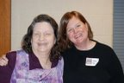
Former and present Presidents, Nina and Nelda at Jultrefest

Membership

It was heartwarming to receive the end of the year report that showed we had 121 members. This gave us a 14% increase in growth from our end of 2007 total of 106 members.This increase is more then the average for lodges and we should feel proud of this growth for us.
For this increase in membership we will receive the Founders Award, which is given to lodges, who have an increase of membership of more than 3%. The award is a $50.00 check for our treasury.
In December we gained new members and re-instated members.
Anders Juel joined us at Juletrefest. He has known about our lodge for quite a while, and we are happy his schedule permitted him to attend Juletrefest and meet other Norwegians. Anders was born in Norway.
Patricia Nelson Schott, was recruited, by Nina at Rousters Farm. Nina’s enthusiasm about Juletrefest, and our lodge encouraged Pat to attend Juletrefest. She then immediately sent in her application for membership to Sons of Norway.
Yvonne Iversen was given the gift of membership, for Christmas by her friend Greg Clark.Yvonne joined us at our January meeting at IKEA.
Karl Flem has rejoined the lodge and, with this renewal, his son Kaleb is also now a full member of the lodge.

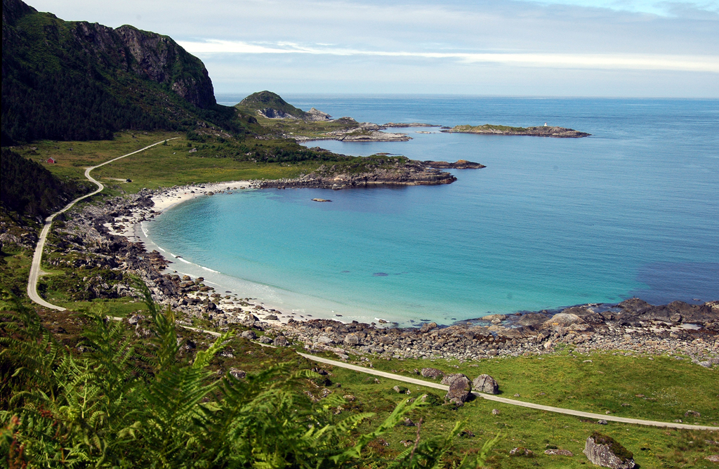
For those seeking a little summer dreaming, on the north side of Flemsoya, there is a sandy beach that draws bathers from Alesund. Picture by Gunnar Standalfrom Sunmorposten.

A friendly reminder about paying your dues on time. The home office will send a statement a couple of weeks before your membership expires. Then they will send one reminder about the dues. Should you linger too long in paying them or forget to pay, you will be automatically dropped from the membership list. You may renew online, or by calling the office in Minneapolis, or even giving your dues to me at a lodge meeting.
Do you know of a place that we can post a flyer about our lodge? We do keep flyers in the Scandinavian room at Jungle Jim’s and have received inquires because of them.
These people received service pins for their membership in Sons of Norway.
5 year pins = Sylvia Casas, Diane Clark, Carol Luiso, Peter Olson, Ray Olson, Ed Vallette and Nancy Vallette.
10 year pins = Iver Bradley and Linda Burge
15 year pins = Carol Olson and Ken Soberg.
If you have any questions about membership or know of someone that might be interested, please contact me.
Thanks,
Esther Charlton, Membership Secretary

Reading Circle
At our last Reading Circle meeting we discussed Thor Heyerdahl’s book Kon-Tiki. Member Trine Wernes told us about her experience working at the Kon-Tiki Museum in Oslo. Trine’s book was autographed by Knut Haugland, a crew member on the Kon-Tiki. Haugland became director of the Kon-Tiki Museum.We also watched the award winning documentary of the Kon-Tiki’s 1947 expedition from South America to the Polynesian islands. Our next meeting will be Saturday, March 7, 9:30 a.m. at Panera Bread, Deerfield Town Center in Mason. For this meeting, you can choose any book by a Norwegian, Norwegian/American, or a book about Norway to read.
If you enjoy reading Norwegian related books, join the group!
If you have questions, contact Carol Luiso, CHLuiso@aol.com or 513.683.3631.
Sons of Norway Foundation
Our foundation mission statement is: “We award scholarships and grants to promote the heritage and culture of Norway, and provide assistance to our members, lodges and their communities”.
The foundation gives 27 scholarships each year as well as grants. Members, children of members and grandchildren of members may qualify for the scholarships. The scholarships are awarded once each year. Visit the Sons of Norway web site: www.sonsofnorway.com/foundation for qualifying information and application forms.


Picture from Donna Marstrander of Luke doing his thing.

MEETING RAFFLES
If you have any Norwegian items (new or gently used) that you would like to donate for our raffles that would be great. Food items like lingonberries, fishballs, candy, etc., are good too - anything Norwegian that you think people might like to have in a raffle.
I would like to have one homemade Norwegian baked goodie for each raffle this year. Would you be willing to bake something Norwegian to donate to a raffle? If so, please let me know.
I can be reached at 336.9810, sneL1234@fuse.net, a meeting, OR stop by & I will put the coffee pot on!
Sandy Nelson
Raffle Chairperson
Facts (and fiction) from Nordic Mythology and Norwegian History
Ting means assembly, and that was what it was. These first Nordic democratic institutions were assemblies of free elected men. Yes, they were men! No women were elected as representatives to the Ting. And you had to be free, of course. A slave or
someone otherwise not free could not speak or vote at the Ting.
Around Norway and the rest of the Nordic countries there were several Ting. They were periodical regional assemblies were anyone (free men) could bring their disputes to be settled. The Ting would also discuss other matters of common interest, like the need to go to war against a nearby area.
In an earlier article I mentioned how Eirik the Red was sentenced by the Ting in Iceland to move to another after murdering his neighbor. Then after a second murder he was outlawed for 3 years. These more serious cases were some of the matter the Ting discussed. They dealt with matters of justice, but they were also passing the laws. So compared to today’s system they were both the legislative and judicial branches of their governing system.
In addition to this the place of the Ting was also a center for cultural and religious activities. These places were well suited since they usually chose a hill were the speaker could be seen and heard by a large assembly. Later on, after Christianity was introduced, the same places were used to build churches. This is one of the reasons for the Norwegian (and Swedish) tradition to build churches on hills; some of them are visible from quite a distance.
The word Ting lives on in the Norwegian language today, here are some examples:
- Storting – The Norwegian parliament
- Tingrett – One of the courts in Norway (also the regional courts in Norway are named Eidsivating, Borgarting, Frostating and Gulating)
- Tinglysing – To make a document public (used to mean to declare something at the Ting)
- And on Isle of Man, which was invaded by Norwegian, the regional assembly is called Tynwald.

There are several places were they used to hold Ting that bear witness of this in their names. At Nordmøre (a coastal area between Bergen and Trondheim) there is a place called Tingvoll (the hill of the Ting), and several smaller places are called
“Tinghaug” (which means the same – hill of the Ting).
Anders Marstrander

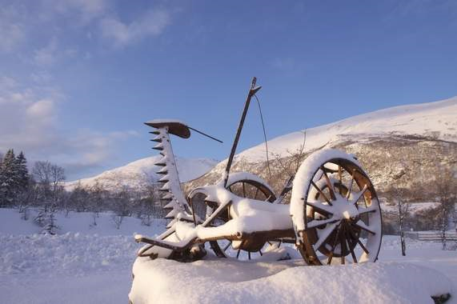
Picture from Sunmorposton, by Per Tormod Nilsen

Birthdays

February
Luke Sutphin[1], Aaron Nelson[5], Tillie Elvrum[5], Jan Garnaes-Johnson[6], Patsy Bannick[6] Lee Luiso[12], Sylvia Casas[15], Linda Burge[17], Bob Bowman[17], Cassi Rice[19], Mark Kosobud[20].

March
Kari Watts[2], Robert Charlton[11], Robert Hippert[13], Karl Flem[14], Megan Luiso[15], Larry Bannick[17], Patricia Nelson Schott[17], Alene Rice[23], Alex Crocker-Lakness[24].

April
Sonja Kinney[1], Katherine Sanders[2], Braden Watts[8], Angela Holman[10], Robert Price, Jr.[18], Donna Kent[25], Robert Price, Sr.[26], Walter Varland[27].

How subtitles can be tiresome
Dear reader, did you think we were talking about reading the subtitles on a movie when you can perfectly well understand and hear what is being said? Oh no, we are thinking about creating the subtitles. That is a profession that we have now got the deepest respect for. The people who do that for a living have a job that requires a lot more than language skills, most of all it requires patience and a lot of time.
How do we know this? Some time in the summer of 2008 we were asked if we could help with writing the subtitles for a movie. Sure, we said, how hard could it be? So in August we received several files with the transcripts of a new movie “Beowulf – Prince of the Geats”. We split them up between us and started working. So between regular jobs, child care and vacation we managed to get it done in time.
The movie is partly produced here in Ohio and the director, Scott Wegener, lives in Cincinnati. Some sections of the movie are produced in Kvam in Norway. He told us that unlike the Hollywood version of the tale of Beowulf, this movie is kept closer to the original script. The movie had its Norwegian premiere at Kvam in Norway late in 2008, according to Scott we must have done a good job with the subtitles (pat on our own backs). The movie is a low budget movie (almost no budget at all), with all the staff and actors volunteering; and yes, the subtitle writes volunteered too! All the proceeds from the movie will go to fighting cancer. The proceeds will be split between the Norwegian cancer society and the American cancer society.
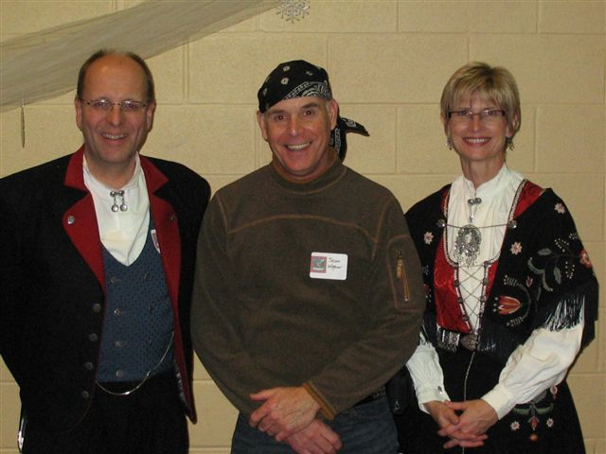
Anders, Scott Wegener, and Siri at Jultrefest. Picture from Siri
Some of you may remember the director and his wife at the Julefest. They brought the trailer for the movie and showed it to us. The movie can be ordered at www.princeofthegeats.com for $19.95 (plus S/H $2.50). At this website you can read more about the movie and see a trailer.
Siri Timo
Anders Marstrander

Remember to go to:
website: www.evensens.net/sons/sons.html

KALENDER
February 14-Krazy Bingo at the home of the Mikaloff's.
March 21-Vis og Fortell at the home of the Elrum's
April 18-White Elephant Auction at home of the Mikaloffs.
May 17- 17 Mai Celebration at home of Kari Poe.
June 20- Summer Soltice Pool Party at the Mikaloffs.

