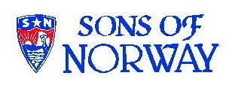
Edvard Grieg Lodge 657 District 5
Cincinnati-Dayton, Ohio, & Kentucky

The First Lodge in Ohio
Sons, Daughters and Friends of Norway
April 2008

Future events (details in newsletter)
April6th, Reading Circle at Carol Luiso’s
April 19th, White Elephant Sale, at Mikaloff’s home.
April 26&27 Ashville Viking Festival
May 7th Cincinnati Art Museum-One World Wednesday
May16th Norwegian Flag raising in Columbus
May17th Scandinavian Luncheon
May 17th Regular Lodge Meeting at Kari Poe’s home
June 21st Annual Summer Solstice Pool Party

President’s message
Hei
I am on my way to Anaheim, California as I write this note, to my national operating room Nurses Annual Congress. I am looking forward to some sunny weather as I am leaving a real wet mess at home. My sump pump decided not to work and therefore the carpet in my basement is wet and a total disaster. Hopefully when I return it will be all cleaned up, mold and all. At least I hope so. This past week has been a “trip” and I am glad to be gone for a week.
Many of you were at the last meeting at the New England Club and met our new insurance representative, Jim Santee, and Advanced Financial Consultant, Darrell Dunn. Both are very nice and ready to answer any questions you might have. Please feel free to contact Jim for any of your insurance needs. The insurance is a very important part of the Sons of Norway.
Who has been to the new Ikea store? It is a huge store so if you haven’t been there wear comfortable shoes. I have been to the Ikea in Oregon but have not

been to ours yet. I want to go when I get back and have plenty of time to look around. The food is very good. I had their meatball dinner, it was wonderful. We will have a meeting there in the future as they have a room we can use, you can shop and attend the meeting or vice versa.
Don’t forget your “white elephant” items for our next meeting. If you haven’t attended the white elephant auction you have missed a real treat, Glen is the auctioneer supreme. Bring new/used items or recycle something you bought last year it doesn’t matter .This is also a big fund raiser for the lodge.

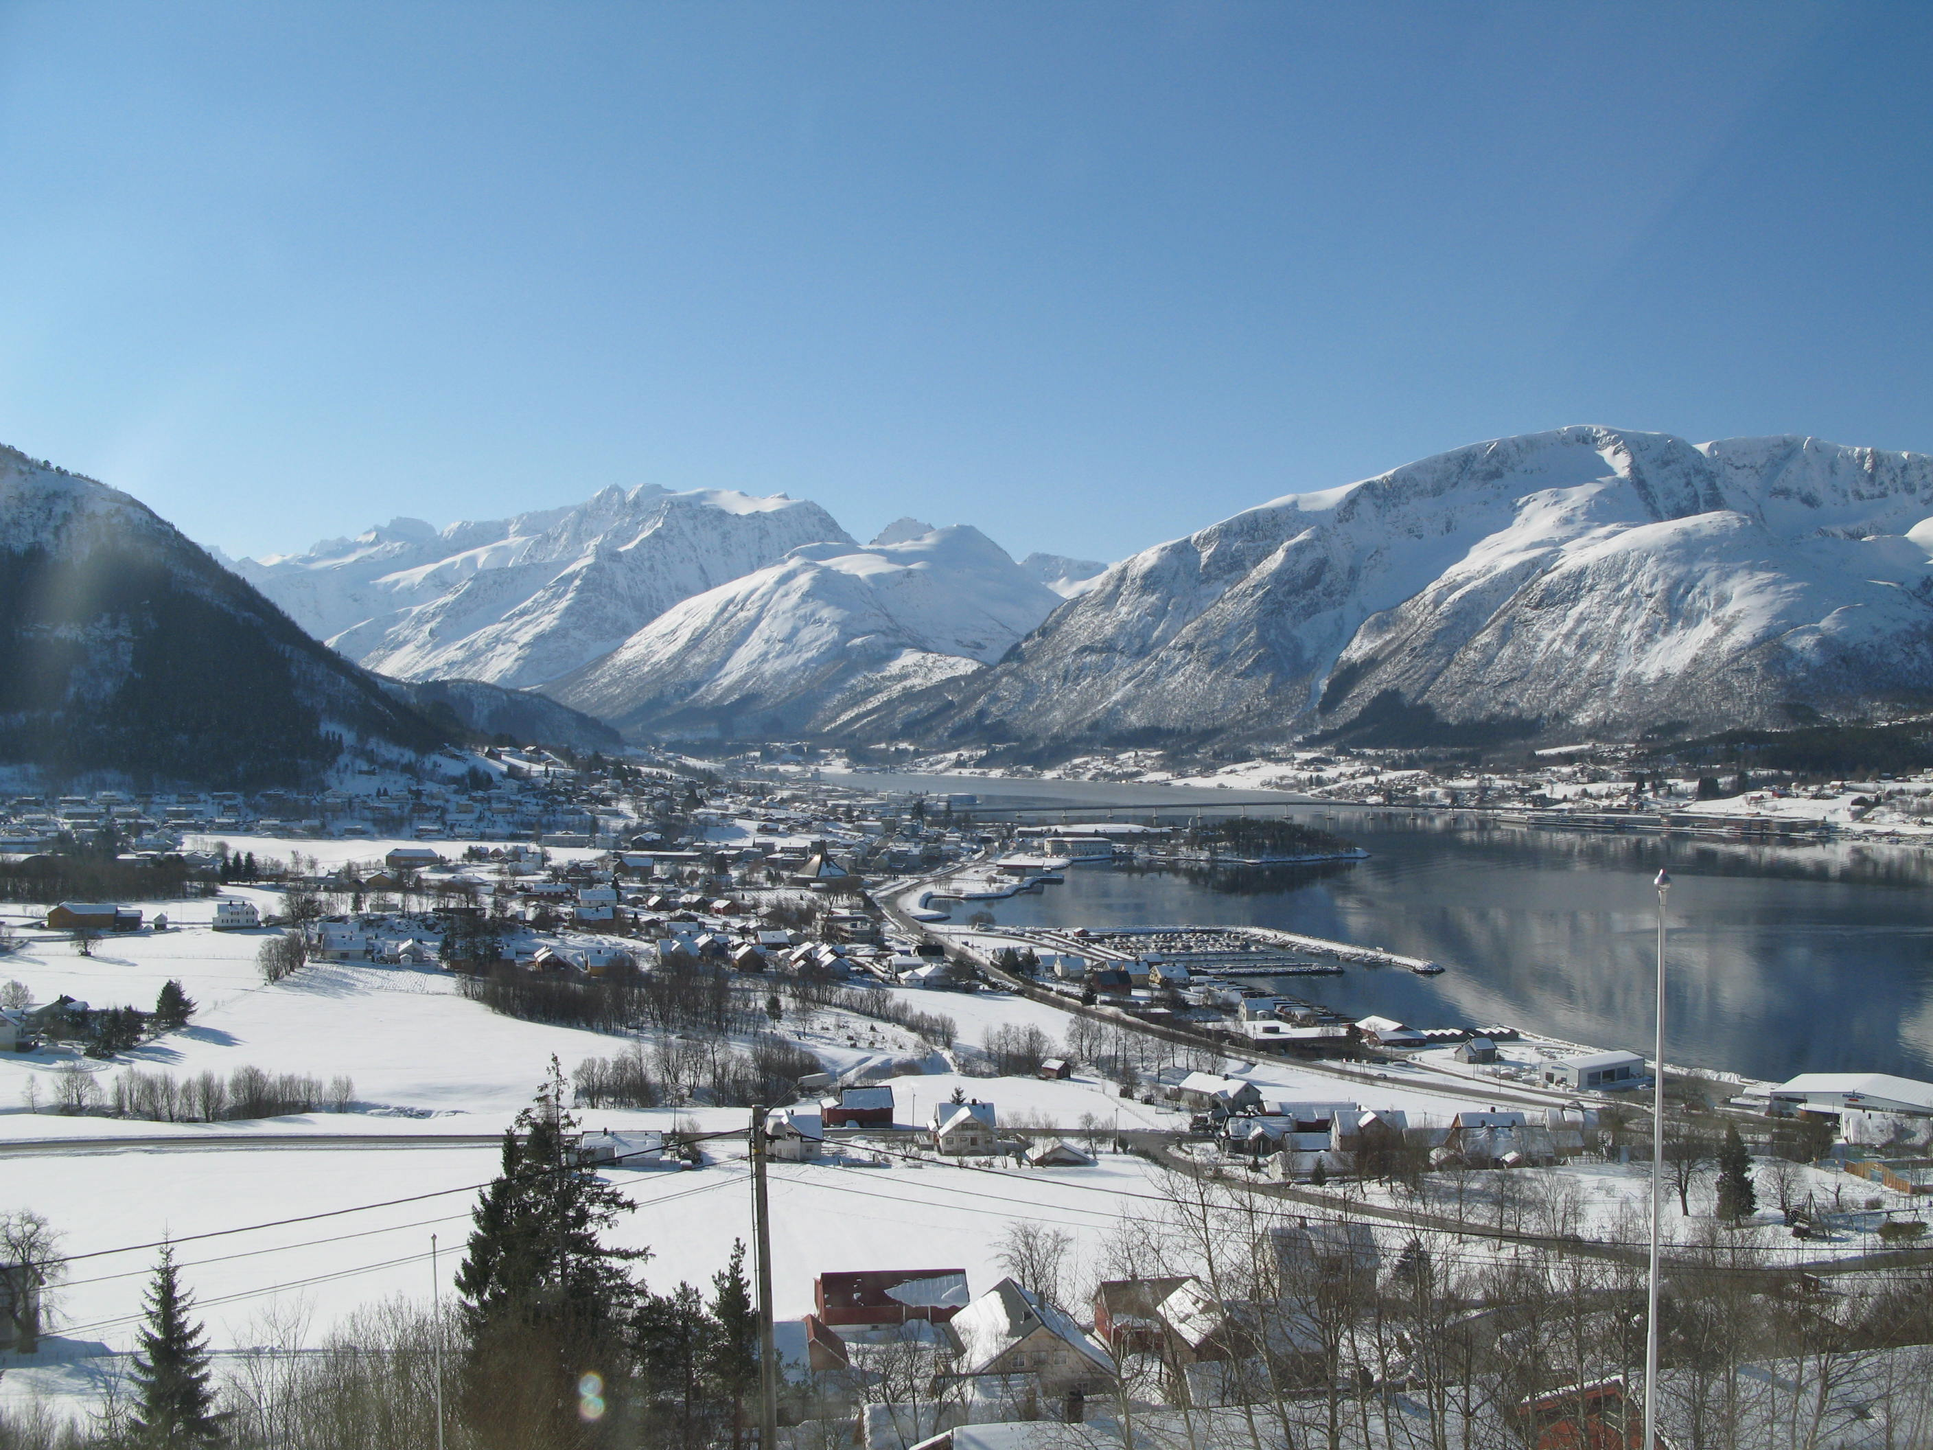
This is a picture fromWebcams in Norway, taken a few days after Easter, of Sykkylven, just east of Ålesund. You might travel through this town if you were going from Ålesund to Geiranger via Hellesylt with a ferry. I think the town across the fjord has the largest frozen pizza factory in Norway .I check this sight daily, and think it’s one of the best available for size and clarity. Editor.

The District 5 Convention is coming up in June. Esther Charlton and I will be the delegates. Carol Luiso may come for part of the convention as a visitor. If you have any concerns that you think the District, or Sons of Norway as a whole should consider, please let either me or Esther know as soon as possible. Any proposal must come from the lodge not from an individual and therefore must be brought to the board and the membership for approval. It must then be sent to the district so it can be placed on the agenda.
Hope your days have been good ones and that the weather continues to be warm and sunny. I know last summer we were begging for rain but I think we have had quite enough for now, at least I know I have.
Hilsen fra Presidenten
Nelda Chandler

Membership
For those of you receiving your membership renewal statements, you will find a card suggesting you give a gift of membership to Sons of Norway. Sandy Nelson did just that for her friend Judy Pieper. Judy lives in Phoenix, Arizona and we are sure she will enjoy receiving her Viking magazine monthly. Your gift of membership can be for anyone, living anywhere.
Ken Soberg has transferred into our lodge. He and his wife Ada moved to Paris, Ky, a little over a year ago. They were happy to finally find our lodge even though it is a bit of a drive to come to lodge meetings. They make a day of it and do some shopping before or after the meeting. They had been very active in Valhall lodge in San Diego, California. That lodge has a membership of over 300 people.
If you have any questions about membership, or know someone that should be contacted about our lodge, do contact me.
Thanks, Esther Charlton, Membership Secretary

Meetings (more details on website)

Reading Circle
Sunday, April 6th at 2PM, hosted by Carol Luiso.
We will continue discussing “Out Stealing Horses” by Per Petterson. Call Carol at 513-683-3631 for details or directions

White Elephant Sale Auction
Saturday, April 19th at 4PM, hosted by Glenn and Susie Mikaloff. Bring items for donation, no matter how outrageous, especially those Norwegian in heritage. This is a potluck dinner so please bring a dish to share. This is a favorite lodge event, designed to have you laugh and share special memories. Glenn and Susie have put this annual event together since the beginning of our lodge programs, and though hard to believe, gets better every year. Please RSVP with Susie at 937-748-8121

Ashville Viking Festival
April 26th & 27th. This is the fifth year for the festival and it keeps getting bigger each year. Our lodge will have a booth at the festival and we need your help. The hot item at our booth last year was cookies. If you can bake some cookies, any kind is fine, we assort them on plates to sell. We need them from you wonderful lodge bakers. Contact Esther Charlton to make delivery arrangements for the cookies.
The Norseman, a Viking ship is returning to the festival. On Friday, April 25th, the Norseman will sail on the Scioto River, North of Dublin, Ohio. Should you like to go for a sail of the Norseman, contact Esther for details.

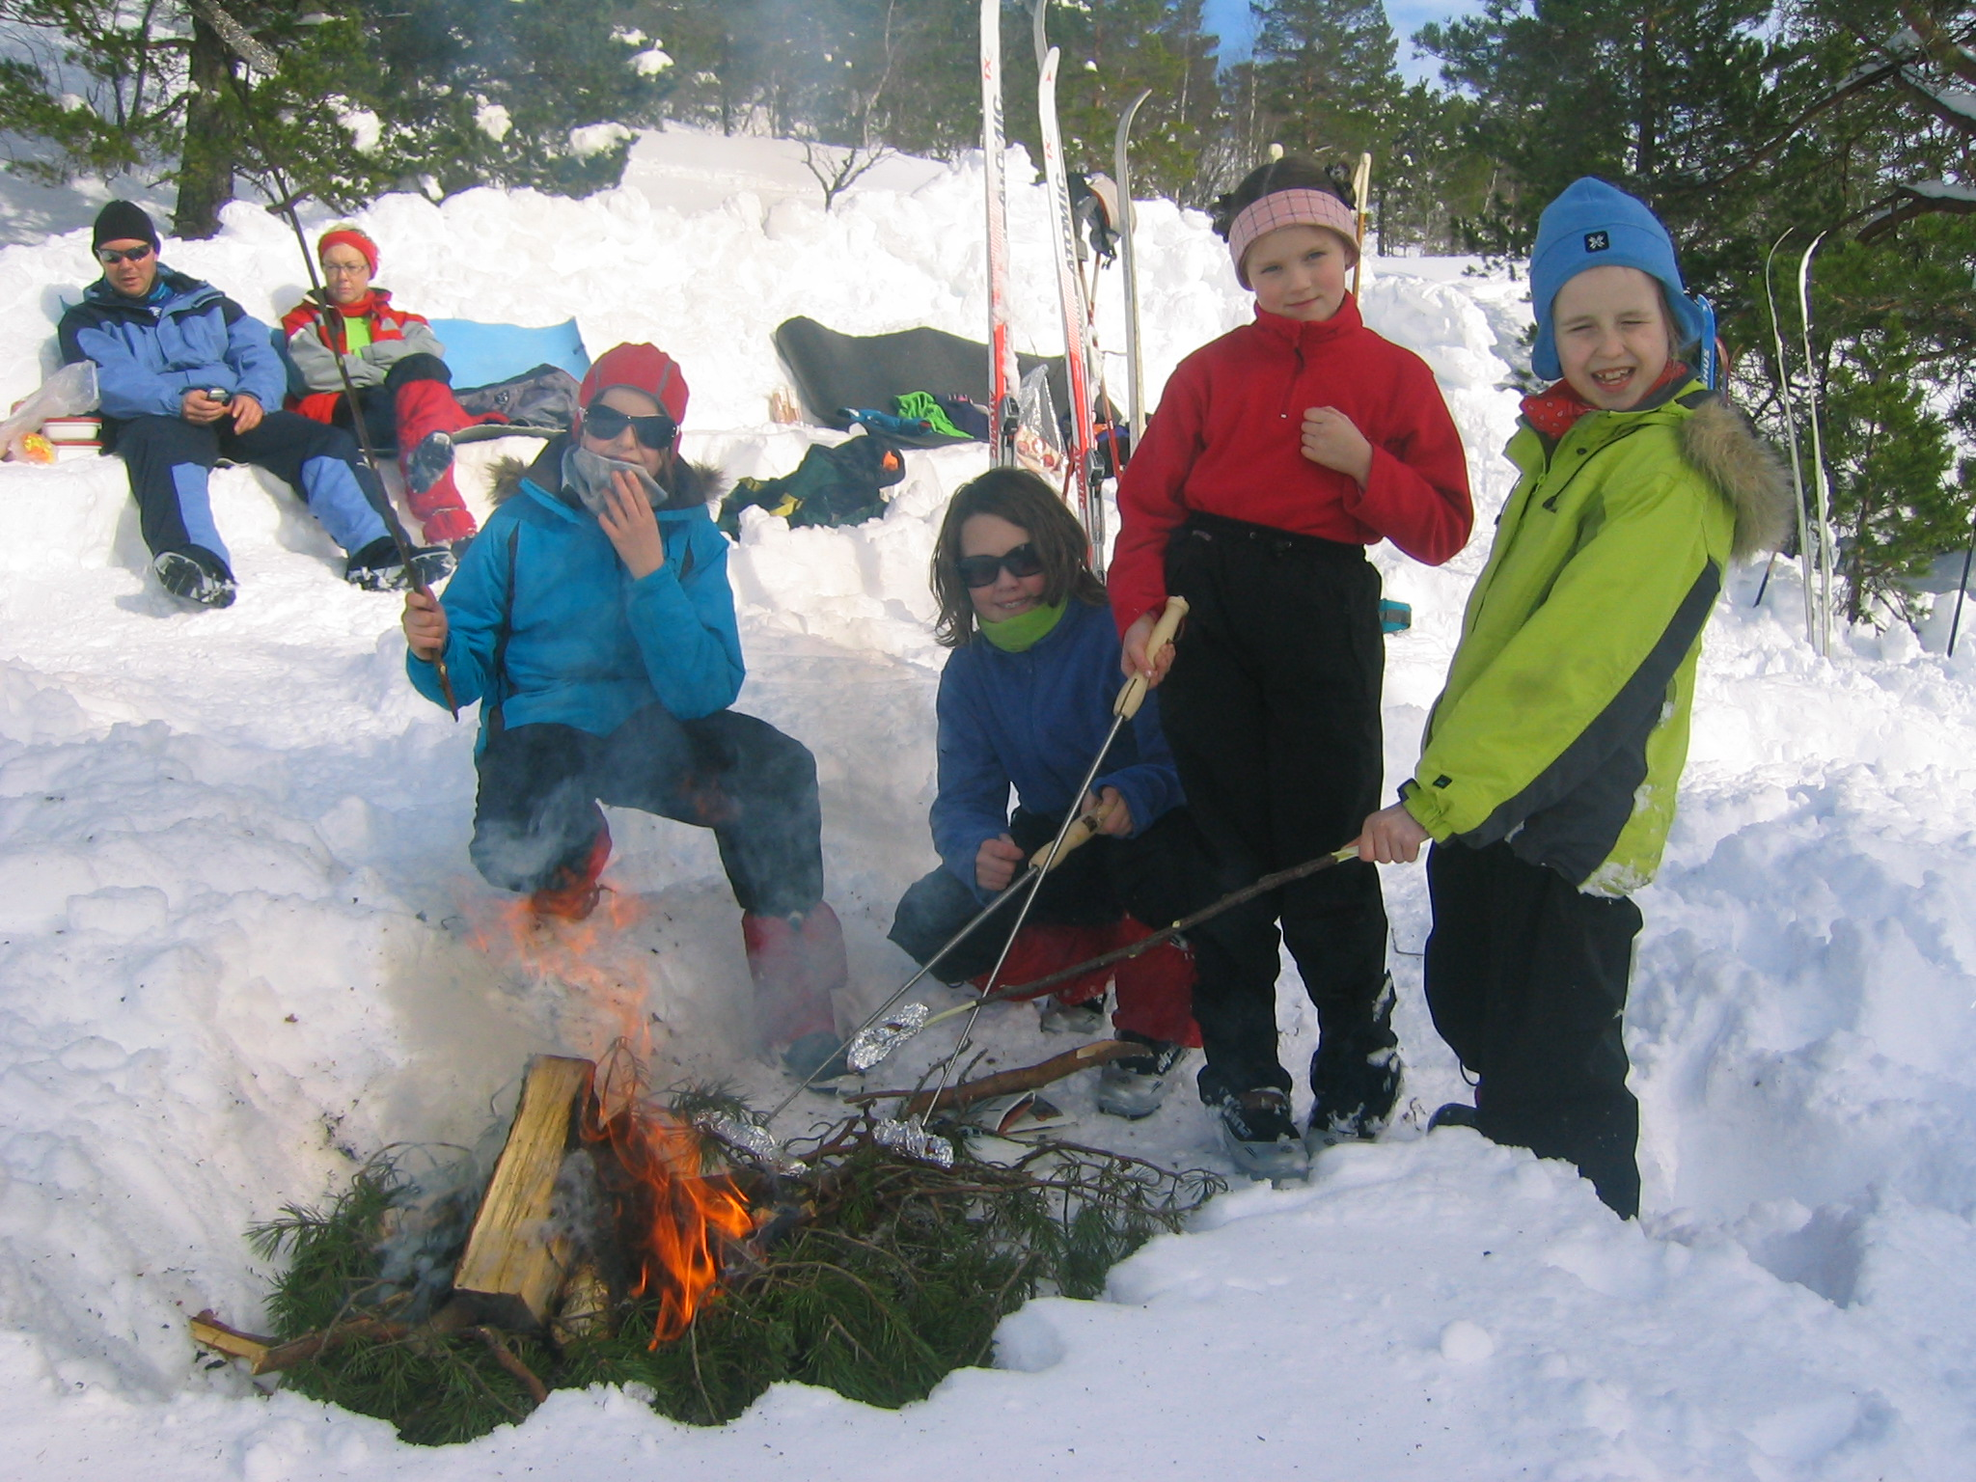
This is how one family(“cousins” of the editor), spent some of their time on Easter vacation. Picture from Gier Hurlin.

One World Wednesday, May 7th
On the first Wednesday of each month, the Cincinnati Art Museum has a special night with a different country or area featured. On May 7th, it will be the countries of Scandinavia. The event will be
from 5:30 until 9 p.m. If you have a bunad and
would be able to come to the Art Museum that night, please contact Esther Charlton for the details. They wish to have as many people as possible in their national costumes.

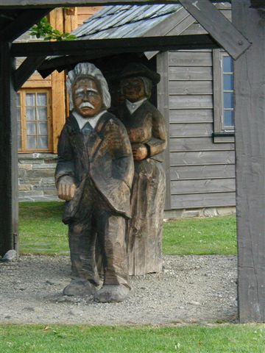
The picture is of a carved wooden statue of Edvard Grieg and his wife (and also his cousin) Nina. They are placed in front of a replica of his summer cabin at the Hotel Ullensvang in Lofthus by the Hardanger Fjord. It is actually not typical that his wife is with him here, he often went to this place after domestic disputes, or just to get away and write his music in peace and quiet. Picture from a recent trip, by Anders Marstrander

Flag Ceremony in Columbus
On Friday, May 16th, the Norwegian flag will be raised over the Capitol in Columbus, to fly for the weekend in honor of Syttende Mai. We gather at 11:30 and we raise the flag at noon. Then we all go

to lunch together in a parade waving our own
Norwegian flags. If you are interested in attending this ceremonial event, contact Esther Charlton as we arrange carpooling.

You are Invited, May17th
The Scandinavian Society invites you to lunch on Saturday, May 17 for their celebration of Syttende Mai. The lunch will be at Friendship United Methodist Church at noon. The program will be Erik Evensen, author of the book Gods of Asgard. He will present a program on Norse Mythology. Do check the lodge website for the details.

May 17th Lodge Meeting
Annual potluck dinner at Kari Poe’s. This great event begins at 3PM with children’s activities, has a parade at 4PM, with dinner after the parade. This is a potluck dinner so bring a favorite dish to share. RSVP with Kari(513-697-7142), or Nina at
Ninatdowns@fuse.net

Summer Solstice Pool Party
June21st, hosted by Susie, and Glenn Mikaloff.
Details in the next newsletter.

Birthdays
April
Sonja Kinney[1], Katherine Sanders[2], Braden Watts[8], Robert Price Jr[18], Donna Kent[25], Robert Price Sr[26], Walter Varland[27].

May
Roald Storetvedt[1], Rosalie Wingler[14], Robert Niehaus[15], Vicki Petreman[15], Dan Beckman[18].

June
Lane Larsen[2], Clare Williams[7], John T. Ericksen[11], Anders Nerli[11], Siri Timo[11], Pamela Nelson[13], Susan Price[18], Joyce Kosobud[23], Kjetil Marstrander[24], Carol Stone[25], James Lee[27], Carol Luiso[28].

Remember to go to:
website: www.evensens.net/sons/sons.html

President Vice-President
Nelda Chandler Nina Downs
11409 Geneva Rd. 1478 Montegor Dr.
Forest Park, OH 45440 Cincinnati,OH 45230
513-742-9504 513-561-1759
nelda1961@Cinci.rr.com Ninatdowns@fuse.net

Secretary Treasurer
Tillie Elvrum Carol Luiso
6724 Trillium Ct 1006 Paxton Lake Dr.
Maineville, OH 45039 Loveland, OH 45140
513-683-5826 513-683-3631
Elvrumjtj@aol.com Chluiso@aol.com

Social Director Webmaster
Nina T. Downs Lois Evensen
1478 Montegor Dr. P.O.Box 9450
Cincinnati, OH 45230 Cincinnati,OH 45209
513-561-1759 513-281-8408
Ninatdowns@fuse.net Lois@evensens.net

Edvard Grieg Lodge 657 District 5
Cincinnati-Dayton, Ohio
C/O Esther Charlton
3798 Susanna Dr.
Cincinnati, OH 45251

Adopt-A-School Tubfrim
Donna Marstrander Alene Rice
5527 Woodvalley Ct. 2 Forest Pl.
Mason, Ohio 45040-2622 Glendale, OH 45246
513-398-4285 513-771-4378
dmarstrander@gmail.com Clocks@zoomtown.com

Membership Newsletter
Esther Charlton Per Flem
3798 Susanna Dr. 4269 Berryhill Ln.
Cincinnati, OH 45251 Blue Ash, OH 45242
513-923-3798 513-791-8942
Esthersofn@aol.com Perflem@rectomolded.com

Publicity Foundation

Siri Timo Anders Marstrander
6873 Rosetree Pl. 5527 Woodbury Ct
Mason, OH 45040 Mason, OH 45040-2622
513-398-4285 513-398-4285
Siri@Cinci.rr.com Anders@Marstrander.com

