
Edvard Grieg Lodge 657 District 5
Cincinnati-Dayton, Ohio & Kentucky

The First Lodge in Ohio
Sons, Daughters and Friends of Norway
April 2009

Meetings
Annual White Elephant Auction
Saturday, April 18th 3:00PM, at Glenn and Susie Mikaloff’s home. Bring items to donate for the auction, and since it is potluck, a dish to share. RSVP Susie at 937-748-8121. This is a favorite meeting, with lots of fun and good food. We will be talking about this one for months.

Reading Circle
Saturday, May 2nd at 2:30PM, at Panera Bread 5095 Deerfield Rd. Mason. Call Carol Luiso at 513-683-3631.

Syttende Mai
Sunday May 17th, with Children’s program at 3:00PM, Children’s parade at 4:00PM, and the normal fabulous dinner at 5:00PM, at Kari Poe’s home. Bring a dish to share. RSVP with Kari at 513-697-7142, or Nina Downs at ninatdowns@fuse.net.
This is a must not miss event!

Annual Summer Solstice Pool Party
Saturday, June 20th, at 3:00 PM, at Glenn and Susie’s home. Bring a dish to share. Contact: Susie Mikaloff at 937-748-8121. After looking at the pool longingly during the White Elephant Auction, you can get into it today. This is our own Summer Solstice tradition, much warmer than in Norway!

Fra Presidenten
Tusen hjerlig takk til Glenn and Susie Mikaloff for hosting our FUN February meeting, CRAZY BINGO! We laughed so much at points that there were tears in our eyes! This will become a new tradition to play in the colder months. Tusen takk til Jerry and Tillie Elvrum for hosting our March meeting, Vis or Fortell. It was interesting to learn more about the Norwegian in fellow members. We have all started practicing and learning the Norwegian Table Prayer at our meetings, (takk Susie!) and beginning in April, we will have a Norsk table or area where only Norwegian will be spoken. We hope this will help some remember, allow some to practice and encourage others to learn. Lykke til!

In between the warmer days and rain showers, the flowers bloom and the birds chirp. Våren er her! (Spring is here!) and with that comes our favorite April White Elephant Auction, 17 Mai Celebration and June Summer Soltice party. We will also continue Rosemaling. Jeg gleder meg til å seg dere allesammen!
God Påske!
Vennlig Hilsen,
Nina

Membership
Let me introduce you to the members of the membership committee.
They are Jerry Elvrum, Teresa Lowen, Konrad Nelson, Pam Nelson and Trine Wernes. They will be brainstorming ideas to help us find new members for our lodge. We could use a couple of more people on the committee. If interested in being on the membership committee, contact Esther. If you know of someone that may be interested in Sons of Norway, suggest that they check our lodge website, where there is a link to membership information.
Esther Charlton, Membership Secretary

Friday, May 15 – Flag Ceremony
On this date at noon the Norwegian flag will be raised over the Ohio Statehouse. The flag will fly for the weekend in honor of Syttende Mai, Norway’s Constitution Day.
After the ceremony, we parade over to a nearby restaurant waving our Norwegian flags. We always have people from the Scandinavian Club of Columbus and sometimes people from the Arctic Circle lodge in NE Ohio.
If you are interested and available for this unique event on Friday, May 15th, contact Esther for details on carpooling.

Action Auction
Our lodge has the opportunity to help at CET’S 42nd annual Action Auction.
Our shift will be Friday, April 17th from 4:30 to 8 p.m. If you wish to join other lodge members at CET, answering phones or other tasks, contact Esther Charlton to get your name on the list. There is only a certain number that we can have at the auction, so call right away if you are available and interested.
You may want to wear your bunads or Norwegian sweaters. It is great fun and will be great publicity for our lodge.

6th Annual Ashville Viking Festival

This festival keeps getting bigger each year. Ashville is a little over 20 miles of Columbus off of route 23. The lodge will again have a booth at the festival as a fundraiser. Among the items we sell are cookies, cans of pop, bottles of water and Norwegian related merchandise.
If you can bake cookies, contact Esther. Cookies sell very well. If you would like to help at the booth, check with Esther about scheduling.
A Viking ship comes from Pa. for the festival and it will be sailing on Friday, April 24th in the Scioto River. If anyone should like to go on the ship for a sail, contact Esther for the arrangements.
The big news for this year is that on Saturday night of the festival they will be screening the English language premier of an Austrian movie titled “RAGNAROK’ – MYTHS AND SAGAS OF THE NORTH. This is a cross between a Scandinavian travelogue, and storytelling around the campfire, as the narrator tells the story of the Viking sagas and Viking religion. It is beautifully and professionally produced by a documentary film company.
This will likely be the only public viewing in the United States. The DVD will also be available for sale at the festival. Admission to the movie will be $5.00. The ticket is worth $5.00 off the price of the DVD.

From Linda Burge:


Anna Catherine Reeder was born January 11th to my daughter Jennie and her husband, Fred. She is a precious little thing! In this photo she is wearing the most beautiful hat, ever! The hat was made by our Diane Person. She is so very talented! Hope you enjoy the photo of the newest addition to our family. Yes, I am a proud BesteMor! Editor’s note: A few years ago I challenged the membership to supply a baby picture for every newsletter. That challenge still exists!

Facts (and fiction) from Nordic Mythology and Norwegian History

The Black Plague, or The Black Death as it was called in Norway (Svartedauen) changed everything. Societies disappeared, political alliances were broken and new formed, trade and cultural exchange suffered and of course people died. A lot of people died; In Norway about half the population perished and Europe as a whole lost 60% of its population (50 mill. of 80 mill.). World wide it is estimated that 75 million people died. Two countries in Europe got away fairly easy: Poland (closed the borders) hardly lost anybody and Iceland (all sailors died before reaching the island) lost “only” 1/3 of its population.

Scientists are debating what the Black Plague was (is). I will not dive into this discussion here, but stay with the most common description. According to this it was (is) a bacterial infection that was delivered to humans by lice. The lice were normally living on rats. One of the misconceptions is that is what the rats themselves that carried the plague, this is not true. It killed fast: It was said that a man could eat lunch with his wife and children and dinner with his parents, meaning he would feel fine at noon and be dead at night. The Black Plague lives on today in certain areas in Asia where it originated. Today we know more about how to treat it, so it is not as dangerous as it was.

In 1347 the first people got sick from the plague in Italy. It was probably carried there by traders coming back from Asia. From there on it spread fast all over Europe. We know that the plague came to Bergen in 1349 and from there on spread all over Norway really fast. It is believed that it came to Oslo late the year before, but that it didn’t spread so fast because it was winter which made the rats and the lice less active.

So how did it change everything? A look at Norway will describe some of the changes that came about:
- When a large portion of the people living on farms died, there were simply not enough people around to keep up the farm. So farms became smaller since they only farmed the fields they could manage, or they disappeared as the forest took back the fields.
- Along the coast people took advantage of the sudden vacancies in the best areas, where fisheries were good and there was good farmland. This left other villages empty.
- It is estimated that 150 years after the Black Plague there were 25,000 farms in Norway, but an additional 40,000 farms were still abandoned.
- The language changed. People lived more isolated and the dialects became more distinct since there was hardly any outside influence.
- New names of places and people were used. Now places were given names like “Ødegården” (deserted farm). Between the age of 1 and 6 I lived at a farm called “Øya”, a name derived from “Øde” (desolate or deserted).
- People in the cities along the coast were still trading with other countries, but the foreign influence stopped there, it hardly reached the rest of Norway.
- The Hanseatic League was formed and took advantage of the vacuum in power and trade. They became a formidable power in Northern Europe.
- And finally, as some may remember that I have written about earlier, the sailings to Greenland stopped. This put a definite stop to the Nordic settlements there.

Anders Marstrander

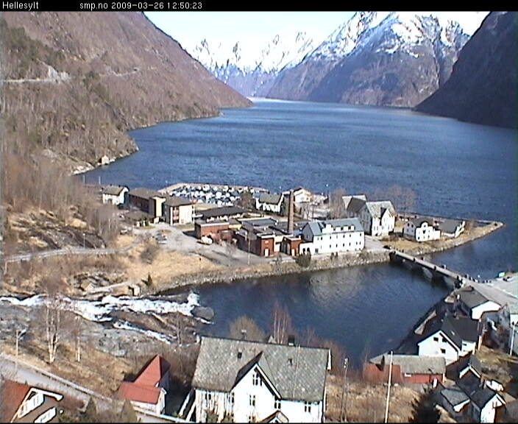
This picture from “webcamsinnorway” is a new webcamera in Hellesylt, a few miles west of Geiranger.

Birthdays

April
Sonja Kinney[1], Katherine Sanders[2], Braden Watts[8], Angela Holman[10], Robert Price Jr[18], Donna Kent[25], Robert Price Sr[26], Walter Varland[27].

May
Roald Storetvedt[1], Taylor Luiso[9], Robert Niehaus[15], Vicki Petreman[15], Dan Beckman[18].

June
Lance Larsen[2], Clare Williams[7], Fredric Sanborn[9], John Ericksen[11], Siri Timo[11], Pamela Nelson[13], Randy Treer[15], Susan Price[18], Joyce Kosobud[23], Jerry Elvrum[24], Kjetil Marstrander[24], Carol Stone[25], James Lee[27], Carol Luiso[28].

Remember to go to:
website: www.evensens.net/sons/sons.html

President Vice-President
Nina Downs Jerry Elvrum
1478 Montegor Dr. 6724 Trillium Ct
Cincinnati,OH 45230 Maineville, OH 45039
513-561-1759 513-683-5826
Ninatdowns@fuse.net Elvrumjtj@aol.com

Secretary Treasurer
Tillie Elvrum Anders Marstrander
6724 Trillium Ct 5527 Woodvalley Ct
Maineville, OH 45039 Mason, OH 45040-2622
513-683-5826 513-398-4285
Elvrumjtj@aol.com Anders@Marstrander.com

Social Director Webmaster
Carol Stone Lois Evensen
P.O.Box 1170. P.O.Box 9450
Berea, KY 40403 Cincinnati,OH 45209
513-490-2488 513-281-8408
CM8Stone@yahoo.com Lois@evensens.net

KALENDER

April 18-White Elephant Auction at home of the Mikaloffs.
May 17- 17 Mai Celebration at home of Kari Poe.
June 20- Summer Soltice Pool Party at the Mikaloffs.
Edvard Grieg Lodge 657 District 5
Cincinnati-Dayton, Ohio
C/O Esther Charlton
3798 Susanna Dr.
Cincinnati, OH 45251

Adopt-A-School Tubfrim
Donna Marstrander Alene Rice
5527 Woodvalley Ct. 2 Forest Pl.
Mason, Ohio 45040-2622 Glendale, OH 45246
513-398-4285 513-771-4378
dmarstrander@gmail.com Clocks@zoomtown.com

Membership Newsletter
Esther Charlton Per Flem
3798 Susanna Dr. 4269 Berryhill Ln.
Cincinnati, OH 45251 Blue Ash, OH 45242
513-923-3798 513-791-8942
Esthersofn@aol.com Perflem@rectomolded.com

Publicity Foundation

Siri Timo Carol Luiso
6841 McDevitt Ct 1006 Paxton Lake Dr
Dublin, OH 43017 Loveland, OH 45230
614-389-2518 513-683-3631
Siri@Columbus.rr.com CLuiso@AOL.com

