
Edvard Grieg Lodge 657 District 5
Cincinnati-Dayton, Ohio

The First Lodge in Ohio
Sons, Daughters and Friends of Norway
June 2007

President’s Message
As I write this note I am sitting here watching and listening to the Memorial Day Concert from Washington, DC. We remember those who have died and been wounded so we could live free in America. Free to celebrate our heritage, whatever that may be. Free to be Norwegian Americans.

Our Sons of Norway Lodge continues to thrive and for that we are grateful. We are, as you know, beginning the planning for our third Julefest. We need volunteers to chair the various committees and for committee members. As you know it takes more than a chair to make a committee.

We also have our regular committees-Social ( Nina), Publicity (Siri), Foundation (Anders), Adopt a school (Donna), and Membership (Esther). We need chairs for Cultural, and Youth and we need members for all these committees. The Sons of Norway national has a fantastic youth program with many suggestions for programs, and we need to involve our youth, they are our future. As it stands now the chairs are doing the job by themselves and really could use help. It is not a large time commitment and they would appreciate the help. Think it over and let me know if you would be willing to help on any of these committees. There are also many suggestions for cultural events. Nina has planned a Rosemalling event for this fall and has gotten us a grant to help defray the cost. More about that later. We are grateful to Nina for taking on this extra project. The cultural and social chairs can work together for many programs. This is your organization and it can only be great if the members are willing to work together to make it great. If you have any suggestions please contact me or one of the other officers or board members listed in the newsletter.

Our summer activities are listed elsewhere in the newsletter, hope you can attend. See you there.

Nelda Chandler-President

White Elephant Night
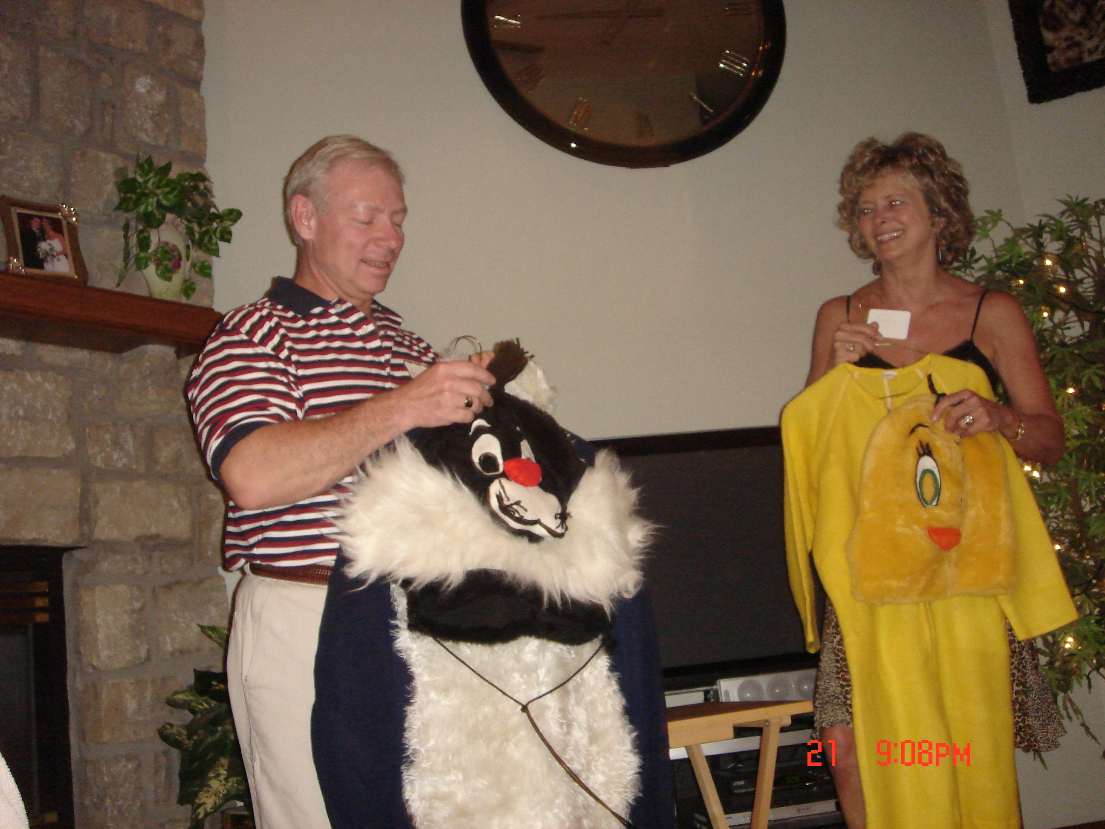
Glenn and Susie Mikaloff, co-hosts of the very popular White Elephant Sale dinner party. The background conversation when this picture was taken, had something to do with “empty nesters”. Find a member who attended to get details.

From Lois Evensen:
Go to this website to get your laugh for the day, it’s a film clip about 2.5 minutes long, so a fast connection is preferred: http://www.devilducky.com/media/57946

17th of May Celebration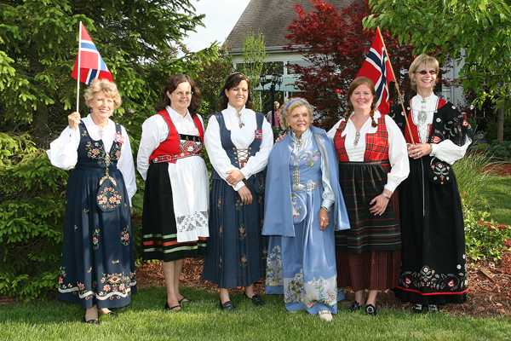
Our Bunad Ladies: Carol,Esther, Dorthe,Kari,Nina and Siri at the 17th dinner. Picture by KjellEvensen

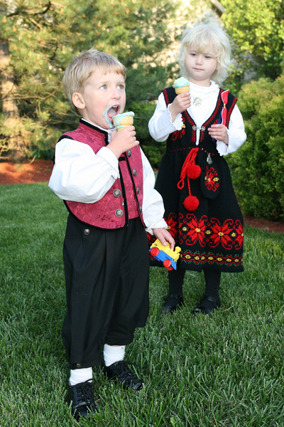
Michael Timo is 2½ and Nicole Timo is 4. Enjoying some ice cream at Kari’s house on the 17th. Picture by Kjell Evensen.

Rosemaling news:
Cindy Olsen, Director of the Sons of Norway Foundation wrote a letter(and check for $450) awarding our lodge with a Local Lodge Partnership Grant towards the up-coming Rosemaling classes this summer. The grant is to: “Promote the culture of Norway to your members in an interactive way”. District President Harland Andersen sends congratulations as well.
June Meeting
The 7th Annual Summer Solstice Celebration will take place on June 23, 3:00PM, at Susie and Glen Mikaloff’s house in Springboro. Meat and drinks are provided. Please bring a side dish or dessert. Contact Nina or Susie for reservations.
Membership
We are happy to welcome new members Melanie Wingler and Matthew Wingler as new lodge members. Rosalie's grown children both live in Virginia. We hope they may be able to combine a visit home with a lodge meeting.
Jim Crocker-Lakness is a new member of our lodge. He is the oldest son of Jean Crocker-Lakness.
Since Luke Sutphin, (Donna's son), and Cassie Rice, (Alene's granddaughter), are both now 16, they are full members of our lodge.
There were some new faces at our May 17th potluck at Kari's house. We hope that they fill out the membership applications and join us.
If you have someone you would like to recommend for membership please let me know. Contact me, if you have questions about the process of membership.
We learned at the Flag Ceremony on May 18th, that Bill Halverson and his wife will be moving to Minneapolis in July. We are sorry to see them leave our lodge. Bill was very instrumental in helping us to name our lodge as he is an expert and author of books on Edvard Grieg.
Thanks to those that made our booth at the Ashville Viking Festival a success. Siri Timo, Beth Monson and Susie Mikaloff made cookies, and we sold 39 plates of assorted cookies. Bob Charlton and Charlotte Ellingson each helped at the booth for a day. Kudos and thanks to all of these people. Our booth was in a great location at the festival which helped people easily find us.

Esther Charlton, Membership Secretary

Birthdays

June
Lance Larsen[2], Clare Williams[7], John T. Ericksen[11], Anders Nerli[11], Siri Timo[11], Pamela Nelson[13], Susan Price[18], Joyce Kosobud[23], Kjetil Marstrander[24], Carol Stone[25], James Lee[27], Carol Luiso[28].

July
Tanya Nerli[1], Kirersten Norbrothen[1], Janice Ohlsen Betscher[7], Elaine Varland[10], Jorgen Jorgensen[17], Judy Merrick[19], Melvin Lakness[24], Gary Morem[26], Beth Monson[27], Bill Halverson[28], Anders Marstrander[29], Kristin Szava[30].

August
Sandra Nelson[12], Diane Person[12], Austin Scherbarth[13], Diane Flautt[14], Jean Crocker-Lakness[14], Trent Evenson French[16], Melanie Wingler[16], Korinn Flem[20], Helen Hippert[22], Kathleen Flem[28], Melanie Petreman[29].

Rare Albino Moose
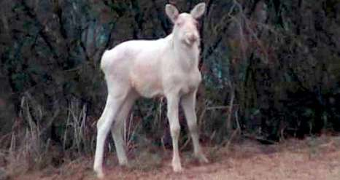
Kurt Nikkinen, 31, was on his way home from a fishing trip when he spotted a white moose in Tanadalen, 30 kilometers east of Karasjok in Finnmark County in northern Norway.
"It was completely white and had red eyes," Nikkinen said.
The Finnmark man had heard rumors of the white moose before and there have been sightings of the animal in the area. Nikkinen believes the moose is a youngster, about a year and a half old. A hunter himself, he said he could never shoot the white moose.
"It would make a special trophy but it won't be on my wall. Such a fine animal should be protected," he said.
According to Nikkinen there were sightings of a white moose in the area around three years ago, and that this is likely a relative. A white moose appeared in Østfold County in southern Norway last October and sparked a heated debate about whether it should be hunted or preserved.
Aftenposten's Norwegian reporter,Morten Andersen
Photo by Kurt Are Boine Nikkinen Video clip available at Aftenposten

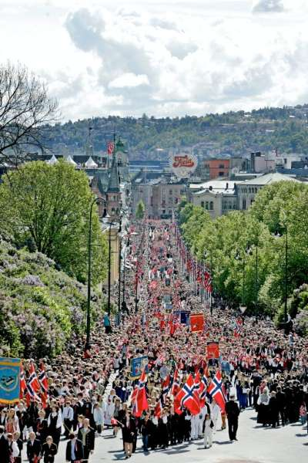
Celebrating May17th in Oslo, a crowd parading down Karl Johans Gate. Picture from Aftenposten,by Stian Lysberg Solum.

Remember to go to:
website: www.evensens.net/sons/sons.html

Upcoming Events:
Saturday June 23:Summer Solstice Celebration at Glenn and
Susie Mikaloff’s house. 3:00PM
Sunday, July 1:Meet and Greet at Panera Bread, Mason-
Montgomery Rd. 5:00PM

President Vice-President
Nelda Chandler Carol Stone
11409 Geneva Rd. 224 Countryside Dr
Forest Park, OH 45440 Lebanon, OH 45036
513-742-9504 513-228-0245
Nelda1961@Cinci.rr.com cm8stone@yahoo.com

Secretary Treasurer
Rosalie Wingler Carol Luiso
7983Quail Meadow Ln. 1006 Paxton Lake Dr.
West Chester,OH 45069 Loveland, OH 45140
513-779-2166 513-683-3631
rwingler@fuse.net Chluiso@aol.com

Social Director Webmaster
Nina T. Downs Lois Evensen
1478 Montegor Dr. P.O.Box 9450
Cincinnati, OH 45230 Cincinnati,OH 45209
513-561-1759 513-281-8408
Ninatdowns@fuse.net Lois@evensens.net

Edvard Grieg Lodge 657 District 5
Cincinnati-Dayton, Ohio
C/O Esther Charlton
3798 Susanna Dr.
Cincinnati, OH 45251

Adopt-A-School Tubfrim
Donna Marstrander Arlene Rice
5527 Woodvalley Ct. 2 Forest Pl.
Mason, Ohio 45040-2622 Glendale, OH 45246
513-398-4285 513-771-4378
dmarstrander@gmail.com Clocks@usadatanet.net

Membership Newsletter
Esther Charlton Per Flem
3798 Susanna Dr. 4269 Berryhill Ln.
Cincinnati, OH 45254 Blue Ash, OH 45242
513-923-3798 513-791-8942
Esthersofn@aol.com Perflem@rectomolded.com

Publicity Foundation

Siri Timo Anders Marstrander
6873 Rosetree Pl. 5527 Woodbury Ct
Mason, OH 45040 Mason, OH 45040-2622
513-398-4285 513-398-4285
Siri@Cinci.rr.com Anders@Marstrander.com

