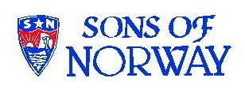
Edvard Grieg Lodge 657 District 5
Cincinnati-Dayton, Ohio

The First Lodge in Ohio
Sons, Daughters and Friends of Norway
August 2006

President’s message:

Hope these notes find each of you healthy and enjoying a wonderful summer.
A warm thank you to all who have telephoned, sent cards or visited during our daughter during her recent illness. Kathleen will be staying home next semester and not going away to College. She sends you her Beste Hilsen(Warmest Regards) and is looking forward to helping out with this years’ Jule Fest.
On July 4th, we flew out to Seattle, Washington, for a family gathering. Our daughter Korinn completed military training at Fort Lewis (Tacoma, Washington) and we were able to have a small family reunion and celebrate my Tante Signey Floathe’s ninety-first birthday.
My aunt had come to Seattle in 1939, from Flemsoya, Norway. She was not able to return home for five years because of the war and the German occupation. At the time she did not speak English and was very homesick for Norway. It was great to be with her and the rest of the family.

While in Ballard we visited the Nordic Heritage Museum, www.nordicmuseum.org,
and the largest Sons of Norway Lodge in America, the Leif Erikson Lodge 2-001 www.hometown.aol.com/LeifELodge/
Our family have been members of this Lodge for many years, in fact, my aunt met her late husband, Hans Floathe, met at a Sons of Norway dance. This Lodge became the first lodge in a new fraternal organization in Seattle for Norwegians and their descendants. It was called The Grand Lodge of the Sons of Norway of the Pacific Coast. The original members officially met for the first time on May 13, 1903.The organization was separate from the Sons of Norway of the Midwestern United States until they eventually merged in 1910.

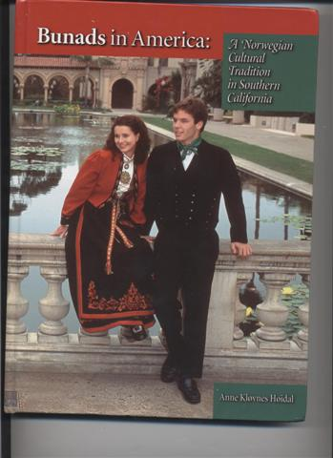
Hey, look at this..?
Bunads in America : A Norwegian Cultural Tradition in Southern California, by Anne KlaaVnes HaaIdal.

This is a beautiful book that I bought for our Lodge ladies to use in the purchase and making of their own bunads. The book tells the story of what one Sons of Norway Lodge did in order to get started making and assembling, their bunads. It is full of suggestions and advice how one Lodge went about the process of securing their own bunads.
What I loved about this book was the description of the close relationships that developed as a result of the ”Bunad Project.” It is exactly what I had hoped our Bunad idea would become and do for our Lodge...close relations and a family atmosphere.
Can’t wait to see all of you at the next Lodge and Board Meetings...
God Bless You All, Karl & Family

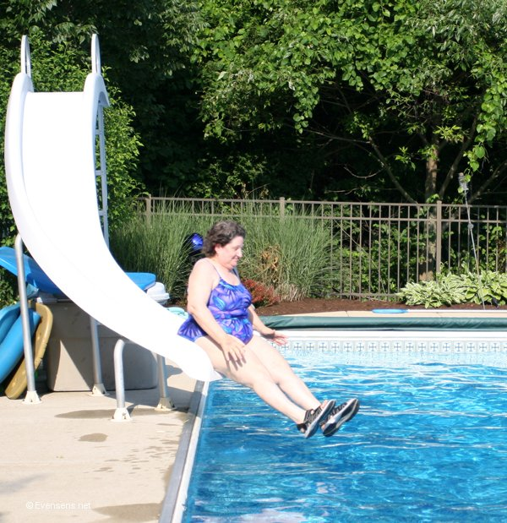

A picture from the pool party in June at Susie, and Glenn Mikloff’s home. Nelda looks like she is having a good time. Picture by Kjell Evensen.

Hardanger Fiddle Concert

Mark your calendars now for Saturday, November 11. We will host Karen Torkelson Solgard for a fiddle concert at Friendship United Methodist Church at 7 p.m. You may hear samples of Karen's music at www.cdbaby.com/solgard. Start telling all your friends about this great event now.

Membership News

We welcome Jens Basberg into our lodge. He originally joined a lodge in Ft. Lauderdale, Fl, and kept his membership there until he found out about our lodge from Nina Downs. At Nina's urging he has transferred into Edvard Grieg Lodge. He will be coming quite a distance to our meetings as he and his family live in Louisville, but we hope they some trips up to our area for a lodge meeting. Jens was born in Norway and is a pilot for DHL.
At the recent District 5 convention in LaCrosse, Wisconsin, our lodge received two awards for membership. One was the Founder's award given by the International Lodge for an increase in membership in the past calendar year. We also received a district award for our increase in membership from January 2005 thru March 2006.
If you have anyone that may be interested in membership, please pass along their names and contact information, as we wish to continue to increase our membership. Should you have ideas on how to publicize or promote our lodge, please contact me.
Esther

A note from our favorite nanny, Dorthe
Dear members of the Lodge.
My time in Ohio is quickly coming to an end. I have enjoyed living here and I go home with many, many good memories.
I would like to say “Thank You” to everyone of you. You have been so kind to me and made me feel real welcome in your Lodge. You have been a very good support for me and it has been nice to have a piece of home, away from home.
I wish you all the best and hope to see you in Norway someday!
Sincerely, Dorthe Helene Baardseth

Language and Culture
Using compound words in English is usually strait forward (for us), but difficult to learn for non-English speakers. Warpath and war bond are examples of our complex language. Usually the rule in Norwegian is the words are always written as a single word. Recently in Norway, there have been instances when space on signs and packages makes long words inconvenient, and mistakes called “orddelingsfeil” are made.
Humorous examples are:
“Ananasringer” which are “pineapple rings”, and “Ananas ringer” which is “pineapples calling”.
“Roykfritt” is smoke free. “Royk fritt is smoke freely.
Michael’s Mass
On September 29th, Norwegians observe Michael’s Mass, a memorial day for Saint Michael. Michael appears in the epic poem Draumkvedet, and shows souls the way to Paradise. In many places Michael’s Mass was moving day for servants, who went from summer to winter employment. On this day traditionally all crops all over Norway would be harvested. The day was therefore often marked by eating “harvest pudding”. In some places, Michael’s Mass was also the day to head home from the summer pasture. From Sons of Norway.
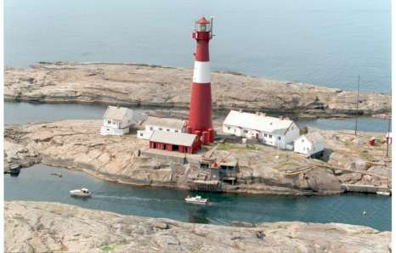
Aftenposten has a series of pictures currently running on their website, that focuses on Lighthouses, and some that have guest facilities. The picture shown above is the “Faerde fyr” lighthouse at the opening of the Oslo Fjord. Picture by Finn Eric Stromberg

July 15th meeting comments by Carol Luiso
"What a wonderful, delightful lodge meeting Saturday. It was so much fun!"
This was a comment made by one of our members after we met Saturday, July 15, to say "Good bye" to Dorthe Baardseth. Dorthe will be returning to Norway after a year as an au pair.
Dorthe has been an active member assisting with the Julefest, giving a program about Norway, and helping us form the new Nina Grieg Syklubb (sewing club). She also brought fantastic Norwegian desserts to the meetings!
The theme of our meeting was "A Lesson in Norwegian". Geir Karlsen, Dorthe's friend, was visiting from Norway. Geir is studying to be a teacher Dorthe and Geir were patient teachers as some of us struggled with the correct pronunciations.
We wish Dorthe the very best and we'll miss her.
Thanks, Nina, for hosting this meeting.
Future meetings
Saturday, August 19
Afternoon picnic at Dan Beckman's at Hidden Valley Lake. Bring a dish to share. Time and directions will be on meeting flyer.

Saturday, September 30
Meeting at the home of Anders and Donna Marstrander, 5527 Woodvalley Ct., Mason, Ohio. Anders mother Helene, and his brothers Kare and Ole-Jocob will be visiting and they will present the program. Time and food details on the meeting flyer.

Birthdays
August
Sandra Nelson[12], Diane Person[12], Jean Crocker-Lakness[14], Eric Karam[15], Michael Karam[16], Trent Evenson French[16], Korinn Flem[20], Helen Hippert[22], Kathleen Flem[28], Melanie Petreman[29].

September
Kjell Evensen[3], Ordelle Hill[4], Christina Kosobud[10], glenn Kinney[12], Larry Welin[19], Per Flem[26], Jimmy Bowman[28].

October
Patrick Johnson[1], Sally Lund[8], Chirs buselmeyer[9], Roby Bowman[12], Nelda Chandler[25], Birgit Jorgensen[25].

You know you are in Norway when:
You know you are in Norway when it's 10 degrees outside it's Christmas time (the most wonderful time of the year) and you hear the ice-cream truck bell just down the road. This is of course because you have the window OPEN!

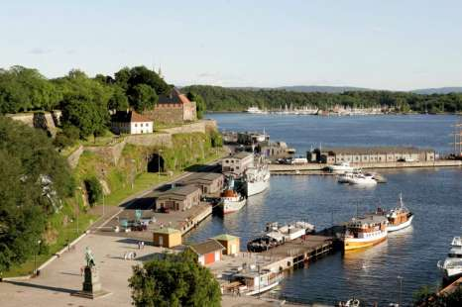

A beautiful summer picture from Aftenposten, taken by Jan Tomas Espedal, shows the 1,000 year old Akershus Fortress and Castle on the left, in Oslo’s Inner Harbor. This is a favorite strolling location for Oslo residents.

Newsletter editor request
Starting in two months, I’m going to have one picture in the newsletter dedicated to the best Norwegian baby picture. Grandparents, please send in your candidate to me. Everybody loves babies, and grandparents most of all. Send to: PerFlem@RectoMolded.com . I’m headed to Norway on Sunday to take my candidate.

website: www.evensens.net/sons/sons.html

President Vice-President
Karl Flem Nelda Chandler
9436 Morrow-Woodson Rd. 11409 Geneva Rd.
Pleasant Plain, OH 45162 Forest Park, OH 45440
513-877-3005 513-742-9504
Flem1973@Yahoo.com Neldandelma@earthlink.net

Secretary Treasurer
Rosalie Wingler Carol Luiso
7983Quail Meadow Ln. 1006 Paxton Lake Dr.
West Chester,OH 45069 Loveland, OH 45140
513-779-2166 513-683-3631
rwingler@fuse.net Chluiso@aol.com

Social Chairman Webmaster
Nina T. Downs Lois Evensen
1478 Montegor Dr. P.O.Box 9450
Cincinnati, OH 45230 Cincinnati,OH 45039
513-561-1759 513-281-8408
Ninatdowns@fuse.net Lois@evensens.net

Social Co-Chair Raffle Chairman
Sandy Nelson Susie Mikaloff
Snel1234@aol.com 7472 Stone Ridge Dr
. Springboro, Oh 45066
Social Co-Chair 937-748-8121
Diane Person g_mikaloff@email.msn.com

Adopt-A-School Tubfrim
Donna Marstrander Arlene Rice
5527 Woodvalley Ct. 2 Forest Pl.
Mason, Ohio 45040-2622 Glendale, OH 45246
513-398-4285 513-771-4378
Donna@Marstrander.com Clocks@goodnews.net

Membership Newsletter
Esther Charlton Per Flem
3798 Susanna Dr. 4269 Berryhill Ln.
Cincinnati, OH 45254 Blue Ash, OH 45242
513-923-3798 513-791-8942
Esthersofn@aol.com perflem@RectoMolded.com

