
Edvard Grieg Lodge 657 District 5
Cincinnati-Dayton, Ohio & N. Ky.

The First Lodge in Ohio
Sons, Daughters and Friends of Norway
August 2007

Hilsener fra Presidenten
Greetings from the President
Our summer is almost over, my has it gone fast. It seems it was just yesterday that it began. We are truly in the ”dog days” of summer as we have day after day of temperatures in the 90’s. My lawn was almost green with the rain we had, now it will be brown again.
We have several programs planned for this fall, including the Rosemalling workshop, which will be in September. A final date has not been selected as yet. I am looking forward to learning about this beautiful art form. I once purchased a couple of starter brushes and a book when I was at the Vesterheim in Decorah, IA but never did anything with them. Now I can learn from a person not just looking in a book.
We still need committee chairs for our cultural and youth committees. Both of these have a great deal of information from the national organization to help you with planning. The youth program comes out every month with suggestions for programs. There is a recreational director for the district to help with planning activities as well. The cultural and program directors work together many times to plan programs for the whole group as well as planning workshops such as the Rosemalling.
Julefest is coming up faster than you think. December 15th will be here before you know it. We will be having a planning meeting in September to set up committees and make some final plans for activities and for the boutique. If you are willing to help in any capacity ie: food, games/crafts for kids, the program, the boutique, set-up, or clean-up please let me, or the chairs Nina Downs and Carol Luiso know your willingness. We need every ones help to make this a success. It will be held at the Friendship Methodist Church Fellowship Hall in Wyoming. We have had several meetings there over the past few years so many of you know where it is located.

Jeg skal hilse fra Presidenten (regards from
president)pronunciation- yaei skahl hilser fraa

Nelda
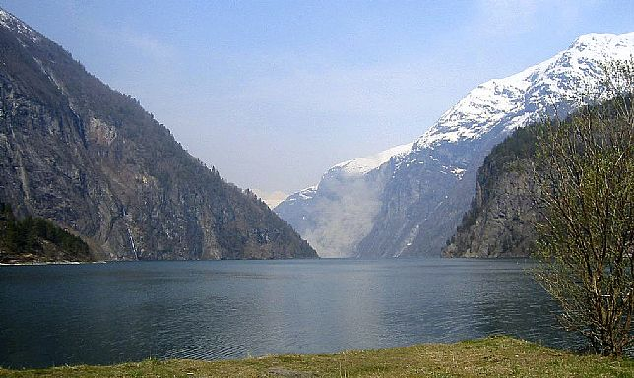
From Sumnerposten: “Tropical nights”. On August 8th, 5 locations reported a minimum temperature of 20 degrees C(69F), a description of a tropical evening. This picture is from the reporting site of Tafjord. Anders Marstrander provided the translation, and suggests looking at http://en.wikipedia.org/wiki/Tafjord to get lost in the fjords.

Tubfrim
Alene Rice has a shipment of stamps nearly ready to go, please send your stamps to Arlene for this very worthy cause. Email Alene at: clocks@usadatanet.net

Membership News
We welcome back into the lodge Catherine Berberich, daughter of our webmaster, Lois Evensen. She was a charter member of our lodge. We hope to utilize some of Catherine’s talents and skills.
Tim Holmen, along with his wife Connie and daughter Angela, have joined our lodge. Angela is a student at the University of Dayton. Tim saw our flyer at Jungle Jim’s and was excited to find a Sons of Norway lodge in this area. They live on the Northwest side of Dayton, but he is originally from North Dakota.
Also, we welcome new members, James and Marlene Hanson who were at our 17th of May dinner at Kari Poe’s home.
If you have ideas of places we could post flyers about our lodge, let us know about them. If you know someone that might be interested in our lodge, pass their name along and we will send them information on Sons of Norway.
Esther Charlton, Membership Secretary

Next Meetings:
Skyklubb
Next meeting will be at Kari Poe’s on September9th at 3:00pm. Contact Nina with RSVP or reservations, 513-697-7142 or ninatdowns@fuse.net

September lodge meeting
“Building a Dream;The Moorhead Stave Church”, a presentation and short documentation by Diane Person. Saturday, September15th at 4:30pm, at the New England Club off Beechmont Ave.

Birthdays
August
Sandra Nelson[12], Diane Person[12], Austin Scherbarth[13], Diane Flautt[14], Jean Crocker-Lakness[14], Trent Evenson French[16, Melanie Wingler[16], Korinn Flem[20], Helen Hippert[22], Kathleen Flem[28], Melanie Petreman[29].

September
Kjell Evensen[3], Ordelle Hill[4], Christina Kosobud[10], Glenn Kinney[12], Larry Welin[19], Per Flem[26], Jimmy Bowman[28].

October
Patrick Johnson[1], Sally Lund[8], Chris Buselmeyer[9], Roby Bowman[12], Catherine Bererich[20], Nelda Chandler[25

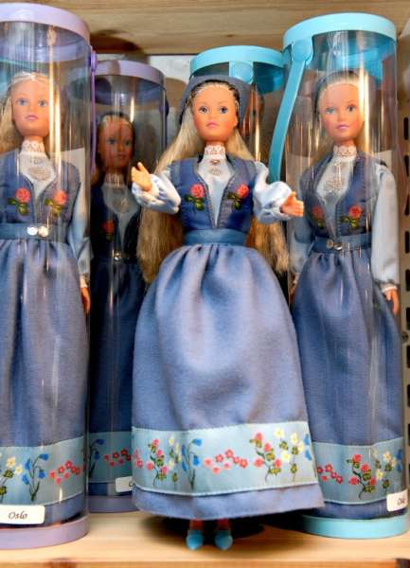

Popular souveniers:Souvenir shop managers that Aftenposten spoke to, said however that tourist from different countries generally buy different souvenirs. The Norwegian jumper is especially popular with Americans, Germans generally prefer a bumper sticker for their car, Britons have a predilection for trolls, while the Spaniards and Italians love the Vikings, said shop manager Tor Fredrik Frøberg.Picture by Jon-Are Berg-Jacobsen.
Turtle Creek Flea Market Membership & Fundraising Activity

We are going to try something new and different on Saturday, August 25. For this day we will have a space at Turtle Creek. This will be to promote our lodge and Sons of Norway and hopefully we will sell a few things for the treasury.
You all can help in a couple of ways. Do you have some “bargain” that after you bought it, you wondered why you did? Donate it and we will see if it sells at Turtle Creek. You can bring some of your own things to sell and donate a portion back to the lodge. Let Esther know if you are interested in helping in any manner. We will work out the times to help.
We are working on maybe selling cookies, but still finding out the requirements necessary to do that.
Turtle Creek Flea Market is at Exit 29 on route 63 just west of I-75. It is open from 9 to 5 on Saturday.
Our space will be reserved on Friday. For those interested we will let you know where exactly we will be located on Friday evening.
If we deem our efforts worthwhile we will do this again. If you can’t help this time maybe on our next visit you can help.
For questions, contact Esther Charlton

Schwan’s USA CUP

Our section donated $50.00 to a youth Soccer program held in Blaine, Minnesota. Every year, around 500 teams (youths 12 to 19) come from all over the world to compete in this event. A month ago two teams from Norway participated.

Reindeer calf joined goat herd

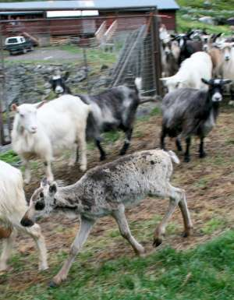

The reindeer calf seems to feel right at home among the goats.
PHOTO: HARALD SKJERDAL

A young and apparently lonesome reindeer took up company with a herd of goats in the Norwegian mountains this week, and then followed them right into their barn when milking time came around
Rancher Einar Lie of Aurland in the county of Sogn og Fjordane said he got quite a surprise when he went into the barn Tuesday to milk his goats.
"I could tell the goats were a bit uneasy, and I heard some unusual sounds," Lie told local newspaper Sogn Avis.
When he went to investigate, a little reindeer calf suddenly turned up among the goats in the barn. "I've never seen anything like it before," Lie said.
The wild reindeer apparently comes from a herd in the mountainous area, not far from Lie's ranch, which lies at a a lower elevation of about 600 meters along Highway 50 near Hol.
There are about 2,000 reindeer in the mountain herd, and a much-used calving area is also nearby. Lie thinks the calf was separated from his mother and simply attached himself to the herd of goats instead.
"He must have survived alone for awhile, and then followed the goats home from their grazing area," Lie said.
The goats seem to have accepted the little reindeer, which in turn has adapted to the herd's hierarchy. Wildlife authorities contacted by Lie's family have determined that the reindeer isn't suffering in any way.
"We tried to give it some goat milk from a bottle, but it didn’t want any," Lie said. "Instead, it eats the feed we have along with grass."
The reindeer has been following the goats out to open grazing all week, and returns with them to the barn for milking. Lie isn't sure what will happen when the calf gets bigger.
"He's becoming tame, and probably wouldn't be accepted by the wild reindeer herd now," he mused. "We hope he can be taken in by a zoo or an animal park later."
Aftenposten's reporter
Randi Johannessen

Remember to go to:
website: www.evensens.net/sons/sons.html

Upcoming Events:
Skyklubb on September 9th at 3:00pm at Kari’s
Lodge Meeting :Stave Church at 4:30pm September 15th at New England Club

President Vice-President
Nelda Chandler Carol Stone
11409 Geneva Rd. 224 Countryside Dr
Forest Park, OH 45440 Lebanon, OH 45036
513-742-9504 513-228-0245
Nelda1961@Cinci.rr.com cm8stone@yahoo.com

Secretary Treasurer
Rosalie Wingler Carol Luiso
7983Quail Meadow Ln. 1006 Paxton Lake Dr.
West Chester,OH 45069 Loveland, OH 45140
513-779-2166 513-683-3631
rwingler@fuse.net Chluiso@aol.com

Social Director Webmaster
Nina T. Downs Lois Evensen
1478 Montegor Dr. P.O.Box 9450
Cincinnati, OH 45230 Cincinnati,OH 45209
513-561-1759 513-281-8408
Ninatdowns@fuse.net Lois@evensens.net

Edvard Grieg Lodge 657 District 5
Cincinnati-Dayton, Ohio
C/O Esther Charlton
3798 Susanna Dr.
Cincinnati, OH 45251

Adopt-A-School Tubfrim
Donna Marstrander Alene Rice
5527 Woodvalley Ct. 2 Forest Pl.
Mason, Ohio 45040-2622 Glendale, OH 45246
513-398-4285 513-771-4378
dmarstrander@gmail.com Clocks@usadatanet.net

Membership Newsletter
Esther Charlton Per Flem
3798 Susanna Dr. 4269 Berryhill Ln.
Cincinnati, OH 45254 Blue Ash, OH 45242
513-923-3798 513-791-8942
Esthersofn@aol.com Perflem@rectomolded.com

Publicity Foundation

Siri Timo Anders Marstrander
6873 Rosetree Pl. 5527 Woodbury Ct
Mason, OH 45040 Mason, OH 45040-2622
513-398-4285 513-398-4285
Siri@Cinci.rr.com Anders@Marstrander.com

