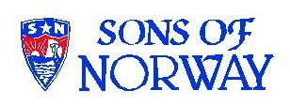
Edvard Grieg Lodge 657 District 5
Cincinnati-Dayton, Ohio, SW Ohio & Kentucky

The First Lodge in Ohio
Sons, Daughters and Friends of Norway
August 2008

August Meeting
Our next Lodge meeting will be August 16, 2008 at the home of Kari Poe, 579 Belle Meade Farm Drive, Loveland, Ohio 45140 at 4:00 p.m. Take a journey on the Hurtigruten, The World's Most Beautiful Voyage. Carol Luiso and Kari Poe will share their experience on the boat ride up the coast of Norway and show a short video of the excursion and it's side trips. Please bring an appetizer or dessert to share. RSVP to Kari Poe at 513.697.7142 or Nina at 513.608.0364/ninatdowns@fuse.net

September
Come and meet our new District Lodge President Mary Bennett and Vice President Burt Bittner on Monday, Sept. 15, 2008 at 5:30 for an informal dinner at IKEA. This is an opportunity to meet as well as discuss any ideas with them. Nelda and Esther will also give a short talk on new ideas as well as what they experienced and learned at the District convention. RSVP to Nina.

Announcement:
Nina, Bob and Benjamin Downs welcomed a new addition to their family on July 16, 2008. Thomas Hassel Downs was born at 5:30 a.m., weighed 7.5 lbs, and was 20.5 inches long.

Editor’s pick of the month
Have you visited YOUTUBE? I never did until searching the web for pictures for this issue I stumbled on a YouTube link. Two hours later it felt as though I suffered from video overload. Never saved a picture for this issue, but must highly recommend those that have high speed internet service spend some time looking at the great videos that have been posted. Here are links for two of them, but those that get the newsletter by mail only have to go to Google and type in Youtube Norway to get to the site. Almost like taking a trip to Norway. If you watch the Fjord videos you can see why Norwegians have strong legs. It’s Darwin at work.http://www.youtube.com/watch?v=_4wo-CeZV1A&NR=1
http://www.youtube.com/watch?v=oJ1jIcJVu_4&eurl=http://www.nordikfolk.com/
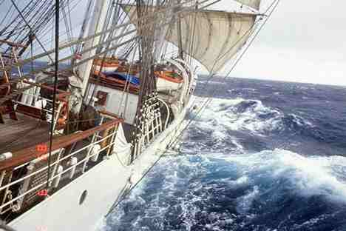
Tall ships are headed for Maaloy near Alesund the first of August, then continuing to Bergen. This picture from Sunmoreposten

Membership
This is just a reminder about the Summer Sizzle Recruitment Contest, which is still going on until August 31, 2008. For every three qualifying members you recruit, you’ll receive a “rosemaled” coffee mug.You might think about a gift of membership to Sons of Norway for a relative or a friend, and with their membership, you are entered into the Norwegian Experience contest for a trip to Norway.
If you have children, or grandchildren age 15 or under they qualify to be a Heritage member of Sons of Norway. They will receive their Viking for Kids on a quarterly basis and learn about Norway. Our lodge already has 18 young people enjoying their Viking for Kids as Heritage members.
If you have any questions about the membership process, please contact me.
Thanks, Esther Charlton, membership secretary.

Recipe from Sandy
This is the way we made coffee at home on the farm for our hired men during threshing & other big family events that always seemed to be at our farm. Also, the ladies aid always did it this way only in BIG pots with more than one going at a time! I know several of us in the lodge remember this and it is truly good.
Norwegian Egg Coffee
To most people, it is quite unusual to brew coffee with an egg in it. However, this is a traditional Norwegian method for making coffee.
How to make it? First, you have to break a single egg and mix the egg with a half a cup of water (about 120 ml) in a slow heated saucepan. Then, add a cup of ground coffee with six cups of boiling water (about 1.5 liter) and leave it to boil in slow heat for about 3-4 minutes. After that, add a half cup of very cold water and let it steep for another 9 minutes before serving.
I bet you would expect a coffee with a mixture of egg floating in it. What's unusual about this coffee is that, you will get a rich, clear coffee. This is due to the fact that the egg protein binds with the ground coffee and it settles the grounds, providing the coffee with the richness in its taste. This is when a half cup of very cold water is added suddenly to the mixture.
Note that there are many variations in making the Norwegian Egg Coffee. Some people may even use the egg together with the shell (broken up). In this case, the coffee must be carefully strained to remove pieces of egg shell. Some people may use only the egg whites. In any cases, whichever method you use, the result will still be the same, i.e. clear and rich coffee.
Sandy Nelson

From Alene Rice:
“Our chapter has its very own grandchild, in Norway”!
“Margay(our daughter) & Erik had their son, Falk Grotli Skogen, on May 12th.”
“Falk translates to falcon, Skogen is forest, and Grotli is the name of the town, and Erik's family.”
“I was there in Trondheim for a month, helping get this baby on the ground.”
“It was lovely walking around that beautiful town for a few weeks before he was born.”
Picture below:

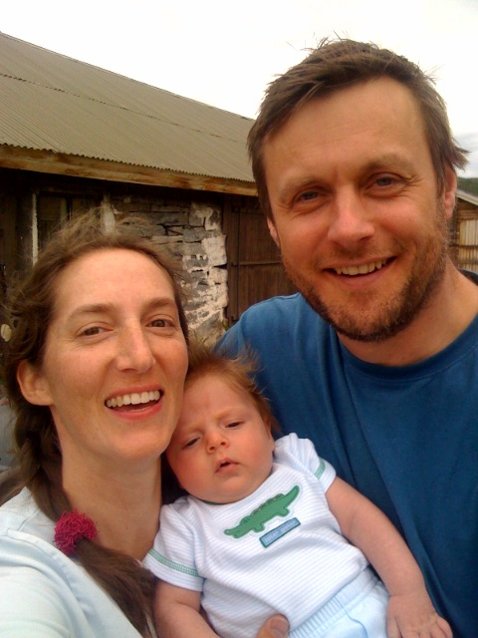

Facts (and fiction) from Nordic Mythology and Norwegian History
The first time the term “Norwegian” was used (that we know of) was by an Irish writer in the year 874 where Ivar, king of Dublin was called “Rex Nordmannorum totius Hiberniae et Britanniae” – King of all Norwegians in Ireland and Britain. This was 2 years after king Harald Fair Hair had united various smaller kingdoms under one crown and thus created the kingdom of Norway.
From my first article we remember that king Halvdan Svarte (The Black) had conquered quite a large area over which he ruled. Harald was his eldest son, and upon Halvdan’s death Harald inherited his kingdom. He then found himself governing most of south-eastern Norway, both sides of the Oslo fjord, a good part of southern Norway as well as a big piece of western Norway. The areas of today’s Norway that he did not rule over was most of western Norway (he only controlled an area north of Sognefjorden) and all of Trøndelag and further north.
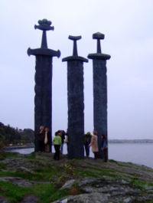
Picture: “Sverd i fjell” – Swords in Stone, at Hafrsfjord commemorates the battle of 872 that resulted in a unified
Norway.

Legend has it that the unification of Norway started as a love story. Harald proposed to Gyda, daughter of Eirik, king of Hordaland (around Bergen), but she rejected the proposal saying that she would not marry him until he became king of all of Norway. Harald then took a vow not to cut his hair until he had laid all of Norway under his rule. Following this, his hair grew long, earning him his original nickname “Luva” – Tangle Hair. Following his success at the battle of Hafrsfjord (near Stavanger) in 872, where he defeated the last of his opponents, he cut his hair short again and earned his new nickname “Hårfagre” – Fair Hair.
Following his victory at Hafrsfjord he made sure that his opponents did not get a chance to rise again. This he did by heavy taxation on them and other harsh means (various ways of harassment). Many of the former petty rulers left the country and settled in Iceland, and on the islands off the coast of Scotland (Hebrides Islands, Faroe Islands, Orkney Islands and Shetland Islands). So it can be said that Harald not only unified Norway, but also indirectly encouraged settlements in places that later was to become part of Norway.
Harald’s kingdom did not follow the borders of Norway as we see them today. It included the Lofoten Islands in the north, but did not go any further north. It also included parts of what is now Sweden (the forest area of Jamtland and Harjedalen and the west coast almost down to Gothenburg.
As Harald grew older he set 12 of his sons to govern a part of the kingdom each. Three years before his death he named his son Eirik “Blodøks” – Blood Axe, as his heir to the unified kingdom.

Reading Circle
The Reading Circle will meet on Saturday, August 9 at 9:30 A.M. at IKEA's, 9500 IKEA Way, West Chester, Ohio 45069
We'll have breakfast and discuss Giants in the Earth: A Saga of the Prairie by O. E. Rolvaag.
If you enjoy reading Norwegian related books, join the group!
For questions or details, contact: Carol Luiso 513-683-3631 or CHLuiso@aol.com

Birthdays:
August
Sandra Nelson[12], Diane Person[12], Austin Scherbarth[13], Diane Flautt[14], Jean Crocker-Lakness[14], Trent Evenson French[16, Melanie Wingler[16], Edwin Rice[22], Helen Hippert[22], Benjamin Downs[27], Melanie Petreman[29].

September
Kjell Evensen[3], Ordelle Hill[4], Nancy Vallette[6], Christina Kosobud[10], Glenn Kinney[12], Larry Welin[19], James Hanson[23], Jack Trefzger[25], Per Flem[26], Jimmy Bowman[28].

October
Sally Lund[8], Chris Buselmeyer[9], Jim Crocker-Lakness[11], Roby Bowman[12], Curtis Anderson[13], Judy Pieper[15], Ken Soberg[19], Jens Basberg[20], Catherine Berberich[20], Nelda Chandler[25], Bailey Stone[26], Sheryl Bergman[26], Marlene Hanson[30].

Remember to go to:
website: www.evensens.net/sons/sons.html

President Vice-President
Nelda Chandler Nina Downs
11409 Geneva Rd. 1478 Montegor Dr.
Forest Park, OH 45240 Cincinnati,OH 45230
513-742-9504 513-561-1759
nelda1961@Cinci.rr.com Ninatdowns@fuse.net

Secretary Treasurer
Tillie Elvrum Carol Luiso
6724 Trillium Ct 1006 Paxton Lake Dr.
Maineville, OH 45039 Loveland, OH 45140
513-683-5826 513-683-3631
Elvrumjtj@aol.com Chluiso@aol.com

Social Director Webmaster
Nina T. Downs Lois Evensen
1478 Montegor Dr. P.O.Box 9450
Cincinnati, OH 45230 Cincinnati,OH 45209
513-561-1759 513-281-8408
Ninatdowns@fuse.net Lois@evensens.net

Edvard Grieg Lodge 657 District 5
Cincinnati-Dayton, Ohio
C/O Esther Charlton
3798 Susanna Dr.
Cincinnati, OH 45251

Adopt-A-School Tubfrim
Donna Marstrander Alene Rice
5527 Woodvalley Ct. 2 Forest Pl.
Mason, Ohio 45040-2622 Glendale, OH 45246
513-398-4285 513-771-4378
dmarstrander@gmail.com Clocks@zoomtown.com

Membership Newsletter
Esther Charlton Per Flem
3798 Susanna Dr. 4269 Berryhill Ln.
Cincinnati, OH 45251 Blue Ash, OH 45242
513-923-3798 513-791-8942
Esthersofn@aol.com Perflem@rectomolded.com

Publicity Foundation

Siri Timo Anders Marstrander
6873 Rosetree Pl. 5527 Woodbury Ct
Mason, OH 45040 Mason, OH 45040-2622
513-398-4285 513-398-4285
Siri@Cinci.rr.com Anders@Marstrander.com

