
Edvard Grieg Lodge 657 District 5
Cincinnati-Dayton, Ohio & Kentucky

The First Lodge in Ohio
Sons, Daughters and Friends of Norway
August 2009

Meetings
August

Our next meeting will be THURSDAY August 20, 2009- A Scavenger Hunt at Jungle Jim's International Market, 5440 Dixie Hwy, Fairfield, OH 45014. Come meet inside by the Starbucks at 6:30 for a fun scavenger hunt! The cost is $5.00 per person, and you will receive a $3.00 gift certificate that you can spend in the Scandinavian section afterwards! (Or wherever you wish...) Stay after and enjoy a deli sandwich or cup of coffee and the fellowship of other members. If you have not been to this store, it is an experience in itself! Please RSVP to Nina at 513.608.0364 or ninatdowns@fuse.net.
September
Saturday, September 19, 2009 enjoy a Pancake Breakfast at The Clifton Mill, 75 Water Street, Clifton, OH 45316, # 937.767.5501. Meet at 10:00 to enjoy an amazing breakfast and then head out for a bike ride, a hike, to do some shopping, sightseeing or go to the dairy to see how they make ice cream! Approximate cost of breakfast is $10.00. Please be prompt as we all need to be present to be seated together. This is also a great camping place if you wish to spend the night before or after. RSVP to Nina.

October Meeting: Apples, Hayrides and Norwegian Fjørd Horses...
November Meeting: Learn Norwegian Folk Dancing from Harry Khamis
December Meeting: Annual Jultrefest
January Meeting: Lutefisk and Lefse

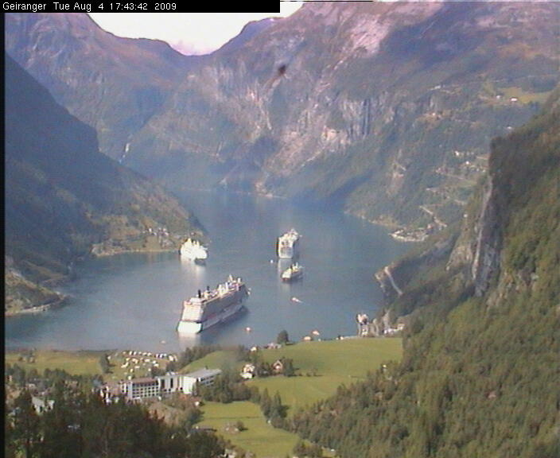
Geiranger , Monday August 3d from WebcamsinNorway.

Presidents message
Planes, Trains and Buses...
Norway, -the word makes me think of fresh air, blue waters, wildflowers and rocky mountains. It also makes me think of pølse med lømpe, Solo, soft is, the best berries and really great chocolate! Our vacation there this past month brought this all to life, and more. In the past I had always stayed with my grandmother and had gotten around in cars...this trip was much different.
Oslo welcomed us with 33C weather and not one place we went had air conditioning! I met my sister Henriette and her family at the airport and we took the “fast train” to Sandvika, to stay with my cousin Anne Catherine. After 3 days we took a bus to Kragerø where our family island, Ærø, is located. We were greeted with gray skies and rainy weather that lasted most of the time we were there. There are 5 cabins on our island, and 4 have electricity, running water and telephones. By choice, we have none of these. We have to go to the mainland or a nearby island to get drinking water, when it is dark we use candles, the stove and refrigerator are powered by propane tanks, we use an outhouse and we wash in the sea. There is no place I would rather be.
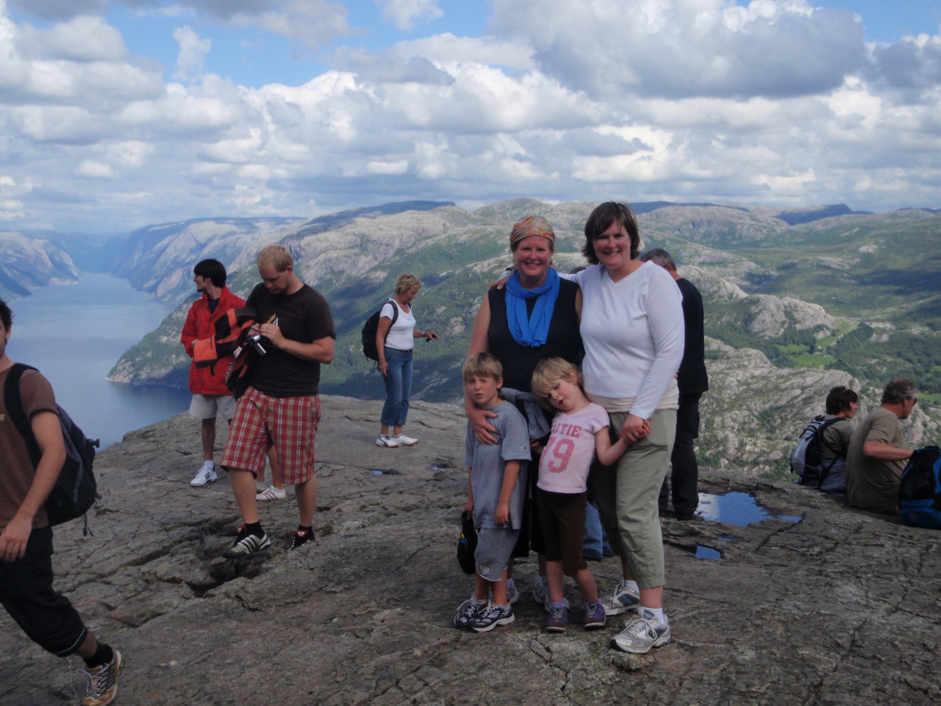
Nina, and Benjamin with Nina’s sister Henriette Oberg and her daughter Lilly atop Preikestolen, east of Stavanger.

Our first full day, we went to a surprise 50th Birthday Celebration for my cousin Ingeborg, given by her husband Tormod. Everyone met at an island not far from ours, called Jomfruland (Virgin Island) where we socialized, swam, walked around, napped and had a lunch of shrimp and Norwegian strawberries and then a few of us took a long, slow sailboat trip back to their cabin (so that Tormod could prepare for the party on the bridge) where we had a Grill Party Dinner. I mention this celebration because I found it very interesting that many of those present had prepared a “talle” or speech to talk about their fondness and memories of my cousin. This lasted quite some time...and is very typical of Norwegian celebrations. I understand the speeches at weddings can take hours.
After a week in Kragerø we went to Stavanger to visit my cousin Odd Christian and his family for a week. The trip took a taxi boat, to a bus to a train, (which had electrical failure) so we got on another train that took us to a bus that took us to another train and then another bus that took us to a bus that ended up at our destination! Public transportation in Norway is so common that people take off their shoes, prop up there feet everywhere (even out the window sometimes) eat fruit, chocolate and boller while pouring coffee from their thermos. I never got over the feeling that I needed to “sit nice”... :-).
Stavanger is an old, beautiful port city on the west coast. The highlight of our trip there, other than Tommy turning 1 year old,(Happy Birthday Tommy!) was our hike up Preikestolen (The Pulpit). The rock extends out 1959 feet above Lysefjørd. Looking over the unrailed edge, it is incomprehensible that you are that high up. For anyone who loves hiking and nature, this is a must do when you go to Norway! The hike with babies and kids took 3 ½ hours up (including a long stop for lunch) and 2 hours with jello-like legs to hike down. It is hands down one of the most intense and memorable experiences of my life! While in Stavanger we also visited King Harald’s Three Swords and the oldest Sardine Factory located in Old Stavanger- these are also a must see.
My sister and I headed back to Kragerø with the kids by bus and enjoyed a week that included several beautiful days filled with sunshine. It was heartwarming to see Ben and my niece Lilly run around the island, clattering on the rocks barefoot, playing with jellyfish and fishing for crabs just like I did as a child. The water was a bit too cold for much swimming for them, so I have to wonder just how much Norwegian is their blood!
The last few days found us staying at our favorite hotel in Oslo, the Radisson SAS Plaza. Once again we traveled by bus, only two this time... The first order of business is showers! There is absolutely nothing better than that first shower after being on the island. I thank God for running water every time I take a shower and have done so for years. The hotel is located in the heart of the city and we enjoyed a long day of walking up Carl Johanns Gate, watched the changing of the guards at the Royal Castle, walked to Aker Bryyge (a major harbor and shopping center located on the Oslo fjørd), and enjoyed a fantastic Italian dinner.
My last day in Norway, Dorthe, a former Sons of Norway member and a dear friend, came and picked up me and my sons and drove us to her family farm in Stange. Stange is located about an hour north of Oslo, on Lake Mjøsa. It was great to meet her family and see where she grew up. Stange happened to be located about fifteen minutes away from Hamar, where my grandparents are buried, so we also went to their gravesite to say hello and pay our respects. This was a pleasant surprise for me and a great way to end my vacation. Dorthe was actually kind enough to give us a ride to the airport which I so much appreciated as I had one more bag than what I came with!
Many places in the city will turn off escalators and rotating doors for extended periods of time during the day. Stores will have their lights go on and off periodically in order to save on electricity. In order to get electricity in our hotel room we had to put our door key in a slot, therefore no lights were left on when we were not in our room. The price of gas was almost $9.00 a gallon, and milk was about $8.00 a gallon. Our Italian dinner was $250 for 3 adults, and 2 children. It rained a lot. It was easy to use the public transportation although I had luggage for 3 people for a month. Norway is still, hands down, the most beautiful country ever, the air was fresh, the water blue, the mountains filled with wildflowers. The brown cows still make the best dairy products and the Norwegian berries are out of this world sweet. It was a fantastic adventure and one I would do again tomorrow. I love my Norway!
On another note, thanks to Glenn and Susie Mikaloff for hosting our June Summer Soltice Pool Party! It was a great day with some new faces. I hope you enjoyed your July and are ready for some exciting meetings this Fall. I am very happy to be home, and look forward to seeing you all soon!
Vennlig Hilsen,
Nina T Downs

Membership
We welcome Taylor Luiso (Carol’s grandson) into the lodge as an adult member. Taylor was a heritage member but recently had his 16th birthday. He now qualifies as a regular member.
We will miss Charlotte Ellingson, who has transferred her membership into Grieg Lodge 2-015, in Portland, Oregon.
Fall Recruitment Blitz is the Sons of Norway membership contest that will start September 15. It ends on December 15. All you need do is recruit a dues paying new member as part of the campaign. The lodge with the largest percentage of growth will receive $500, for their lodge. There will be more information about the Fall Recruitment Bliz in the September Viking.
Our lodge will have our own membership recruitment contest concurrently with the national contest. For every dues paying new member you recruit, the lodge will give you a gift. Our contest will run from September 1 to December 1, so that we can present the gifts at Juletrefest on December 5.
If you have any questions about the membership process, do contact me.

Esther Charlton, Membership Secretary

PHOTOGENIC BUNDLES OF JOY:

They may not stay very cuddly for long, but this little bear pair has created a sensation at the Polar Zoo in northern Norway. PHOTO: Kjell Solbakken/Harstad TIdende/Views and News of Norway.

Norwegian among the 'most difficult languages to learn to speak'
A veteran professor of languages claims that Norwegian is among the world's languages that's the most difficult to learn to speak well. Russian professor Valerij Pavlovitsj Berkov, who has spent decades perfecting his own Norwegian, told newspaper Aftenposten over the weekend that the tonelag (inflection and musical accent) needed to speak Norwegian properly is almost impossible for non-Norwegians to master. "Norwegian is one of the world's most difficult languages to learn to speak perfectly," said Berkov, who will turn 80 this month. Non-Norwegians will find it nearly impossible, he contends, to speak the language without revealing that they are foreigners. Berkov is a long-time professor of languages at both the St Petersburg State University and the Nordic Institute at the University of Oslo, teaching Norwegian to Russians and Russian to Norwegians among other subjects. He also has taught English, German, Icelandic and several other languages, is fluent in around 16 languages himself and has written the 1,121-page Russian-Norwegian dictionary as well as its companion Norwegian-Russian dictionary. He's been fascinated with Norwegian since he was a child and had taught Norwegian for 15 years before he was first allowed to visit Norway, in 1966. Another 21 years passed before he was allowed to return, in 1987, and says he still doesn't know why the authorities denied him travel permission or who "worked against me." Now he and his wife divide their time between St Petersburg and Oslo. Berkov strives to stay firmly out of the ongoing debate over the various forms of Norwegian, but allowed that the language isn't well-served without a norm. He notes that broen, brua, bruen and broa, for example, can all be used for "the bridge," and that the lack of one preferred version in fact does away with the norm. He wouldn't comment, though, on whether it's wise for a country to have two official languages, as Norway does with bokmal and nynorsk. "It's stupid for a foreigner to try to tell a Norwegian how they should use their own language," he said.

Obama picks his man for Oslo
US President Barack Obama has settled on a veteran Boston lawyer to be his new ambassador to Norway. Barry B White, not surprisingly, is also a major campaign fundraiser for the Democrats and worked hard to help get Obama elected.
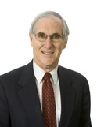
White has a long and distinguished career behind him. He graduated from Harvard College in 1964 and from Harvard Law School in 1967, after serving as editor of the prestigious Harvard Law Review. He's worked for the Foley Hoag law firm in Boston for 40 years, serving as its managing partner for more than 13 years and, according to Foley Hoag, specializing in areas of the law dealing with business and venture capital, especially technology business ventures.
White also headed Lex Mundi, billed as "the world's largest international association of independent law firms." He's also been general counsel for he Greater Boston Chamber of Commerce, is a director of the Massachusetts Alliance for International Business and has served on a long list of boards of directors.
From: Views and News from Norway.

Facts (and fiction) from Nordic Mythology and Norwegian History
It’s time for a little discussion about the arts and how they influence the society they reside in. There is and have, of course, always been artists in Norway. However some periods are recognized as more important than others. Without doubt one of the most important periods in Norwegian arts was the so-called National Romantic period. This period had its peak during the last half of the 19th century, but it can trace its roots back to the writing of the constitution in 1814.
One of the original Eidsvold men, as the framers of the constitution were called was a minister named Nicolai Wergeland from Kristiandsand. His son Henrik Wergeland was only 6 years old in 1814, but when his family moved to Eidsvold 3 years later when his father became the minister there, he soon became convinced about the importance of defending the constitution. This came as a natural development from being raised in a family that played an important role when writing the constitution and also living in the same place were the constitution was written.
Henrik Wergeland died young in 1845; he is remembered as probably the best poet in Norway ever and also as the proponent of changing and defending the constitution. He led a campaign to have the so-called Jew-paragraph removed (it declared Jews and Jesuits as unwanted in the country), and turned in the proposal himself in 1841. It passed, but not with a high enough majority. Six years after his death the constitution was changed the way he wanted it. He also used his status as a celebrity when he a few years earlier arranged the first children’s parade to celebrate the constitution on May 17th. He is forever known as the man that started this tradition.
Later on there were Henrik Ibsen who wrote plays that were critical to certain elements in society. He is well known and I will not dwell more on him here.
Among Bjørnstjerne Bjørnson’s novels are his “Bondefortellinger” the most famous. They describe the life in the country with hardships and joy. He describes how a simple young Norwegian could overcome difficulties and win the daughter of the big farmer. His works along with songs and paintings from the period were very nationalistic in nature. If you visit the National Gallery in Oslo (it is free and I highly recommend it), you will see some of these pictures. They would create paintings that seem real life, but are actually manufactured to look more dramatic. Some of these painters are Gude, Tiedeman, Dahl and Balke.
It was also in the same period that Asbjørnsen and Moe walked the countryside and wrote down all the stories people could tell. Their work is what we now read when we read about the trolls and princesses and “Askeladden”, the unlikely hero.
All the National Romantic artists were giving life to the popular opinion that Norwegians could handle themselves very well. We were a country of “Askeladder”, a people who have been looked down on and seen as someone who could hardly take care of themselves. The sentiment among the population was about to change, and all it took was a spark to ignite the fire. In 1905 Norway broke away from the union with Sweden and became a true sovereign country. Many of the events on the artistic front of the last 50 years before the breakup of the union, were an important part of the awakening of the Norwegian people, and I am sure that the events in 1905 could not have taken place without the National Romantic period leading up to it.
Anders Marstrander

Thefts soar at Oslo's main airport
Never before have police registered so many thefts at Oslo's main airport at Gardermoen as they did in the first six months of this year. Reports of stolen luggage, purses, cameras and wallets were up 13.2 percent though the end of June, reports newspaper Aftenposten. Police blame organized bands of professional thieves who prey on travelers in holiday moods, who aren't paying close enough attention to their belongings. "It seems like people are only thinking about where they're going, not what they have with them," said airport police station chief Hans Holmgrunn. His staff has dealt with 653 reports of stolen goods, most of which are never recovered. There's also been a marked increase in thefts from cars parked at the airport. Police are issuing more warnings over airport loudspeakers, setting up signs warning travelers of the theft rate and more uniformed staff are on patrol in the terminal buildings.

Reading Circle
There are many wonderful books by Norwegians and about Norway, and also their settlement here in America. Join us as we read and share our thoughts about some of them, such as: Kon Tiki, Out Stealing Horses, and Giants in the Earth.
We also have a good time trying to learn a bit of the language (uff da) thanks to Trine who speaks it fluently and is so patient with us.
The next meeting will be on Sept. 12th at 2:30 at the Panera in Deerfield Town Center. Then we'll be talking about each individual's choice of book. Call Carol Luiso(513-683-3631) if you have a question, or just come.
We enjoy the members in our group, always finding Lance's input interesting. He might appreciate some other male attendees!

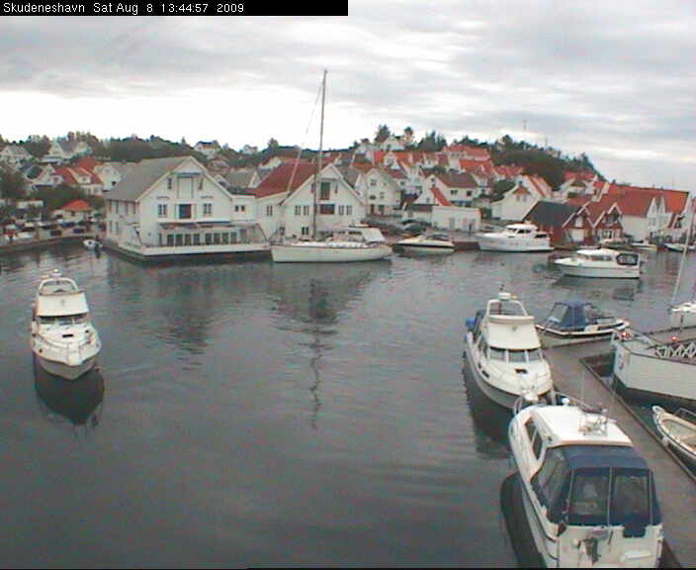
Skudeneshavn is northwest of Stavanger, on the southern coast of Karmoy. A number of fisherman emigrated to New Bedford Massachusetts from this island, from WebcamsinNorway.

Birthdays

August
Sandy Nelson[12], Diane Person[12], Austin Scherbarth[13], Diane Flautt[14], Jean Crocker-Lakness[15], Helen Hippert[22], Edwin Rice[22], Benjamin Downs[27], Melanie Petreman[29.

September
Kjell Evensen[3], Nancy Hocking[3], Ordell Hill[4], Nancy Vallette[6], Christina Kosobud[10], Glenn Kinney[17], Larry Welin[19], James Hanson[23], Per Flem[26], Jimmy Bowman[28].

October
Mililani Basberg[2], Sally Lund[8], Chris Buselmeier[9], Jim Crocker-Lakness[11], Roby Bowman[12], Curtis Anderson[13], Judy Pieper[15], Ken Soberg[19],Sandra Hoskins[19], Jens Basberg[20], Catherine Berberich[20], Nelda Chandler[25], Bailey Stone[28], Marlene Hanson[30].

Remember to go to:
website: www.evensens.net/sons/sons.html

Officers:

President Vice-President
Nina Downs Jerry Elvrum
513-561-1759 513-683-5826
Ninatdowns@fuse.net Elvrumjtj@aol.com

Secretary Treasurer
Tillie Elvrum Anders Marstrander
513-683-5826 513-398-4285
Elvrumjtj@aol.com Anders@Marstrander.com

Social Director Webmaster
Pat Nelson Schott Lois Evensen
513-490-2488 513-281-8408
jackpakpat@cinci.rr.com Lois@evensens.net

KALENDER
August 20th at Jungle Jims-Scavanger Hunt
Setember 12th Reading Circle at Panera, Mason
September 19th Pancake Breakfast

Edvard Grieg Lodge 657 District 5
Cincinnati-Dayton, Ohio
C/O Esther Charlton
3798 Susanna Dr.
Cincinnati, OH 45251

Adopt-A-School Tubfrim
Donna Marstrander Alene Rice
513-398-4285 513-771-4378
dmarstrander@gmail.com Clocks@zoomtown.com

Membership Newsletter
Esther Charlton Per Flem
513-923-3798 513-791-8942
Esthersofn@aol.com Perflem@rectomolded.com

Publicity Foundation

Siri Timo Carol Luiso
614-389-2518 513-683-3631
Siri@Columbus.rr.com CLuiso@AOL.com

