
Edvard Grieg Lodge 657 District 5
Cincinnati-Dayton, Ohio

The First Lodge in Ohio
Sons, Daughters and Friends of Norway
October 2006

President’s message:
Hei,
It is a pleasure and honor to once again write you about what is happening in our Lodge. This time of the year is so beautiful with all of the changing autumn colors. Another year will soon be history. With this seasonal transition comes a most joyous and exciting time of the year for Norwegians worldwide.
First, I need to share with you news regarding our Jule Fest plans and preparations. Also, it is essential to briefly discuss the upcoming nomination and election of Lodge officers. This nomination and election process is essential to the future of your Lodge. Hopefully, with good leadership, we will be able to continue many of the great Lodge activities for our grandchildren.
Before I get started talking about Jule Fest, I want to thank so many of you for your caring concern during the illness of my daughter. Kathleen is doing much better but she will be living at home and not be going to college until next year. My wife and I appreciate your prayers and understanding.
Wow! Jule Fest will soon be here. Have you seen any Julenissen lurking around your house? A few Saturdays ago, several of us met at the Goshen Methodist Church to make plans. This Church will be the location for this year’s festivities. The building is easy to find and it looks grand. I appreciate the twelve Lodge members who were at the Jule Fest planning meeting. After our meeting we conducted a brief Board Meeting and then several of us went out to lunch. We had a great time!
Last year we held our first Jule Fest. All who attended said they had a wonderful time. The positive response was overwhelming and I now believe our Jule Fest has become an annual event. Our first Jule Fest made a reality out of a dream that many of us had for the Lodge. It was wonderful to see the solidarity, enjoyment and love that went into last year’s activities. It was truly a night full of precious memories. This year we are going to promote and encourage even more traditional Norwegian customs and food.

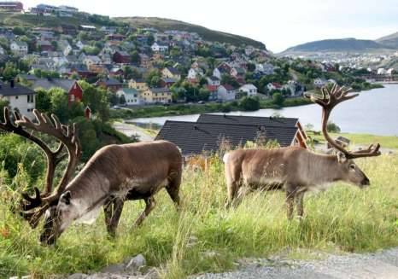
We in Cincinnati complain about (or love) the deer that have become part of our everyday life. In Hammerfest, it is a bigger problem in all ways. Here is a picture from Aftenposten, taken by Ole Magnus Rapp.

Once again, Carol Stone has graciously consented to organize and direct our Jule Fest. She did a magnificent job planning last year’s activities and we are looking forward to an even greater event this year. We had over one hundred and twenty people in attendance last year. This time we are anticipating an even larger crowd. Consequently, we are going to request a minimal increase in dinner price of ten dollars for adults. This nominal addition in price will help us defray costs and provide gifts for the children. Also, this year we are going to conduct special Jule Fest activities for the little ones that were not included last year.
There are several Jule Fest committees that have been created to help facilitate success. We need your assistance on one of these committees. Please contact Carol Stone as soon as possible and let her know how you can help.
At last year’s Jule Fest it was heart warming to see so many dressed up in their beautiful bunads. The children were especially cute in their native apparel. Hopefully, we can repeat that this year and get many pictures. We are going to attempt to get some of the pictures published in the Viking magazine. If you have access to a bunad or festival dress, please wear it to the Jule Fest.
Finally, just a word or two, I need to encourage you to get involved with your Lodge as we approach the transition of leadership and officers. I have been honored to serve as your president for the last two years but my term as your president is quickly passing. If you would like to be on the nominating committee or would like serve the Lodge as an executive officer please let us know.
Beste Hilsen,
Karl

Membership News
Great News! Three new members have joined our lodge.
Anders and Tanya Nerli have joined after finding our lodge website. Anders is Norwegian born and the second Anders in our lodge. They met at the Oslo airport, but they can give you more of the story.
Charlotte Ellingson has joined us after finding our website. She lives in Tipp City, but was happy to find our Sons of Norway lodge. She has been to Norway and visited the farm of her great grandfather in Hol, Norway.
Newest member, Siri Timo joined the lodge, at the lodge meeting on September 30. She would have joined sooner, but spent over a month in Norway with family recently.
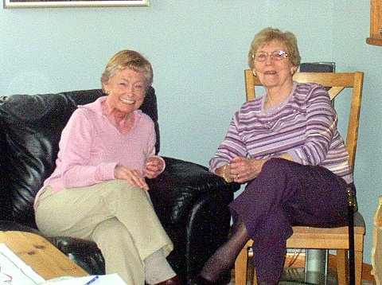
New member Charlotte Ellingson (talkingto Adelheid Price) drove the furthest to our meeting on Saturday .Picture from Bob Hippert.
Our membership is at 103, plus 7 Heritage members who are our young people 15 and under in age.
Just a reminder on the many ways you can renew your membership. Your can send a check with your bill as soon as you receive your note to renew. You can call the 800 number and renew over the phone. You can give your check to me, your membership secretary and I will send it for you, or you can renew online if it is within the renewal time frame.
If you have any questions on membership, or have friends that might be interested in membership in Sons of Norway, please contact me.
Thanks,
Esther Charlton

Sympathy
The lodge extends our sympathy to the family of Patricia Lakness on her recent passing. Patricia was one of the lodge's charter members. Her husband Melvin, and daughter Jeanne Crocker-Lakness, members of the lodge, are also charter members. A donation has been made to the Sons of Norway Foundation in Patricia's name, from the lodge.

Recipe from Norway: from editor
When I visited Norway, everyone had made their own delicious jam. It was less sweet, but juicier.
1# of sugar. (A vanilla sugar is one option)
4# of berries, raspberries, or strawberries.
One package of Certo by Kraft.
Hand mix, don’t whip.
Freeze in convenient containers, don’t cook.
“Some Sunny Night”
Those of us who journeyed to Middletown on September 28 to attend the US premiere of “Some Sunny Night” were more than glad we made the trip, for we were rewarded with a dazzling spectacle of sight and sound that was pleasing to both eye and ear even as it touched some of our deepest emotions.
“Some Sunny Night” is a musical play—one could even call it an opera—based on the true story of the friendship of Mark Wang, a Chinese paraplegic, and the late Ketil Moe, a Norwegian victim of cystic fibrosis who nonetheless became a marathon runner. Like the famous Man of La Mancha, Mark and Ketil dared to “dream the impossible dream” and then went on to make it come true. With the help of such Norwegian sports heroes as Johan Olav Koss and Grete Waitz, they organized marathons for handicapped people in both Norway and China. In the opera-musical we meet these two amazing young men and their girlfriends and mothers, their doctors and their friends, in love, joy, sorrow and hope.

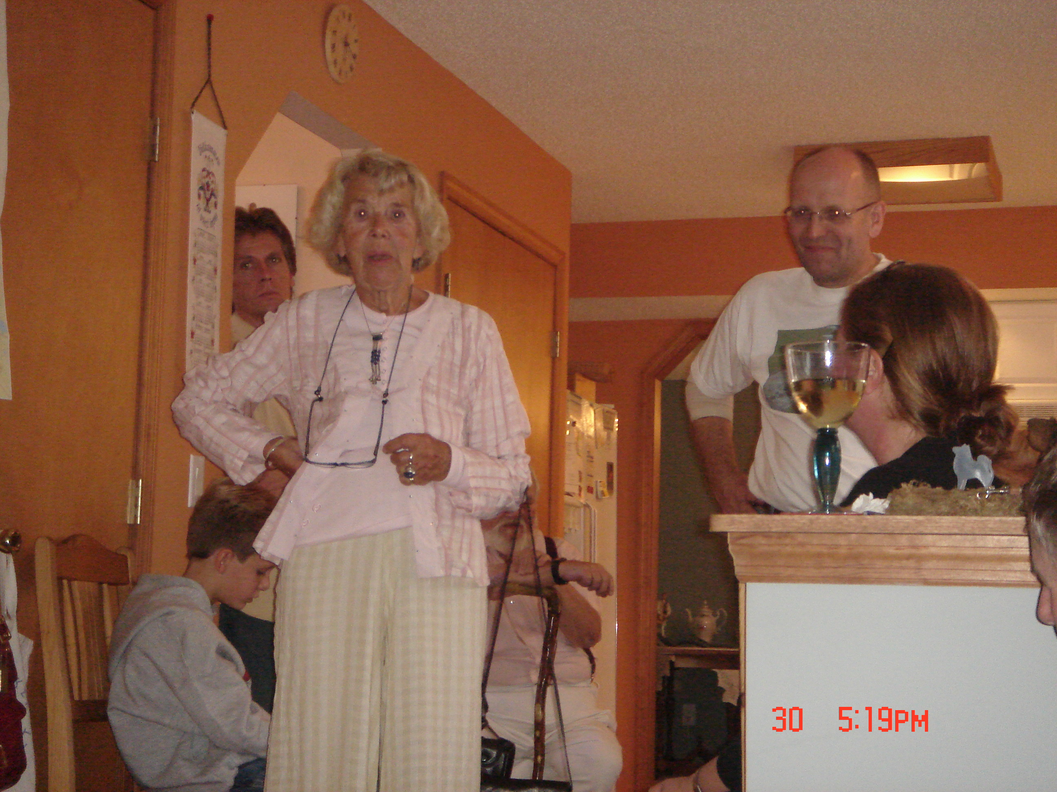
Our guest speaker at Saturday’s meeting, Helene Marstrander (Anders Marstrander’s mother), tells us what it was like growing up on the Barents Sea in Northern Norway.

Wang, who participated in the performance as a narrator, is a national hero in China and a role model for China’s 80 million handicapped citizens. His mother Shen Liping, who interrupted her career as an artist to care for her son, also made a cameo appearance at this performance as a narrator.
The composer of this remarkable work is 29-year-old Norwegian composer Thomas Stanghelle, who also played the part of Mark Wang in the play. The part of Ketil Moe was brilliantly played by Columbus actor Robert Kerr.
This was just the third performance of “Some Sunny Night,” the previous two having been at the Sunnaas Rehabilitation Hospital in Norway and, amazingly, at The Great Hall of the People in Beijing.
The next scheduled performances are in Brussels, Belgium, in November of this year and in Beijing, China, during the 2008 Olympics.
William Halverson

Meeting Schedule
Our next meeting will be Sat. Oct 21, 2006 at 5:00 pm at the Mallards of Mason Clubhouse. (Directions are posted on the website.) Susie Mikaloff will give a presentation on Leif Ericson and a demonstration on making lefse. This is one you will not want to miss! Children will really enjoy this meeting. Please bring a dish to enjoy along with the provided lefse. RSVP to Sandy Nelson at 513-336-9810.

November 11, 2006. 7PM. Our lodge is proud to present Karen Torkelson Solgard in concert. This is a rare treat and opportunity for us to have someone of Karen's talent and quality in our area. You may find out more about Karen at her website, www.cdbaby.com/solgard.
The location for the concert is Friendship United Methodist Church, 1025 Springfield Pike, Wyoming. Come early for good parking and good seats. There will be a free will offering during the performance.
For those of you attending the concert, we need your help. Please bring a goodie for the refreshment table, like cookies or brownies. Also, bring your canceled stamps for Tubrim.
If you have any questions concerning the concert, contact Esther Charlton.

Mark your calender for our Second Annual Julefest Celebration, Sat. Dec. 9, 2006 at 4:00. Remember this is the big one! If you go to one meeting a year, this is the one to go to. Last year we had over 120 guests. To help on a committee contact Carol Stone at 513-228-0245 or cm8stone@yahoo.com or Nina Downs at 513-561-1759 or ninatdowns@fuse.net.

Grieg tour:
The Norskedalen Nature and Heritage Center is sponsoring a trip to the Bergen area, May30 to June 10, 2007. This is an educational program with Prof. William Halverson, a noted Grieg expert. It’s a 12 day event costing $4,444 (double occupancy) with lots of free time to wander the area around Bergen, and visit the country side that inspired Edvard Grieg. For more information contact Janet Melby at 507-895-6468, or djmelby@acegroup.cc

Crown Prince to USA (from Aftenposten)

Crown Prince Haakon of Norway will visit New York and New Orleans from Oct. 10-15.
The palace made the announcement on their web site on Thursday.
The tour will begin with a visit to the United Nations headquarters in New York City, where the crown prince will take part in the launch of the UN study of violence against children, and other events linked to this study.
Then Crown Prince Haakon moves on to New Orleans where he will help celebrate the 100th anniversary of the Norwegian Church Abroad (Sjømannskirken).

Sjømannskirken, The Norwegian Church Abroad
From Wikipedia: The Norwegian seamen’s church is a religious organization serving Norwegians and other Scandinavians traveling abroad. Founded in 1864, The Norwegian Seamen’s Mission - Sjømannsmisjonen - was established to secure the moral and religious education of Scandinavian seafarers, but also to give them a "breathing room" where a fellow countryman was available to lend an ear and give some attention. Today, the churches and their staff together with traveling pastors around the globe represent a "resource center" for all Norwegians traveling internationally.
Sjømannskirken annually serves around 700.000 Norwegians through over 30 churches and 16 mobile services in 30 countries around the world. Several churches are operated on a Scandinavian basis. The Norwegian Church Abroad, its main office in Bergen, is a charitable organization supported by the Church of Norway and the Norwegian Government. Sjømannskirken is also a member of ICMA and the Council of Nordic Seamen's Missions.
For most Norwegians traveling abroad, Sjømannskirkenit is a nice resting place: one can read newspapers from home, buy Norwegian food and speak to other Norwegians. Many Norwegians living permanently abroad use the seamen's churches instead of the local ones.

According to Donna Marstrander:

You know your in Norway when: It’s a beautiful clear crisp winter afternoon , the snow is shimmering ,parents are inside by their fireplaces relaxing because the baby has finally fallen asleep , outside in the baby buggy on the front porch!

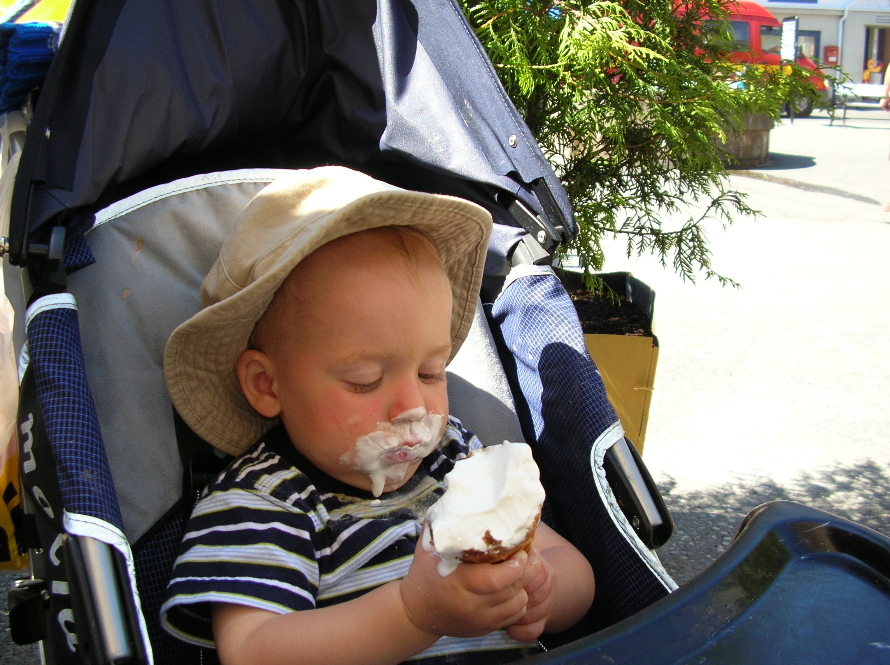

The first of a series of Norwegian baby pictures comes from Nina Downs, Benjamin having “soft ice” in Norway last summer .If you want one of your favorites in a newsletter, please send to Per Flem

Birthdays:
October
Sally Lund(8), Patrick Johnson(8), Chris Buselmeier(9), Roby Bowman(12), Nelda Chandler(25), Birgit Jorgensen(25), Bailey Stone(28).
November
Peter Olson(1), Dianne Clark(5), Nina Downs(9), Ed Vallette(11), Ann Christiansen(12), Thomas Traut(14), Glenn Mikaloff(14), Kaleb Flem(30).
December
Lois Evensen(5), Susan Mikaloff(7), Kari Poe(8), Charlotte Ellingson(9), Esther Charlton(12), Edmund Charlton(13), Richard Monson(14), Neil Sorum(15), Carol Olson(16), Konrad Nelson(29).

Syklubb
The Nina Grieg Syklubb will be baking Norwegian Christmas cookies the first week of December. The cookies will be sold at the Jule Fest. Baking, and holiday fun-while making Jul memories-come join us! If you are interested call Nina Downs at 513-561-1759 or email ninatdowns@fuse.net for more information.

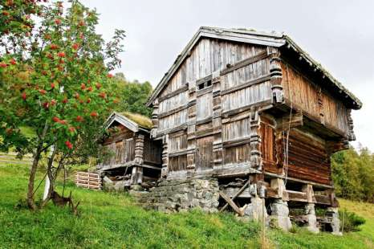
Aftenposten has a series called Holidays with Histories. This picture is from this series and is an old farm called Djuvland Fjellgard in Rauland. The farm takes guests and is run by Bjorn Helge Malkomsen and his wife Astrid Laghammer. For more pictures go to www.aftenposten.no, Picture by Dag W. Grundseth

website: www.evensens.net/sons/sons.html

President Vice-President
Karl Flem Nelda Chandler
9436 Morrow-Woodson Rd. 11409 Geneva Rd.
Pleasant Plain, OH 45162 Forest Park, OH 45440
513-877-3005 513-742-9504
Flem1973@Yahoo.com Neldandelma@earthlink.net

Secretary Treasurer
Rosalie Wingler Carol Luiso
7983Quail Meadow Ln. 1006 Paxton Lake Dr.
West Chester,OH 45069 Loveland, OH 45140
513-779-2166 513-683-3631
rwingler@fuse.net Chluiso@aol.com

Social Chairman Webmaster
Nina T. Downs Lois Evensen
1478 Montegor Dr. P.O.Box 9450
Cincinnati, OH 45230 Cincinnati,OH 45039
513-561-1759 513-281-8408
Ninatdowns@fuse.net Lois@evensens.net

Social Co-Chair Raffle Chairman
Sandy Nelson Susie Mikaloff
Snel1234@aol.com 7472 Stone Ridge Dr
. Springboro, Oh 45066
Social Co-Chair 937-748-8121
Diane Person g_mikaloff@email.msn.com

Adopt-A-School Tubfrim
Donna Marstrander Arlene Rice
5527 Woodvalley Ct. 2 Forest Pl.
Mason, Ohio 45040-2622 Glendale, OH 45246
513-398-4285 513-771-4378
Donna@Marstrander.com Clocks@usadatanet.net

Membership Newsletter
Esther Charlton Per Flem
3798 Susanna Dr. 4269 Berryhill Ln.
Cincinnati, OH 45254 Blue Ash, OH 45242
513-923-3798 513-791-8942
Esthersofn@aol.com perflem@RectoMolded.com

Edvard Grieg Lodge 657 District 5
Cincinnati-Dayton, Ohio
C/O Esther Charlton
3798 Susanna Dr.
Cincinnati,Oh 45254

