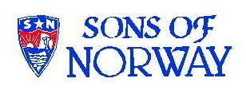
Edvard Grieg Lodge 657 District 5
Cincinnati-Dayton, Ohio

The First Lodge in Ohio
Sons, Daughters and Friends of Norway
October 2007

Hilsener fra Presidenten
Greetings from the President

Summer is over?? At least fall is supposed to be here. We have had some great programs this summer and I am looking forward to more great programs already planned for this fall. Look through the rest of the newsletter for more information about the programs and other events planned.
I have received information about the Insurance Revenue Sharing Program, which is a program that shares 3% of Sons of Norway’s net gain from operations with the local lodges. The amount received is determined by the total insurance premiums collected from members of our lodge divided by the total premiums collected from all lodges. In addition our lodge receives $4.00 for each new insurance member. This change has been introduced for several reasons: first this allows local lodges to share in the profitability of Sons of Norway. Secondly more money will be paid to the local lodges than the old program. Third it uses all premiums where as the old program did not take into account any annuity members and only a portion of the premiums on life insurance contracts over $50,000.00. Finally it rewards lodges that have more insurance members and increasing these members is a goal of the Board of Directors of Sons of Norway. I have some information on planning for retirement and leaving a legacy form our representative Eric Nichols, CLU, ChFC. His contact information is: Phone: 877-684-7667 Fax:248-685-2237 email: wnf@globalsl.net

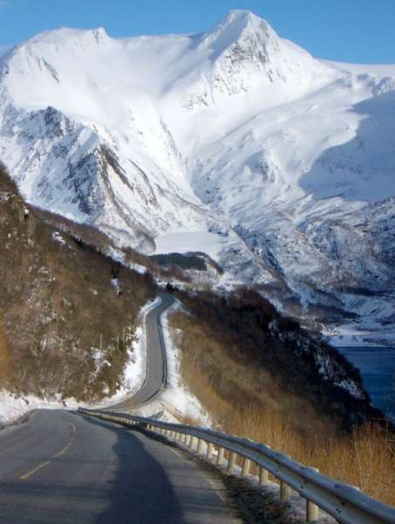
This picture from Aftenposten, is National Highway 17 near Holand on the Helgeland coast. This is one of the candidates for National Tourist Road. Picture by Steinar Skår/Statens Vegvesen.

Ski for Light, Inc. –Sons of Norway members and lodges have played a major role in the evolution of this program. We are fortunate to have a member, Dan Beckman, who has participated in this event for several years and has presented programs for our

lodge. It will be held in Bend, Oregon this year, which is about 40 miles from my hometown, February 10-17, 2008. This is the 33rd annual event and nearly 300 participants are expected to attend including a delegation of about 30 guides and disabled skiers from Norway. They are always seeking new guides and new disables participants. If anyone is interested or if you know someone who would like to participate in either capacity, I have information for both of these areas. Dan I am sure would be glad to give you any information or help you needed in making application or questions about participating.
I have been sent information about Norwegian and Swedish Collectors Calendars. I will bring the info to the next meeting. They are listed at $12.50 but are being offered at a “wholesale price” of $6.82 plus shipping and handling. These are for 2008. If you are interested but not able to come to the next meeting please contact me and I can order for you. I will try to have a sample by the next meeting.
Nelda

Foundation
The Sons of Norway Foundation was founded in 1966 and has awarded over $900,000.00 in 335 grants and over 2,000 scholarships to our members, lodges and their communities. Most of these have been in the last 10 years. The Mission : “The Sons of Norway Foundation awards scholarships and grants to promote the heritage and culture of Norway, and provides assistance to our members, lodges and their communities.”
Grants have been given for many kinds of studies in Norway and the US, to experience cross-cultural exchanges at the Norwegian Folk High Schools. The Foundation has awarded grants to local lodges to offer unique Norwegian art and culture presentations, such as the one we received for our Rosemaling class.
There is a Humanitarian Fund which stands ready to provide assistance to members and communities when the need arises. You can help make a difference in the lives of countless people by making a donation to the Foundation. Please see our Foundation Director, Anders Marstrander for more information or a donation card.

Norwegian Interpreters.
Siri Timo, Kjetil Marstrander and Anders Marstrander are now signed up as interpreters for Affordable Language Services (ALS) in Cincinnati. Their specialty is of course Norwegian, but they can also interpret for Danish and Swedish speaking people. This new assignment came as a result of a request from ALS to our lodge for someone who could interpret for Norwegian. There was a family coming from Norway late August visiting Cincinnati Children’s Hospital who needed an interpreter. In due time before the family arrived here the three "brave" volunteers filled out forms, attended an educational seminar and took different vaccinations and blood tests. There is a lot more to being an interpreter than just knowing a foreign language or two!
When the Norwegian family arrived Siri and Anders split the hours between them (Kjetil had to go to school). They showed up armed with regular dictionaries and a medical dictionary. The job turned out to be fairly easy, the family spoke and understood English rather well. They just needed a little assistance with some sentences and words. The family left Cincinnati after a couple of days knowing that they had received the interpreting help they needed, and the new interpreters achieved some practical experience and are ready for new assignments.

October meeting
The October 7th meeting will be at Dan Beckman’s home at Hidden Valley Lake 1138 Montclair Ct., Lawrenceburg, IN 47025The 3:00PM meeting will have Esther talking about Roald Amunsen, the Artic explorer. Please bring a dish to share.
Contact: ninatdowns@fuse.net.

Rosemaling Cultural Skills Program
There will be a Beginners Rosemaling Course at the home of Kari Poe, 579 Belle Meade Farm Drive, Loveland, OH 45140 on October 20th from 10am to 6 pm. Those members participating will qualify for the Sons of Norway Cultural Skills Award in Norwegian Rosemaling. The cost is $35 plus the cost of brushes. All of supplies by a grant the Lodge received. Contact: ninatdowns@fuse.net or 513.608.0364

Turtle Creek Flea Market
Membership & Fundraiser Activity
Saturday, October 20
Thanks to Siri Timo and Beth Monson for baking cookies for our first time at Turtle Creek. It was one of those really hot days and the people traffic was a bit light, but we did sell lots of plates of cookies.
We are going to Turtle Creek again on Saturday, October 20. If you can bake cookies or brownies or any other type of baked goods call Esther, for the details. We will arrange a pick up for them.
Turtle Creek Flea Market is at Exit 29, on route 63, just west of I-75. It is open from 9-5 on Saturday, but we may pack up our things a little earlier. We will know which space we will have early in the week, in case anyone wishes to stop and visit. If you want to come and help, contact Esther.

November Meeting-Nov, 17-1:00 pm
The November meeting will be hosted by Donna and Anders Marstrander, 5527 Woodvalley Ct., Mason, OH 45040. A presentation on Norse Mythology will be given by Anders and Kjetil Marstrander. Please bring a dish to share. Contact Nina Downs at ninatdowns@fuse.net

December Meeting-JULEFEST!-4:00pm
This is the famous Julefest Event we all talk about! Save the date on your calendar. Bring your favorite holiday dish, preferably Norwegian, and come ready to sing and dance around the Christmas tree! This year the Julefest will be held at Friendship United Methodsit Church, 1025 Springfield Pike, Cincinnati, OH 45215. To help on a committee, or for further information contact Nina Downs at ninatdowns@fuse.net or 513.608.0364
Membership
Do you know of someone who may be interested in our lodge and Sons of Norway? Pass along their name or encourage them to come to a lodge meeting with you.
The year-long contest to recruit someone (and get your name in for a drawing for a trip to Norway) will end at the end of December. If you were thinking of signing up a relative or friend, do it now!
If you have ideas of where we might post flyers about our lodge, let us know of them. Siri, our publicity chair, or I will see that they get posted.
Thanks,
Esther Charlton, Membership Secretary

Pampered Chef Fundraiser
Thanks go out to all the members who participated in the Pampered Chef Fundraiser. With your help we made $225.00. Special thanks to Kari Poe for her gracious hospitality and hosting the event in her home.

Syklubb Meeting-Nov 4-3:00pm
Our next Syklubb meeting will be hosted by Carol Luiso, 1006 Paxton Lake Drive, Loveland, OH 45140. Contact Carol at chluiso@aol.com or 513.683.3631.

Birthdays
October
Sally Lund[8], Chris Buselmeier[9], Roby Bowman[12], Catherine Berberich[20], Nelda Chandler[25], Bailey Stone[28].

November
Peter Olson[1], Dianne Clark[5], Nina Downs[9], Ed Vallette[11], Ann Christiansen[12], Thomas Traut[14], Glenn Mikaloff[14], Kaleb Flem[30].

December
Lois Evensen[5], Susan Mikaloff[7], Kari Poe[8], Charlotte Ellingson[9], Esther Charlton[12], Edmund Charlton[13], Richard Monson[14], Neil Sorum[15], Carol Olson[16], Konrad Nelson[29].

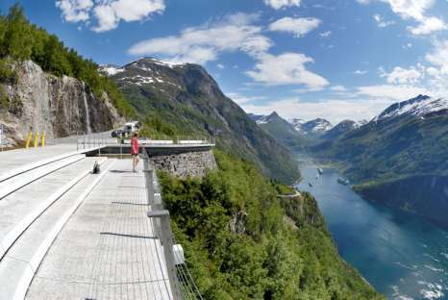
This candidate for “National Tourist Highway”, is the road from Gieranger to Trollsteigen at Ørnesvingen.From Aftenposten, picture by Jarle Wæhler/ Statens Vegvesen.

Remember to go to:
website: www.evensens.net/sons/sons.html

Upcoming Events:
October7, Regular Monthly meeting at Dan Beckmans’ home. “Roald Amunsen”.
Oct 20, Rosmaling Seminar at Kari Poe’s home.
Nov 17, Norse Mythology by Anders and Kjeltil Marstrander.

President Vice-President
Nelda Chandler Carol Stone
11409 Geneva Rd. 224 Countryside Dr
Forest Park, OH 45440 Lebanon, OH 45036
513-742-9540 513-228-0245
nelda1961@Cinci.rr.com cm8stone@yahoo.com

Secretary Treasurer
Rosalie Wingler Carol Luiso
7983Quail Meadow Ln. 1006 Paxton Lake Dr.
West Chester,OH 45069 Loveland, OH 45140
513-779-2166 513-683-3631
rwingler@fuse.net Chluiso@aol.com

Social Director Webmaster
Nina T. Downs Lois Evensen
1478 Montegor Dr. P.O.Box 9450
Cincinnati, OH 45230 Cincinnati,OH 45209
513-561-1759 513-281-8408
Ninatdowns@fuse.net Lois@evensens.net

Edvard Grieg Lodge 657 District 5
Cincinnati-Dayton, Ohio
C/O Esther Charlton
3798 Susanna Dr.
Cincinnati, OH 45251

Adopt-A-School Tubfrim
Donna Marstrander Alene Rice
5527 Woodvalley Ct. 2 Forest Pl.
Mason, Ohio 45040-2622 Glendale, OH 45246
513-398-4285 513-771-4378
dmarstrander@gmail.com Clocks@usadatanet.net

Membership Newsletter
Esther Charlton Per Flem
3798 Susanna Dr. 4269 Berryhill Ln.
Cincinnati, OH 45254 Blue Ash, OH 45242
513-923-3798 513-791-8942
Esthersofn@aol.com Perflem@rectomolded.com

Publicity Foundation

Siri Timo Anders Marstrander
6873 Rosetree Pl. 5527 Woodbury Ct
Mason, OH 45040 Mason, OH 45040-2622
513-398-4285 513-398-4285
Siri@Cinci.rr.com Anders@Marstrander.com

