
Edvard Grieg Lodge 657 District 5
Cincinnati-Dayton, Ohio & Kentucky

The First Lodge in Ohio
Sons, Daughters and Friends of Norway
October 2008

Meetings:
Saturday October 18th
Velkommen til Skogfjorden, a regular lodge meeting 4:00PM Ascension Lutheran Church. Montgomery.
Saturday November 22nd
Norway and WWII, a regular lodge meeting at 4:00PM at IHOP on Colerain Ave.
Saturday December 6th
Juletrefest, a special lodge meeting at 4:00PM at Friendship Methodist Church,Springfield Pike.

Hilsen Fra Presidenten
This has been quite a month. Ike really caused havoc in this area of the country. Thank goodness we didn’t have rain along with the wind because I personally would have had a flooded basement again as my sump pump doesn’t have a battery back up,, yet. My power came back on Wednesday about 2 AM., and because I had a full freezer, I didn’t loose everything. As for the wind, a couple of large limbs fell but no damage to the house. One of my limbs fell into the neighbors’ yard and did hit her house but did no damage, thank goodness. I hope none of you had too much damage.
We did meet with the district officers on the 15th of September. The President, Mary Jane Bennett, VP Burt Bittner, Treasurer Ray Knutson, international director Josten Bakken, and Burts’ wife Jean.
Ikea was open but on generator, so the restaurant was not open. We went to Springdale and ate at Riley’s Restaurant on the corner of Rt. 4 and Kemper. The meal was very good. If you have opportunity to be in that area I would highly recommend it. It is a good family restaurant that has reasonable prices. Our visitors then went on to Indianapolis. Esther, Bob and son Ed, Richard Glatfelter, and myself were the local attendees. Richard is a potential new member for our lodge. He has been a S of N member since 1990 but recently moved to this area.
We have begun the planning for Jultrefest, and are still looking for people to help with the various committees. If you are willing to help please contact myself or VP Nina Downs who is chairing the event. Jultrefest will be held at Friendship Methodist Church, where we have met before, on December 6th. We will be having dinner and dancing around the Christmas Tree as we have done in the past. Please pray for good weather so we don’t have to cancel this year.

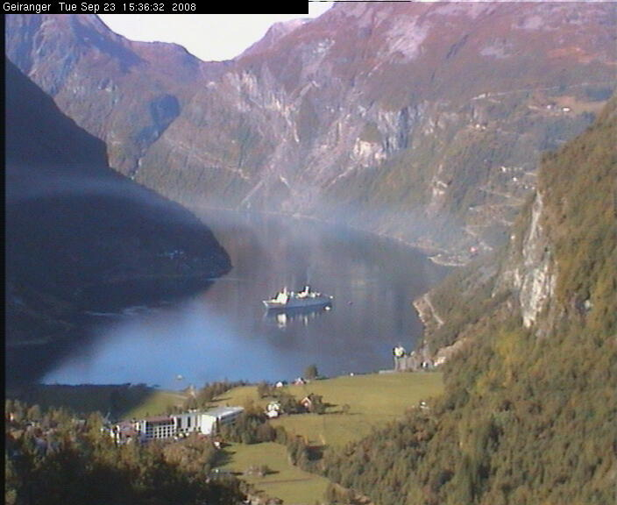
You may remember that the editor has a thing about Geiranger. This is the prettiest picture from web cams in Norway in years.

Our own Esther was a delegate from the district representing our Zone 6 to the International Convention in San Diego, Ca. Ask her about her trip and read her report in this newsletter.
October is Foundation month. The “pig” will be there in October if you care to donate. The money will be sent in after this meeting, and then we will start collecting for next year. Loose change or paper money gratefully accepted. The money is used for scholarships, for victims of natural disasters, and for grants such as the one we received for our Rosemalling seminar and the supplies for painting. We could not have done it without this grant and we are eligible for another if someone comes up with another cultural project ( ie carving, knife making) or a youth activity.
Hope to see you all in October.
Nelda
Norwegian Forest Cat; Skogkatt.
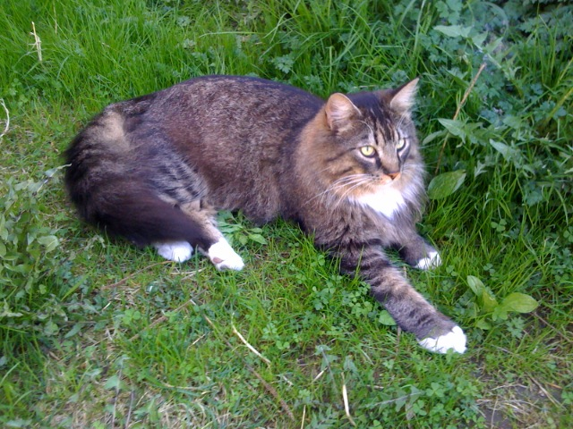
Picture from Alene Rice, taken in Bakklandet, a neighborhood in Trondheim.
Bright emerald green eyes with a band of gold. Long flowing hair. Sweet-expressioned faces. Jaunty ear and toe trimmings. These are the cats that explored the world with the Vikings, protecting the grain stores on land and sea, and which are believed to have left their progeny on the shores of North America as a legacy to the future.
These lovely cats are really two for the price of one, they can differ so greatly in looks from summer to winter. Some time in the spring they take off their “winter underwear,” the downy undercoat that provides warmth, and the long non-tangling outer guardhairs that act as protection from rain and snow. The contrast can be quite extreme. The inner-ear hair that deflects the wind and snow (and can be three to four inches long, curving out and around the ear like flexible racing stripes) remains all year. The tail is always magnificent, being as much as twelve inches or more when fanned to its fullest. Perhaps the most impressive part of the coat is the mane. On a fully mature cat, i.e. one over five years of age and which is challenged by the most adverse cold weather, the mane is nothing less than spectacular. It is long, dense and very, very impressive! This, unfortunately, may disappear in the spring, but rest assured that it will begin to lengthen again as the days begin to shorten. Is their Norse name accurate? Yes, the skogkatt, meaning forest cat, really did come out of the Scandinavian forests some time in the last 4,000 years. Skogkatt was introduced into Europe by the Romans. Text in part from Cat Fancier’s Association web site.
Meetings
October 18th.
Randy Treer, one of our newer members, will describe his adventure at the Concordia Norwegian language weekend. Meeting starts at 4:00PM, and is at Ascension Lutheran on 7333 Pfeiffer Rd, just east of Interstate 71. Bring soup, salad, or desert to share. RSVP Nina Downs
November 22nd.
First hand information about Norway during WWII, beginning at 4:00PM. Meeting is at IHOP on 9540 Colerain Ave. RSVP by the 20th. RSVP Esther
December 6th.
This is the big one! Juletrefest, A Norwegian Family Celebration starts at 4:00PM at Friendship Methodist Church, 1025 Springfield Pike in Wyoming. Cost $5.00 for ages 6 and older. Bring appetizer or dessert. Shop at “The Norse Butikk”.
RSVP Esther.
See last page for telephone numbers.

Membership News
We have four new members to introduce to the lodge.
First we have Nancy Bridston, who lives in Albuquerque, and joined our lodge because her fiancé is stationed at Wright Patterson. She will be moving to our area in January.
Thomas Varland has joined our lodge. Several years ago, he and his wife took a cruise on the MS Nordkapp to Antarctic and their trip was written up in the Enquirer. Tom is the nephew of Walt Varland, one of our Charter members.
Teresa Lowen lives in the Dayton area and recently found our website. She has family Norwegian connections. She has already been to the Reading Circle group.
Trine Wernes recently moved here from the East Coast. She has a daughter and grandchildren in our area. She plans to bring her family to our October meeting. Many years ago, Trine was a member of Fredriksten Lodge in Philadelphia.
We are sorry to lose Charlotte Ellingson, who has moved to the Portland, Oregon area. She was an active member of our lodge for the last two years.
If you know of someone that may be interested in our lodge, please pass along their name and information.
Thanks,
Esther Charlton, Membership Secretary

International Convention – San Diego, August 27-30
It was an honor to be elected a delegate to the convention from our area of District Five. There were 144 delegates from the 8 districts, plus twelve international board members.
We learned much about Sons of Norway, and approved some changes. The constitution is going to be re-ordered. A committee has been working on this process since the last International Convention. It was also decided to add put back into the mission statement Nordic Countries. This was a matter that was heavily discussed. Some of the entertainment during the convention was from the San Diego Marine Band, Jim Martinez, a pianist, who has done Grieg music with a jazz influence, and a men’s chorus from the host lodge.
I did put a daily report on our lodge website message board, and the new international officers are listed there.
The next International Convention will be in Coeur d’ Alene, Idaho around Labor Day of 2010.
Esther Charlton

Reading Circle
The Reading Circle will meet on Saturday, Jan 10, 2009 at 9:30 A.M. at IKEA's, 9500 IKEA Way, West Chester, Ohio 45069.
We'll have breakfast and discuss Kon-Tiki by Thor Heyerdahl. If you enjoy reading Norwegian related books, join the group!For questions or details, contact: Carol Luiso 513-683-3631 or CHLuiso@aol.com

Juletrefest
If there is one meeting to attend, this is it! Good food, music, Norwegian cultural topics, and kids have a great time. Last year unfortunately was cancelled at the last minute due to a snowstorm, so we are a little earlier this year.
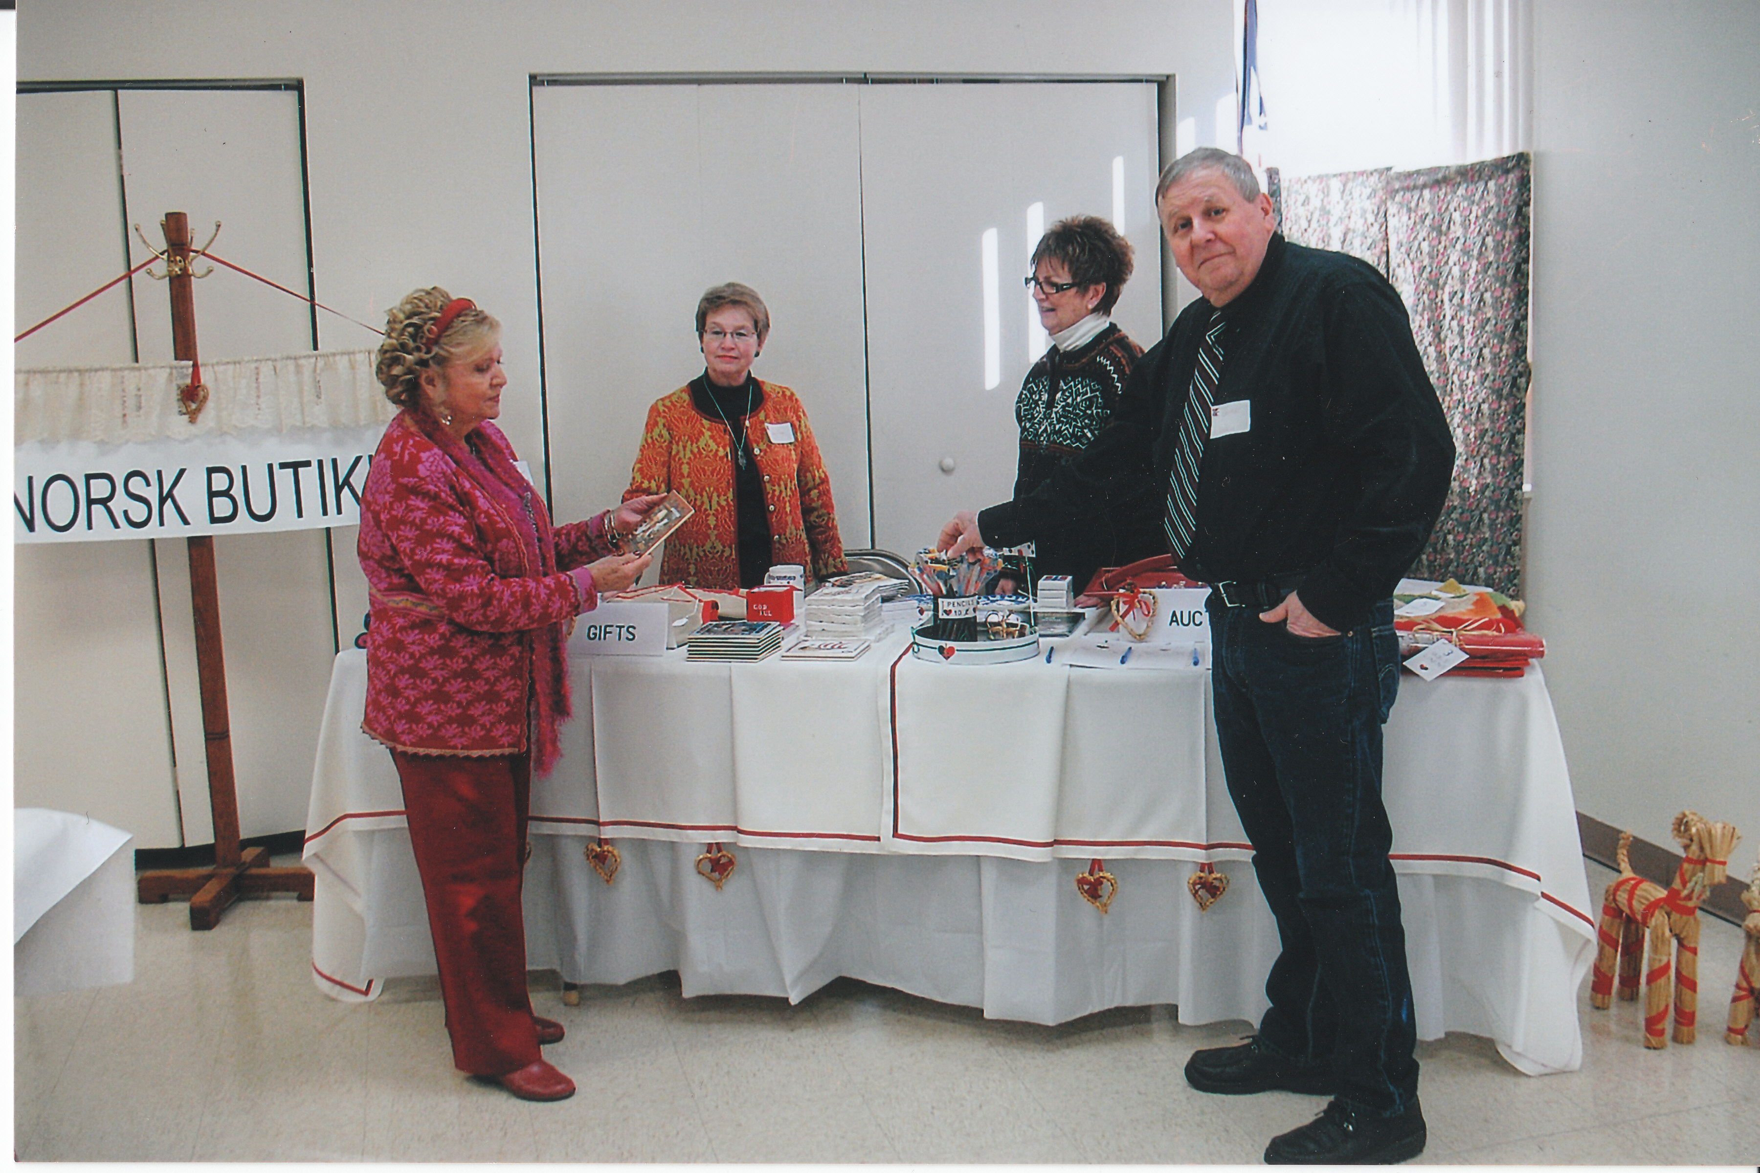
We are excited about the Norsk Butikk at the Jultrefest this year. We will have a large variety of items for sale. Some of the items will be 2009 Splendor of Norway calendars, books, kitchen items, ornaments, linens, candy, greeting cards and stocking stuffers. Norske presents for all! Kari, Sandy, Diane, and Lance are seen above checking out the merchandise.

Lodge Library News
We have four new books that have been added to our library. Here they are, “Gods of Asgard”, by Erik Evensen,” Kon-Tik”i by Thor Heyerdahl, “The Sorrows of An American” by Siri Hustvedt and “Out Stealing Horses” by Per Petterson. There are brief descriptions of these books on the library link of our lodge website.

Notes from the Road, by Charlotte Ellingson who is travelling west and her new home.
August 25, 2008
Day one
This is my last day in Ohio for a while. It is a bitter sweet moment, but I am comfortable going back to the West Coast . My friend Rosalie and I will do some errands and drop off a cooler and chair at my son’s house before we leave for the road ahead.
Leaving Ohio feels a little sad as I have made some great friends here and my granddaughters are living here. I will stay in touch as friends and family are important to me. We are on our way and enter I-70. The trucks drive slower so we ease around them and plan our first night in Galesburg Illinois. These states are green and pleasant to drive through. The traffic is light so driving is easy. The Western sun becomes a problem as we get into the late afternoon; it is bright as we drive towards it.
We have crossed the Ilinois border and start looking for the little town of Galesburg. I am very tired and am looking forward to food and rest. We find a wonderful French Bistro in the historic part of this cute little town. The place is antique French with white table cloths and friendly staff. I have a crep and Rosalie has pasta. It is a wonderful setting with lots of old items from the past. I enjoyed it a lot.
Now we are at the hotel and I begin to relax on a wonderful bed. It was an early night, exhaustion fills my body and I am feeling a little conflicted with my emotions. Sleep overtakes me and tomorrow is another adventure.
Day two
We are up early to get started on another day of adventure on the road. The hotel has a breakfast so we eat and take some coffee to go. Driving the Illinois landscape turns to low rolling green hills. Soon we are in long stretches of isolated green fields of corn and soy beans. I hear a pop and wonder what it is; I look in the rear view mirror and see nothing so I continue driving. The wind begins to blow harder and seems to move my car. I slow down and look for an exit from I-80. The town of Council Bluffs is next so I take the exit and drive to the nearest service station. A look around the car reveals a flat tire. Oh no, and some other words that will not be repeated here. I call AAA, they route me to an Iowa agent and soon he drives up in a car which causes some suspicion on my part. However, he opens the trunk of his car and I see that he is from AAA. He tells me to back up and put some air in the tire so we can drive it across the road to the Sears tire store. Well, I drive to the intersection and the tire blows, good thing I was stopped. Traffic is backed up and the cars drive around us as needed. He finally changes the tire and we are off to the tire store.
I go to the counter and tell my story of woe then we settle on two tires that closely match the other tires. It will be a while so Rosalie and I walk across the street to the mall and have a late lunch. We walk back and the car is ready, I do business then we are off to Kearny (pronounced Karny). Irish I believe. On the way to Nebraska over to the left, is a long line of Black Angus cows walking in a straight line following their leader I suppose. We joke about the orderly cows and then off to the right we see more Back Angus cows all in a line following a red pick-up truck. It’s a puzzling and interesting sight for a couple of city slickers. It has been a long day as we drive into the late afternoon sun heading for a night of rest. The hotel is a welcome sight for our tired bodies. We check in drop the luggage and head over to the Mexican restaurant next door with a very interesting name, ”Carlos O’Kelly”. A family restaurant that has a friendly, happy staff. Our bellies are full and so it was an early night for two city ladies. Tomorrow it will be Wyoming.
Days three and four next month.

Moose hunt is big business
Norway's annual moose hunt started Thursday, with millions of kroner invested by enthusiasts in hunting rights, clothing, weapons and other gear. In addition comes the value of the meat to be sold.
In central Norway alone, an estimated 12,000 hunters were expected to head into local forests in the hopes of shooting down the huge, majestic animals. Often called the "King of the Forest," (Skogens Konge), a moose head makes for a prized trophy on many a hunter's wall.
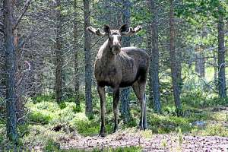
Norwayhas a lot of moose, and none of them are safe until after October 31.
PHOTO: KJELL ERIK ENGMARK

State authorities have set this year's quota at about 35,000 nationwide, 8,000 just in central Norway. The value of the moose meat is likely to hit NOK 340 million (nearly USD 60 million), according to a study done by Trondheim newspaper Adresseavisen.
Hunters in central Norway are estimated to have spent around NOK 37 million on equipment.
"In addition comes the cost of butchering and processing the meat, and, not least, the major social value the hunt has," said wildlife manager Paul Harald Pedersen of Nord-Trøndelag County.
The moose hunting season lasts until October 31. From Aftenposten.
Birthdays

October
Sally Lund[8], Chris Buselmeier[9],Jim Crocker-Lakness[11], Roby Bowman[12], Curtis Anderson[13], Judy Pieper[15], Ken Soberg[19], Catherine Berberich[20], Jens Basberg[20], Nelda Chandler[25], Sheryl Bergman[26], Bailey Stone[28], Marlene Hanson[30].

November
Peter Olson[1], Dianne Clark[5], Nina Downs[9], Ed Vallette[11], Ann Christiansen[12], Thomas Traut[14], Trine Wermes[15], Glenn Mikaloff[14], Michel Luiso[29], Shelby Sansom[29].

December
Lois Evensen[5], Susan Mikaloff[7], Kari Poe[8], Charlotte Ellingson[9], Esther Charlton[12], Nicholas Chandler[13], Ed Charlton[13], JD Elvrum[13], Richard Monson[14], Teresa Lowen[15], Neil Sorum[15], Carol Olson[16], Konrad Nelson[29].

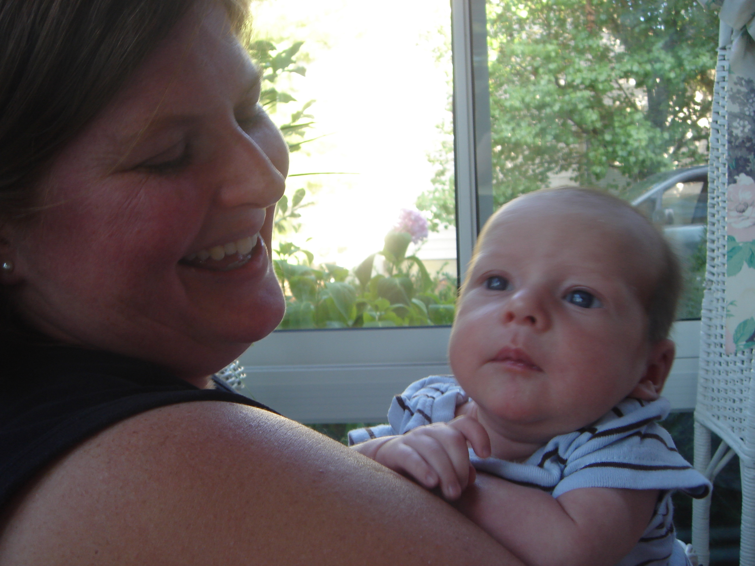
Nina Downs showing off the newest member, Thomas Hassel Downs at our meeting in August.

Facts (and fiction) from Nordic Mythology and Norwegian History
David Letterman has a running sequence in his shows called Fun Facts. To my knowledge, which I admit is somewhat limited; he has never given any substantial attention to Norwegian Fun Facts. I’ll try to rectify this inbalance. So here are some short facts about Norway, some “fun” and some not.
Did you know that …..
- The current king is the first one born in Norway since the country regained it’s independence in 1905. King Haakon VII was a Danish prince when elected king of Norway and his son who became king Olav V was 2 years old when his father accepted the throne.
- Norway has had a female prime minister 3 times. It was the same woman all three times: Gro Harlem Brundtland. She was the prime minister for 8 months in 1981, from 1986 – 1989 and 1990 – 1996.
- The singer Leona Næss is the daughter of Diana Ross and her husband for several years, the Norwegian shipping magnate Arne Næss.
- Edvard Grieg and his wife Nina were cousins.
- Norwegian film industry has had a few contenders for an Academy Award, but only one film has ever won: The documentary “Kon Tiki” which describes the expedition in the Pacific led by Norwegian Thor Heyerdahl.
- Three Norwegians have won the Nobel Prize in Literature. The first one was Bjørnstjerne Bjørnson in 1903. In 1920 Knut Hamsun won the prize and in 1928 it was Sigrid Undset who claimed the prize.
- Norway has hosted the Olympic Games twice; both times it was the winter games. Most of us will remember the 1994 Games in Lillehamer. Oslo was the host in 1952.

Anders Marstrander

Newsletter Information
Our lodge newsletter is sent around the first of every other month (Feb., April, June, etc.). After our editor finishes putting it together, he emails it to Esther who then emails it to those that wish it by email, and mails it to those that wish it by regular mail. Around the same time, Lois puts it on our lodge website.
Perhaps you would like to receive the newsletter by email and save the lodge a stamp. If so, email Esther at esthersofn@aol.com for a test/trial to see if you like it by email. If you are one of those already receiving the newsletter by email, we thank you!

Remember to go to:
website: www.evensens.net/sons/sons.html

President Vice-President
Nelda Chandler Nina Downs
11409 Geneva Rd. 1478 Montegor Dr.
Forest Park, OH 45240 Cincinnati,OH 45230
513-742-9504 513-561-1759
nelda1961@Cinci.rr.com Ninatdowns@fuse.net

Secretary Treasurer
Tillie Elvrum Carol Luiso
6724 Trillium Ct 1006 Paxton Lake Dr.
Maineville, OH 45039 Loveland, OH 45140
513-683-5826 513-683-3631
Elvrumjtj@aol.com Chluiso@aol.com

Social Director Webmaster
Nina T. Downs Lois Evensen
1478 Montegor Dr. P.O.Box 9450
Cincinnati, OH 45230 Cincinnati,OH 45209
513-561-1759 513-281-8408
Ninatdowns@fuse.net Lois@evensens.net

Edvard Grieg Lodge 657 District 5
Cincinnati-Dayton, Ohio
C/O Esther Charlton
3798 Susanna Dr.
Cincinnati, OH 45251

Adopt-A-School Tubfrim
Donna Marstrander Alene Rice
5527 Woodvalley Ct. 2 Forest Pl.
Mason, Ohio 45040-2622 Glendale, OH 45246
513-398-4285 513-771-4378
dmarstrander@gmail.com Clocks@zoomtown.com

Membership Newsletter
Esther Charlton Per Flem
3798 Susanna Dr. 4269 Berryhill Ln.
Cincinnati, OH 45251 Blue Ash, OH 45242
513-923-3798 513-791-8942
Esthersofn@aol.com Perflem@rectomolded.com

Publicity Foundation

Siri Timo Anders Marstrander
6873 Rosetree Pl. 5527 Woodbury Ct
Mason, OH 45040 Mason, OH 45040-2622
513-398-4285 513-398-4285
Siri@Cinci.rr.com Anders@Marstrander.com

