
Edvard Grieg Lodge 657 District 5
Cincinnati-Dayton, Ohio

The First Lodge in Ohio
Sons, Daughters and Friends of Norway
December 2006

Julefest
The biggest and best party of the season is this
coming Saturday, December 9th. This years Julefest will take place at the Goshen United Methodist Church in Goshen (maps are below). Festivities will begin at 4:00PM. If you haven’t sent in your reservation yet you are late, but will be forgiven. Call Esther right away.
The Julefest is going to be a family oriented party with activities planned for kids from 1 to 99! The cost is $10 for adults, $5 for children ages 2-12, and free for children under 2. The lodge will be providing the meat, drinks, and lefse, We’re asking people to bring their favorite Christmas side dish (last name A-G), appetizer (last name H-O), or a dessert to share (last name P-Z).
More information is available on the website(see end of newsletter).
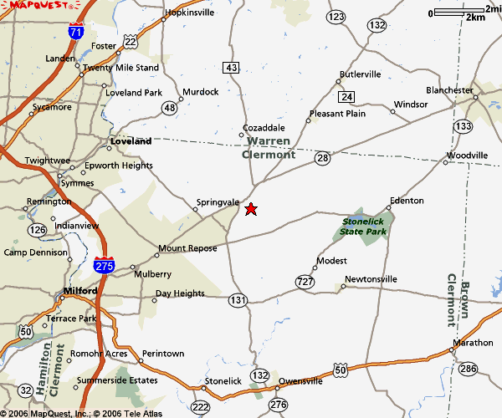

General direction to get you to Goshen.

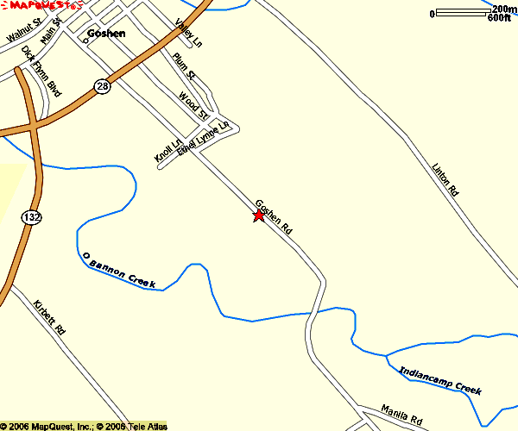
Directions when you get to Goshen.

Nominating Committee
The results of the recent election are:
Nelda Chandler – President
Carol Stone – Vice President
We thank all candidates for their participation in this process, and since each candidate got a significant number of votes, it appears that all were quite popular, a good indicator for future elections.

President’s message
Final notes from Karl…
The calendar bears witness that the days are passing and bringing to a close my time as your President. I want to thank those of you who nominated, elected and supported me during my tenure as President. Your cooperation, understanding and encouragement sustained me going during the difficult times. It has been an eventful six years, four as Vice-President, and these last two years as your President. As Bob Hope said and sang, “Thanks for the memories”.

One person does not a Lodge make, as it takes all of us. It was never my desire for the organization to be “my” Lodge, but “our” Lodge. In the early days of my presidency I sought your advice regarding the direction and desires for the Lodge. I believe I honored what the majority wished. Thank you for respecting the decisions that were made, in what I believed, to be in the best interests for the future of this organization.

As your President, I was gladdened to see us return to more of our Norwegian traditions. Jule Fest, Syttende Mai and Ladies Bunad sewing club have been great for the Lodge. My foremost objective was to make our Lodge a “family of friends” who were “family friendly”. I believe that together, we have succeeded.
Further, I want to thank those of you who graciously opened your homes to the Lodge. I cannot thank you enough for your hospitality. It is my hope that there will always be a place in our Lodge for young families, especially those that have small children, and that we will not lose sight that they are our future.

A word of thanks goes to all of you, you know who you are, who worked so hard behind the scenes to make the Lodge and my Presidency a success. I will not mention any names in order to save embarrassment, but your initials are: Carol, Nina, Sandy, Linda, Diane ,Bob, Kari, Esther, Lois, Nelda, Kjell, Bob, Leif, Helen, Anders, Donna, Susie, Glenn, Les, Alene, Rosalie, Kaleb, Kortney, Korinn, Kathleen, Kris, Tante Signey and of course my beautiful wife, Pam. I especially want to thank Per Flem for keeping us all in touch through the Newsletter. Each of you assumed various duties and that made me look good. The countless hours that you contributed to our Lodge, this is the real story. Thank you from the depths of my heart.
Finally, I hope that you will join me in congratulating our new President, Nelda Chandler. She brings a wealth of leadership experience and much talent to the office. I know you will give her your courtesy and cooperation as she assumes her new role of President.

God bless you, warmest wishes this Christmas season and in the coming New Year.
Beste Hilsen,
Karl

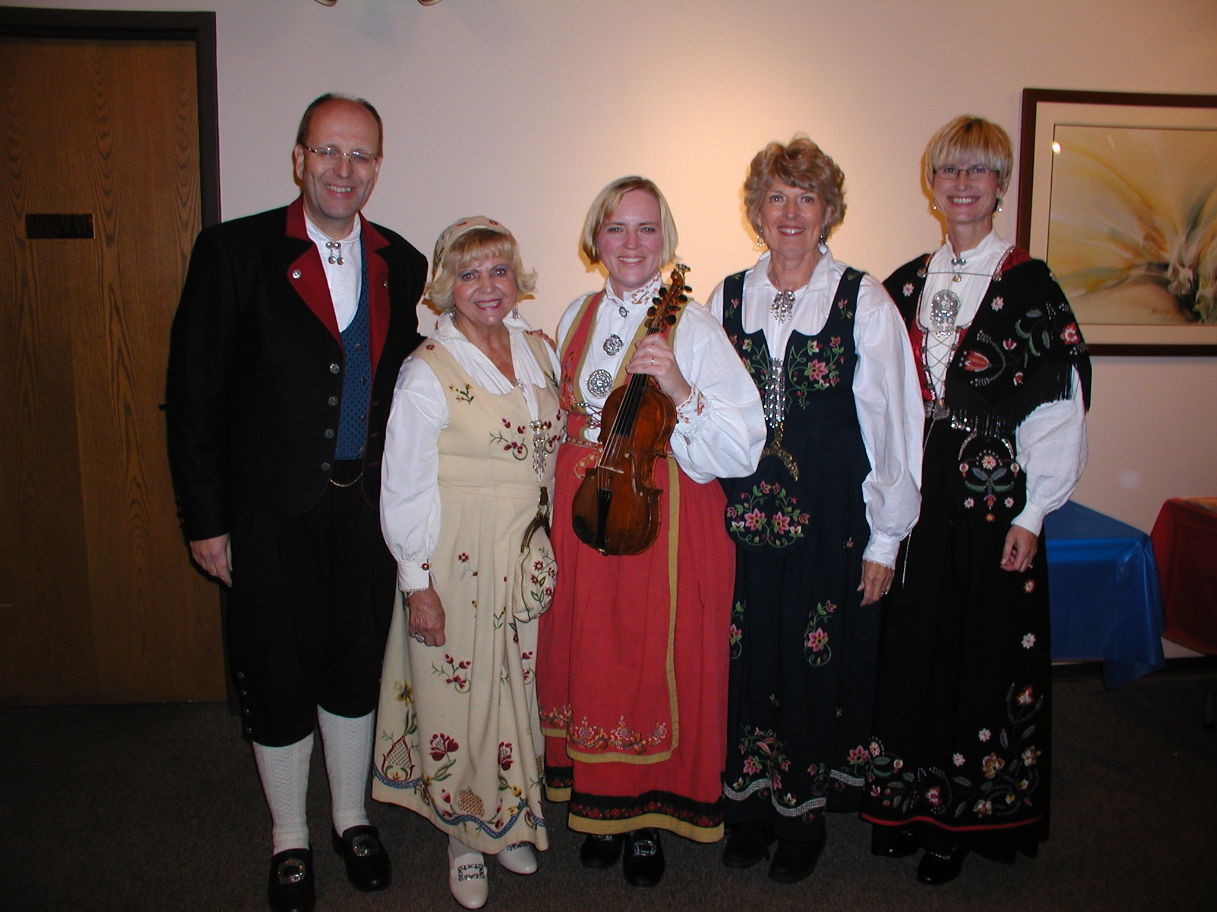
This picture, taken during our Hardanger Concert in November, has Anders Marstrander, Kari Poe, Karen Torkelson(with Fiddle), Carol Luiso, and Siri Timo in full Bunad Regalia. Picture by Carol Stone.

From Donna:
You know you‘re in Norway when…….
You find the worlds best hotdogs wrapped in a lompe served exclusively at locally owned …..gas stations.
Donna Marstrander

January 20th Meeting
The regular lodge meeting will be a late lunch (2:00P.M.) and will take place at Parker’s Grill at 4200 Cooper Rd. in Blue Ash. Speaker will be Burt Bittner, a district director from Sons of Norway. Installation of Officers will take place. A limited menu will be available, and can be seen on the website soon. Please email or call Nina Downs with reservations.
Telephone#513-561-1759
Email: ninadowns@fuse.net

Membership
New Members
We welcome three Heritage members. At our last "Meet & Greet", we received applications from Hannah Hoetger,(daughter of Siri Timo), and Cassi and Edwin Rice,(grandchildren of Alene Rice).
Jack Trefzger, who joined Sons of Norway at a festival booth while traveling, is now a member of our lodge. He lives in the Montgomery area.
While calling to find out about Julefest, we found out that Gretta Hahn and her husband will be in South America at that time, we will miss them. New member Charlotte Ellingson had recent surgery and is still on the mend, so is sorry that she will miss Julefest.
If you have encountered, or heard of someone that may be interested in Sons of Norway, please give me their names and address, so that information may be sent to them.

Service Pins
At this time, the end of our 6th year as a Sons of Norway lodge, we would like to congratulate those members receiving service pins.
Joyce Kosobud, Mark Kosobud and Gary Morem will receive 10-year pins.These people were all members of Sons of Norway before we organized our lodge.
These members will receive 5-year pins: Bob Charlton, John Ericksen, Trent French, Glenn & Sonja Kinney, Donna Marstrander, Luke Sutphin and Kristin Szava.
The pins will be presented at the January 20th lodge meeting, when our new officers will be installed.

Thanks, Esther Charlton

"Meet and Greet" & Celebrate!
Please come to our next "Meet and Greet" on December 29, in the IHOP at 9450 Colerain Avenue. This is a celebration of our lodge's 6th Anniversary, and a chance to wish each other a Happy New Year a few days early.
"Meet and Greet" is a time for a casual meal and talk about our connection to Norway. We welcome new members into the lodge. We have met at Perkins, Panera Bread and IHOP so far. We are always open to suggestions for future locations.
Please RSVP to Esther, by December 27, if you plan to celebrate.
Birthdays

December
Lois Evensen[5], Susan Mikaloff[7], Kari Poe[8], Charlotte Ellingson[9], Esther Charlton[12], Ed Charlton[13], Richard Monson[14], Neil Sorum[15], Carol Olson[16], Konrad Nelson[29].

January
Francis Kosobud[1], Ray Olson[1], Adelheid Price[19], Kelly Lawson[28], Willy Tychesen[28], Margie Mays[29], Donna Marstrander[30].

February
Luke Sutphin[1], Jan Garnaes Johnson[6], Patsy Bannick[6], Sylvia Casas[15], Linda Burge[17], Cassi Rice[19], Jo Marie Karam[20], Mark Kosobud[20], Nicholas Karam[25], Carol Mostad[27].

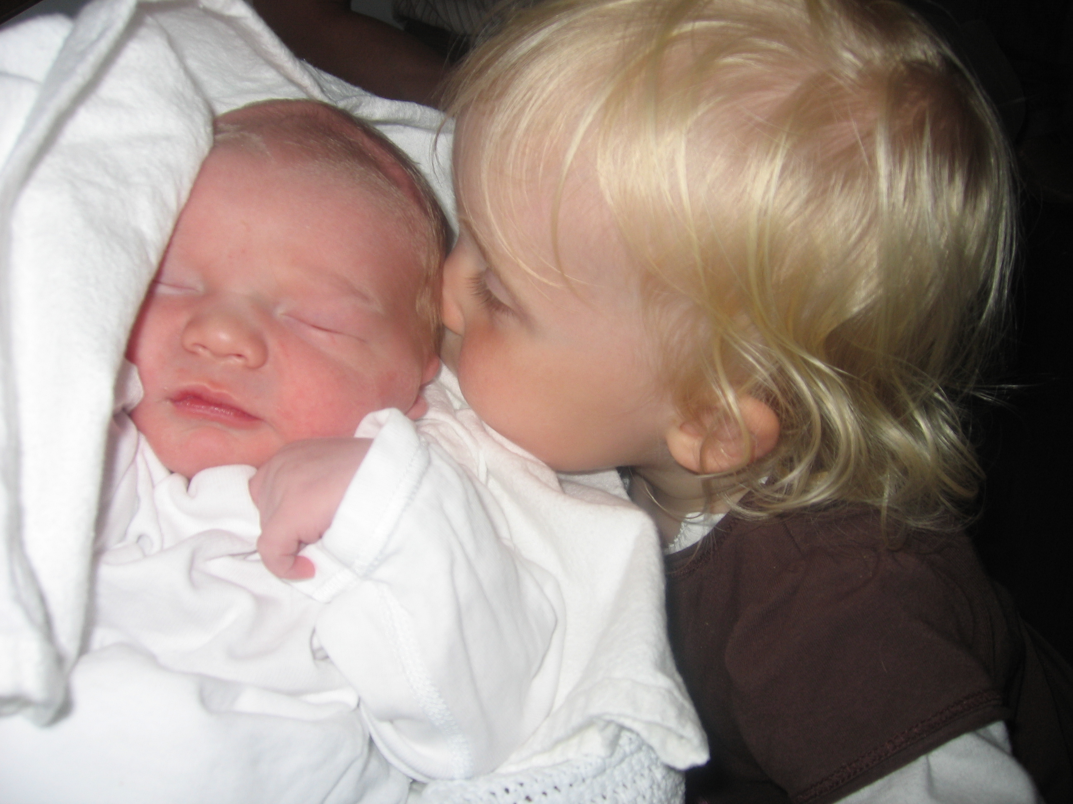
Since I have received no baby pictures, I’m going into my own files: Sigrid Odegard, meeting her 5 hour old brother Andor, last August. They live just outside of Alesund. Picture by proud father Jarle Odegard, my second cousin. Editor.

Remember to go to :
website: www.evensens.net/sons/sons.html

President Vice-President
Karl Flem Nelda Chandler
9436 Morrow-Woodson Rd. 11409 Geneva Rd.
Pleasant Plain, OH 45162 Forest Park, OH 45440
513-877-3005 513-742-9504
Flem1973@Yahoo.com Neldandelma@earthlink.net

Secretary Treasurer
Rosalie Wingler Carol Luiso
7983Quail Meadow Ln. 1006 Paxton Lake Dr.
West Chester,OH 45069 Loveland, OH 45140
513-779-2166 513-683-3631
rwingler@fuse.net Chluiso@aol.com



A Christmas tree, hundred years old, and 85 feet high, the annual gift to the city of London England, was cut down last Thursday in Oslo. This annual tribute is in remembrance of England’s help during World War II. Picture by: Bjorn Sigurdson, from Aftenposten.

Edvard Grieg Lodge 657 District 5
Cincinnati-Dayton, Ohio
C/O Esther Charlton
3798 Susanna Dr.
Cincinnati,Oh 45254

Social Chairman Webmaster
Nina T. Downs Lois A. Evensen
1478 Montegor Dr. P.O.Box 9450
Cincinnati, OH 45230 Cincinnati,OH 45209
513-561-1759 513-281-8408
Ninatdowns@fuse.net Lois@evensens.net

Adopt-A-School Tubfrim
Donna Marstrander Arlene Rice
5527 Woodvalley Ct. 2 Forest Pl.
Mason, Ohio 45040-2622 Glendale, OH 45246
513-398-4285 513-771-4378
Donna@Marstrander.com Clocks@usadatanet.net

Membership Newsletter
Esther Charlton Per Flem
3798 Susanna Dr. 4269 Berryhill Ln.
Cincinnati, OH 45254 Blue Ash, OH 45242
513-923-3798 513-791-8942
Esthersofn@aol.com perflem@RectoMolded.com

