
Edvard Grieg Lodge 657 District 5
Cincinnati-Dayton, Ohio & N. Ky.

The First Lodge in Ohio
Sons, Daughters and Friends of Norway
December 2007

Ord fra presidenten…
I hope you all had a great Thanksgiving. We all have so much to be thankful for, and I know I don’t say it often enough. We are all so busy at this time of year, so many activities. I sometimes wonder how to fit them all in the schedule.

Fall? Winter? Whatever, it is finally here. The leaves from my trees have fallen and my back yard isn’t green anymore. It is yellow, and rusty, solid leaves. Anybody want leaves? I will gladly share.

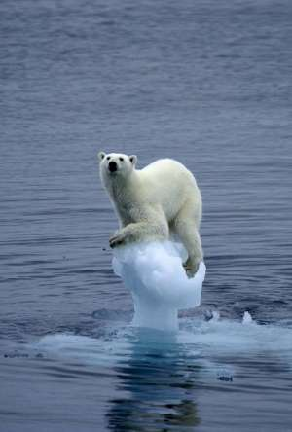
This picture from Aftenposten, was taken by Arne Nævra, east of Barent’s Island. Arne won second place in a Shell Wildlife competition at London’s Natural History Museum.

If you missed the last meeting at the Marstranders’ you missed an excellent program on Viking mythology. Anders and Kjetell both provided some
interesting facts about the gods and goddesses of Viking history. You also missed the one thing that is always good when we get together, the food.
Are you ready for our Juletrefest? We have discovered we have been calling it Julefest and that is not correct. The plans are made and we are feverishly working to make this the best yet. Some committees could still use some help. Sandy Nelson is handling the gift table and has many items for sale. We have cookbooks from District 5, that are really nice. We will also have calendars with Norwegian pictures on each month’s page. Norwegian cookies again will be sold, and that is one place we could use help. I hope to see all of you there,, it will be a great evening. Nina Downs and Carol Luiso and the co-chairs and have done a fantastic job. Contact them or myself if you would be willing to help.
We will also be celebrating the 7th anniversary of our Edvard Greig Lodge. In some ways it seems like yesterday we began and yet we have come a long way. We have studied many aspects of our Norwegian Heritage, and have learned about the culture of our ancestors. Some of us are learning about Rosemalling, so there is more about that in another area of the newsletter. I am really enjoying the painting, I certainly have a lot to learn and hope we can have more classes as we go along. A cultural director is a vacant position on our board, and we could use some help. There are guidelines sent out by Sons of Norway to help, and a great deal online to facilitate programs about our cultural heritage.
If anyone is interested please contact me, I will be glad to help. In some instances,, you and the program director (Nina) would work together in planning programs.
Have a very Merry Christmas and a great New Year. See you at Juletrefest!
Beste hilsen
Nelda

Future meetings
January Syklubb meeting. Our Next Syklubb, (Sewing Club) meeting will be held on Jan. 13, 2008 at 2:00 pm at the home of Nina Downs, 1478 Montegor Drive, Cincinnati, Ohio 45230. RSVP to Nina 513.608.0364 or ninatdowns@fuse.net. Bring

something you are working on, and get together for some friendship and laughter!
Lodge Meeting:January 19 at 4:30PM.
Join the crew as we relive the adventures of a dream and sail a Viking ship across the
Atlantic to Norway! We will meet Jan 19, 2008 at 4:30 at The New England Club, 8135 Beechmont Ave, Cincinnati, OH 45255.
In 1971, Robert Asp, a guidance counselor at the high school in Moorhead, MN, had a dream. His dream was to honor his Norwegian heritage and build a Viking ship to sail to Norway. He named the ship Hjemkonst (Yem-komst) meaning Homecoming.
While building the Hjemkomst, Mr. Asp was diagnosed with leukemia. With determination and help from family and friends, the Hjemkomst was completed in 1980. Today, this ship is housed in the Hjemkomst Center in Moorhead, MN.
"The Hjemkomst of Robert Asp", a half hour documentary, became available this fall and is an inspiration to young and old. Mark your calendar. You won't want to miss the voyage!
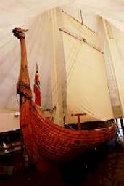
Hjemkomst Viking Ship John Borge, Photographer

February meeting, at day at the slopes.
Come join us for a Norwegian day of skiing, sledding, or tubing. We will meet at Feb. 16, 2008 at 10:00 at Perfect North slopes, 19074 Perfect Place Lane, Lawrenceburg, IN 47025. For details go to www.perfectnorth.com or call 812.537.3754. Group rates apply if 15 or more people will be skiing. If you don't want to battle the slopes, come join us for card games and coffee in the Lodge! RSVP to Nina at ninatdowns@fuse.net or 513.608.0364.

Reading Circle
Several members have shown an interest in forming a Reading Circle. We would read books by Norwegian and Norwegian-American authors as required under the Cultural Skills Program, and gear our meetings toward acquiring this badge.
Helen Hippert, has enthusiastically recommended the book "Out Stealing Horses" by Per Petterson. This book was featured on the last page of the Nov. '07 issue of our Viking magazine and would be our first read. Put it on your Christmas list!
If you are interested in participating in the Reading Circle, contact Carol Luiso at 513.683.3631 or CHLuiso @aol.com. Our first meeting would be on February 3, 2008 at 2:00 at the home of Carol Luiso. This will be an informal meeting and besides discussing our first selection, we will discuss when and where we would like to meet in the future as well as books we are all interested in reading.
From the Norwegian Embassy in Washington, DC
Tree Lighting
Norway is pleased to present a 32-foot tall Christmas tree as a gift to the people of Washington, D.C. The tree is a symbol of friendship between the United States and Norway. It also expresses Norway’s gratitude for assistance received from the United States during and after World War II. Holiday songs will be performed by the nationally recognized Children’s Chorus of Washington, which represents over 100 schools in the metropolitan Washington area.
When: Thursday, November 29, 6 p.m. The tree will be up through December 27.
Where: Union Station, Main Hall, 50 Massachusetts Avenue, N.E., Washington, D.C.
Admission: FREE, no tickets
Info: (202) 333-6000


For the 10th year in a row, the Norwegian Government gives a 30-foot tall Christmas tree as a gift to the people of Washington, D.C.Photo: Arild Strømmen
BAZAAR
Norwegian-American Holiday Bazaar
Norwegian-American organizations host a shopping extravaganza featuring traditional crafts from Norway, including hand made items, jewelry, calendars, trolls, dolls, holiday ornaments, pewter items, sweaters, and food.
When: Friday, December 7, 10 a.m.-7 p.m. and Saturday, December 8, 10 a.m.-3.30 p.m.
Where: Union Station, Main Hall, 50 Massachusetts Avenue, N.E., Washington, D.C.
Info: (202) 333-6000
CONCERTS
Grieg Competition at Levine School of Music
Levine’s top piano, string and vocal students will perform music by Edvard Grieg in a competition sponsored by the Norwegian Embassy. The event is in recognition of the 100th anniversary this year of Norwegian composer and pianist Edvard Grieg’s passing. The competition will be followed at 4 p.m. by an award ceremony and reception.
When: Saturday, December 1, 1:30 p.m. – 5:00 p.m.
Where: Levine School of Music, Jane Lang Recital Hall, 2801 Upton Street N.W., Washington, D.C.
Admission: FREE, no tickets
Info: (202) 686-8000 or www.levineschool.org/

Membership News
We have Hostfest(in Minot, North Dakota) to thank for our newest members. When Carol Luiso was there she signed up her son Lee Luiso, and her four grandchildren as Heritage members. Our newest Heritage members are Maria Luiso(5), Megan Luiso(11), Michael Luiso(2) and Taylor Luiso(14) and we hope to see all of them at Julefest with their parents. When I checked the membership list I also found Sharon Baglein. When contacted, she told me that she was at Hostfest as well and joined at the Sons of Norway booth! Sharon lives in Western Hills and is looking forward to being involved with our lodge.
At the end of our seventh year as a lodge we are delighted to present 5-year service pins to five of our members, Margie Mays, Anders Marstrander, Judy Merrick, Ordelle Hill and Diane Flautt.
With the holidays upon us, think about giving the gift of membership to Sons of Norway. It is a gift of heritage, culture and traditions of Norway. Let me know if you need an application for a gift membership and I will help you with the process. This will need to be done by December 15, which is our Juletrefest.
As always, if you learn or know of someone who may be interested in our lodge, do pass along their name to me.
Esther Charlton, Membership Secretary

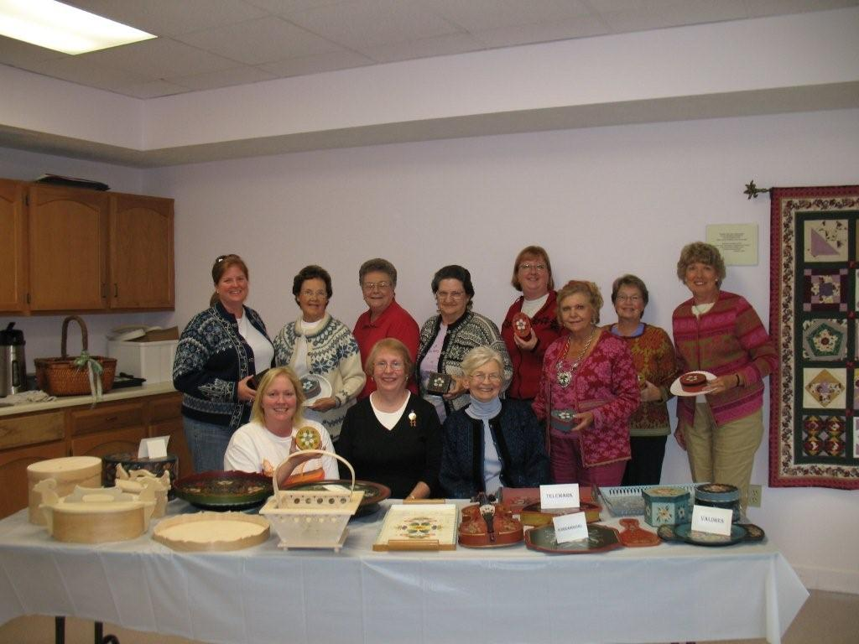
Rosemaling members. Standing: Nina Downs, Marlene Hanson, Sonja Kinney, Nelda Chandler, Rosalie Wingler, Kari Poe, Sandra Nelson, Carol Luiso
Seated: Donna Marstrander, Sally Hurst (Instructor), and Donna Kent

Rosemaling Class
A beginners Rosemaling Class was held Oct 20, 2007 with ten members participating.
Rosemaling means "decorative or flower painting" and is one of the most practiced Norwegian folk arts. It consists of scrolls, taken from the acanthus vine, and stylized flowers. The styles vary depending upon the area of Norway where they originated.
Rosemaling was used to decorate homes and objects used in the home. It was usually done on wood.
Nina Downs, our Social Director, obtained an instructor, applied for and received a grant from Sons of Norway, and purchased all the supplies for us. Mange takk, Nina!
Our instructor was from Indianapolis and taught us the Hallingdal method of rosemaling. At the end of the workshop, we each had painted a small box to take home. Our "masterpieces" will be on display at the Julefest. We have continued to meet to and practice together. Anyone who was unable to take the class, but is interested in joining us is welcome. We will give you the beginners "crash course"! Please contact Nina at 513.608.0364
Facts (and fiction) from Nordic Mythology and Norwegian History by:Anders Marstrander
Under this headline I will try to share with you some facts from Norwegian history, some stories and legends from Nordic Mythology and other tales where the fact part of it may be a little disputed. My plan is to write a repeating column for every newsletter for as long as I have something to share.
Sometimes it may be a story that I tell with my own words, I find that by doing it that way it gets easier to understand than if I just transcribed something from the old manuscripts. I am free to adjust a little and thus make it easier to understand for those who are not familiar with Norwegian geography in detail and the social life and structure of the time. This sounds very serious, so I will start this month by telling a rather strange story about King Halvdan Svarte.

Halvdan Svarte (Halvdan the Black from his black hair, 810 AD – 860 AD) was the ruling king of a large part of eastern Norway from south of Oslo to the northen end of lake Mjøsa. He was well liked by the other powerful men under him. One winter he
had been to a large party at one of the farms at Hadeland, when it was time to return home he got into his sled and had the horses pull him across the ice on the lake Randsfjorden. During the winter the local farmers had led their cattle out on the ice where they could drink from a hole in the ice. The cattle had done like cattle do, they had left their droppings on the ice. When Halvdan traveled across the sun had started to do its work on the ice and where the cattle droppings were the ice had melted down to just a thin sheet. This is where Halvdan was crossing. The ice broke underneath his sled and he drowned there.
When the people learned that Halvdan had died they all wanted him buried in their area. The most powerful of the men in his kingdom gathered together and finally agreed that all would have to share the good fortune of having the king buried in their area. They then decided to cut the body in four parts, one area got the head, another area the torso, the third area got his legs and the arms ended up in the fourth area. All four parts were buried in large mounds and they are still called “Halvdanshaugen” (The Halvdan mound). One of them is at Hadeland, not far from where I grew up, and very appropriate they have built an outdoors historic museum there. Also, one of the oldest churches in the area (St. Petri, 1220 AD) was built next to this Halvdanshaug. This was a natural development since people were already used to traveling to this place and the roads were in good shape.
Halvdan’s oldest son was Harald. His most famous nickname was “Luva” (uncombed), after his death this was changed to “Hårfagre (Fair hair). He was the king that conquered the other regional kingdoms in Norway and “founded” Norway as one
kingdom. We will hear more about him in a later article.

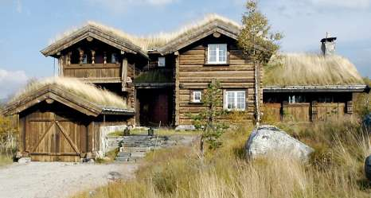
As Norwegians become more comfortable economically, the “Hytte life” is changing dramatically. Some hytte’s are bigger and grander than the regular home. This picture by Eva Kylland is from a new series in Aftenposten showing some beautiful interiors as well.

Birthdays:

December
Lois Evensen[5], Susan Mikaloff[7], Kari Poe[8], Charlotte Ellingson[9], Esther Charlton[12], Ed Charlton[13], Richard Monson[14], Neil Sorum[15], Carol Olson[16], Konrad Nelson[29].

January
Francis Kosobud[1], Ray Olson[1], Carolyn Hahn[4], Connie Holman[10], Matthew Wingler[18], Adelheid Price[19], Alex Culpepper[21], Kelly Lawson[28], Margie Mays[29], Donna Marstrander[30].

February
Luke Sutphin[1], Jan Garnaes Johnson[6], Patsy Bannick[6], Lee Luiso[12], Sylvia Casas[15], Linda Burge[17], Cassi Rice[19], Mark Kosobud[20].

Remember to go to:
website: www.evensens.net/sons/sons.html

Upcoming Events:
Juletrefest, Saturday December15th at 4:00pm.
Syklubb, January 13th at 2:00pm.
January 19th lodge meeting “.Trans Atlantic trip in a Viking Ship”.

President Vice-President
Nelda Chandler Carol Stone
11409 Geneva Rd. 224 Countryside Dr
Forest Park, OH 45440 Lebanon, OH 45036
513-742-9540 513-228-0245
nelda1961@Cinci.rr.com cm8stone@yahoo.com

Secretary Treasurer
Rosalie Wingler Carol Luiso
7983Quail Meadow Ln. 1006 Paxton Lake Dr.
West Chester,OH 45069 Loveland, OH 45140
513-779-2166 513-683-3631
rwingler@fuse.net Chluiso@aol.com

Social Director Webmaster
Nina T. Downs Lois Evensen
1478 Montegor Dr. P.O.Box 9450
Cincinnati, OH 45230 Cincinnati,OH 45209
513-561-1759 513-281-8408
Ninatdowns@fuse.net Lois@evensens.net

RSVP now for Juletrefest

Edvard Grieg Lodge 657 District 5
Cincinnati-Dayton, Ohio
C/O Esther Charlton
3798 Susanna Dr.
Cincinnati, OH 45251

Adopt-A-School Tubfrim
Donna Marstrander Alene Rice
5527 Woodvalley Ct. 2 Forest Pl.
Mason, Ohio 45040-2622 Glendale, OH 45246
513-398-4285 513-771-4378
dmarstrander@gmail.com Clocks@usadatanet.net

Membership Newsletter
Esther Charlton Per Flem
3798 Susanna Dr. 4269 Berryhill Ln.
Cincinnati, OH 45254 Blue Ash, OH 45242
513-923-3798 513-791-8942
Esthersofn@aol.com Perflem@rectomolded.com

Publicity Foundation

Siri Timo Anders Marstrander
6873 Rosetree Pl. 5527 Woodbury Ct
Mason, OH 45040 Mason, OH 45040-2622
513-398-4285 513-398-4285
Siri@Cinci.rr.com Anders@Marstrander.com

