
Edvard Grieg Lodge 657 District 5
Cincinnati-Dayton, SW Ohio & Kentucky

The First Lodge in Ohio
Sons, Daughters and Friends of Norway
December 2009

December meeting; Jultrefest
The Fifth Annual Jultrefest will be held on December 5th, beginning at 4:00pm and going to 7:00pm at Friendship United Methodist Church 1025 Springfield Pike, Wyoming. This ”Norwegian Family Celebration”, is a major lodge meeting, where everyone shows up. Children under 5 are free, adults $5.00, with the lodge providing the main course and members bringing appetizers and desserts. This event is focused on the children, and provides a glimpse of Norwegian customs during a favorite holiday. RSVP with Esther, 513-923-3798, or Esthersofn@Aol.com .

NORSK BUTIKK
NORWEGIAN BOUTIQUE
DECEMBER 5, 2009
At JULTREFEST
The “Best Little Norwegian Shop!”
Come and enjoy a very fine collection of items for
sale at the Norsk Butikk!
All items will be very reasonably priced…bring your holiday shopping list! There will be
something for everyone, young and old, male and female!
Besides any holiday goodies you may find, you will also see a great selection of items for
yourself, your family and your home.
Highlights include linens, candles, home décor, books, music and more. Stocking stuffers
Galore! There may be some vintage Norge items and special and unexpected finds. The variety of
this year’s items is vast.
Looking toward the Christmas holiday and planning your shopping list…see what the Butikk has
to offer. We think you will be very pleased and surprised!
God Jul to alle and hope to see you there!

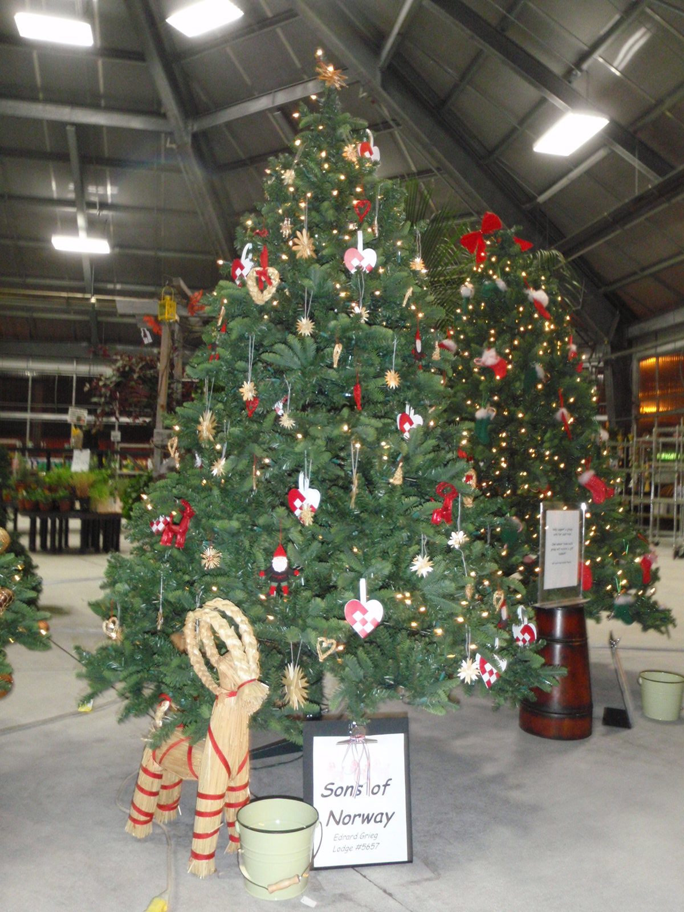
Nina and Diane decorated this beautiful Christmastree at Jungle Jim’s. Read the article further into the newsletter for details. This picture needed to be in the middle of Jultrefest. Thanks for the picture Nina.

January Meeting
On January 16,2010 we are invited to Donna and Anders home at 5527 Woodvalley Ct in Mason at 4:00pm, where Anders will describe the relationship between Sweden and Norway. RSVP Anders at 513-398-4285

Presidents Message
Greetings to our Sons of Norway Members! The Edvard Grieg Lodge has had a very busy fall.
In October, our first annual Waffles and Raffles meeting was a huge success. Anders Marstrander and Nina Downs served the most delicious waffles with all the traditional Norwegian accompaniments. At each of their waffle stations our members had the opportunity to contribute to the Sons of Norway Foundation. Sandy Nelson, our host for the meeting and Raffle Chair, put together a wonderful array of raffle items…I think we had one of our most successful raffles ever. In fact, at the conclusion of our meeting the Edvard Grieg Lodge had raised enough money to bring our yearly donation to the Sons of Norway Foundation to five-hundred dollars! Thanks to all of our members who have given so generously over the past year to our raffles, fundraisers, and of course to our Pass The Piggy efforts. Carol Luiso has done a wonderful job in keeping our lodge up to date on the Sons of Norway Foundation and all of the work that they do.
On November 7th, I had the opportunity to meet with some of our Lodge’s newest members, the Johnson Family from Lebanon, Ohio. We are so excited to have them join us and look forward to getting to know them better – be sure and say “Hei” to them at Jultrefest.
We also had a great turnout for our Norwegian Folk Dancing workshop on November 14th. Thanks to everyone who came out to learn and try something new. Harry Khamis was a very knowledgeable and engaging instructor. I learned a lot and I hope you did, too. Thanks to Nina for organizing the event at her church.
As we come upon the close of the year, I encourage all of our members who are working on their Cultural Skills and Sports Medals to get their paperwork in. You’ve all been working hard and I look forward to awarding your Medals at future meetings. Also, do you have a friend or relative that would appreciate the gift of membership to Sons of Norway…Christmas is right around the corner and this is the perfect opportunity to get your friends and family signed up! Who wouldn’t want to find the latest Viking Magazine in their stocking on Christmas morning?!!?
That is all for now, Tillie, J.D., and I look forward to seeing you all at Jultrefest on December 5th. As always, if you have any questions or concerns please feel free to call me at 513-683-5826 or email me at Elvrumjtj@aol.com.

Respectfully,
Jerry Elvrum

A place to do some Christmas shopping:

www.norwegiantees.com

From Nina Downs.
“Visit the Garden Center at Jungle Jim's and see our organizations decorated tree! The greenhouse is next to the Shasta Gift Shop. Take a minute to fill out an entry form, and be entered into a drawing for a gift basket. They will be drawing a gift basket for each tree decorated. Remember to write your name and telephone number on the form so you can be notified if you are a winner. You may enter once for each time you visit Jungle Jim’s, from now until January 1st. They will pick one winner from each tree on January 2, 2010. The winners will be notified by phone.”


MagnusCarlson. Picture by Rolleiv Solholm,story bu Norway Post.
Norweigan Chess master
Norway's chess ace Magnus Carlsen (19) now tops the unofficial world ranking list, after he beat Hungarian former world champion Peter Leko in the last match of the Tal Memorial chess tournament in Moscow on Saturday.
Russian Vladimir Kramnik took clear first place in the Moscow tournament with 6/9, half a point clear of Ukraine's Vassily Ivanchuk and Magnus Carlsen. Aronian beat World Champion Viswanathan Anand

in the final round and Magnus Carlsen won his second game in a row.
Reading Circle (Book Club)
We've been reading many Norwegian related books and one of our favorites was In Cod We Trust:Living the Norwegian Dream" by Eric Dregni. Eric received a Fulbright Fellowship to study at the University in Trondheim. There are many amusing experiences Eric, his wife and new born baby have the year they lived in Norway, the land where Eric's great grandfather was born.

Next meeting: Saturday, Jan 9, 2010 at 2:30 P.M. Panera Bread, Mason Montgomery Rd., Mason, OH
We will discuss Beyond Sing the Woods by Trygve Gulbranssen. This is the first book of a trilogy.
New members are always welcome.



Come to Jultrefest and see for yourself how Jerry does all of the cooking by himself…

Membership Service Pins
Service pins are awarded for each five years of membership in Sons of Norway. Because our lodge was organized and formed over 2000 and 2001, we will be presenting a large number of 10-year pins, this year and next year.
Our lodge has members that joined Sons of Norway in other areas and moved to our area and people that joined as members at large, prior to the formation of our lodge. Therefore, we have members that will receive membership pins for 15, 20, 25 and 35 years respectively.
The pins will be presented during the program of our Juletrefest.
If you have any questions about the membership service pins, please contact me.
Esther Charlton

Membership
To Linda Burge, a huge “thank you”! She has given the gift of membership to four people. Her gifts include her daughters, Leah Burge Sedler, and Jennifer Burge Reeder, sister-in-law Carole Hanson Burge and cousin Marlene Opsahl Kennedy. Linda has also signed up her three grandchildren, Dominic, Charlie and Anna as Heritage members.
Larry Bannick has signed up his granddaughter Ciera Bannick as a Heritage member.
According to Burt Bittner, District Vice-President, our lodge does better then most lodges. We keep gaining in membership. At the moment we are at 125 members and if some of our potential/prospective members submit their applications soon, we could have over 130 members at the end of the year.
Remember that our lodge recruitment contest deadline is December 1. Recruit a new paying member or give the gift of membership by 12/1, and you will receive a gift from the lodge at Juletrefest.
If you have any questions about recruiting members, contact me.
Thanks, Esther Charlton, Membership Secretary

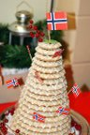
Typical fare at Jultrefest

Foundation News
Mange takk to all who attended the October meeting and generously supported the fundraiser for the Foundation. The raffle items were wonderful and waffles delicious! All proceeds from the afternoon and the "Piggy" we've been passing around at the meetings, were sent to the Foundation.
Since 1966, the Sons of Norway Foundation has awarded over $900,000 in 335 grants and over 2,000 scholarships to members, lodges and communities.
Fraternally,
Carol Luiso, Foundation Chair

2009 Raffle Report
Tusen takk til alle who donated items, and/or baked a Norwegian goodie for our raffles this year. They are: Linda Burge, Esther Charlton, Nina Downs, Tillie Elvrum, Yvonne Iversen, Lance Larsen, Carol Luiso, Anders Marstrander, Susie Mikaloff, Diane Person, Pat Schott and Karen Watts. A few 2008 unsold Norsk Butikk items were utilized as well.
We held six raffles and made a total of $487.00. Out of this total $119.00 was donated to the Foundation and $29.21 was the expense of purchasing some items. Our profit of $338.79 was deposited into the general treasury of our lodge.
Sandy Nelson
2009 Raffle Chairperson

President Obama visits Norway.
President Barack Obama visits Norway on December 10th to accept the Nobel Peace Prize. National media will most likely cover the event, but there are some interesting facets that make this trip a little different than other countries he has visited, or what other visitors might encounter.
The President usually has his vehicles “registered” in the country that he is visiting. In Norway, this fee amounts to $700,000/car due to weight (armor cladding), and large engine (fuel consumption). A “loaner registration” will be offered.

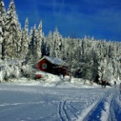
The president will probably not stay here.

Unlike Britain, Saudi Arabia and Japan, bowing to the Monarch is not likely to occur.
More than likely, the President will miss the luxurious trip from Gardermoen to Oslo on the high speed train. For Americans, this high class accommodation by train is a significant contrast to trip on a Chicago train.
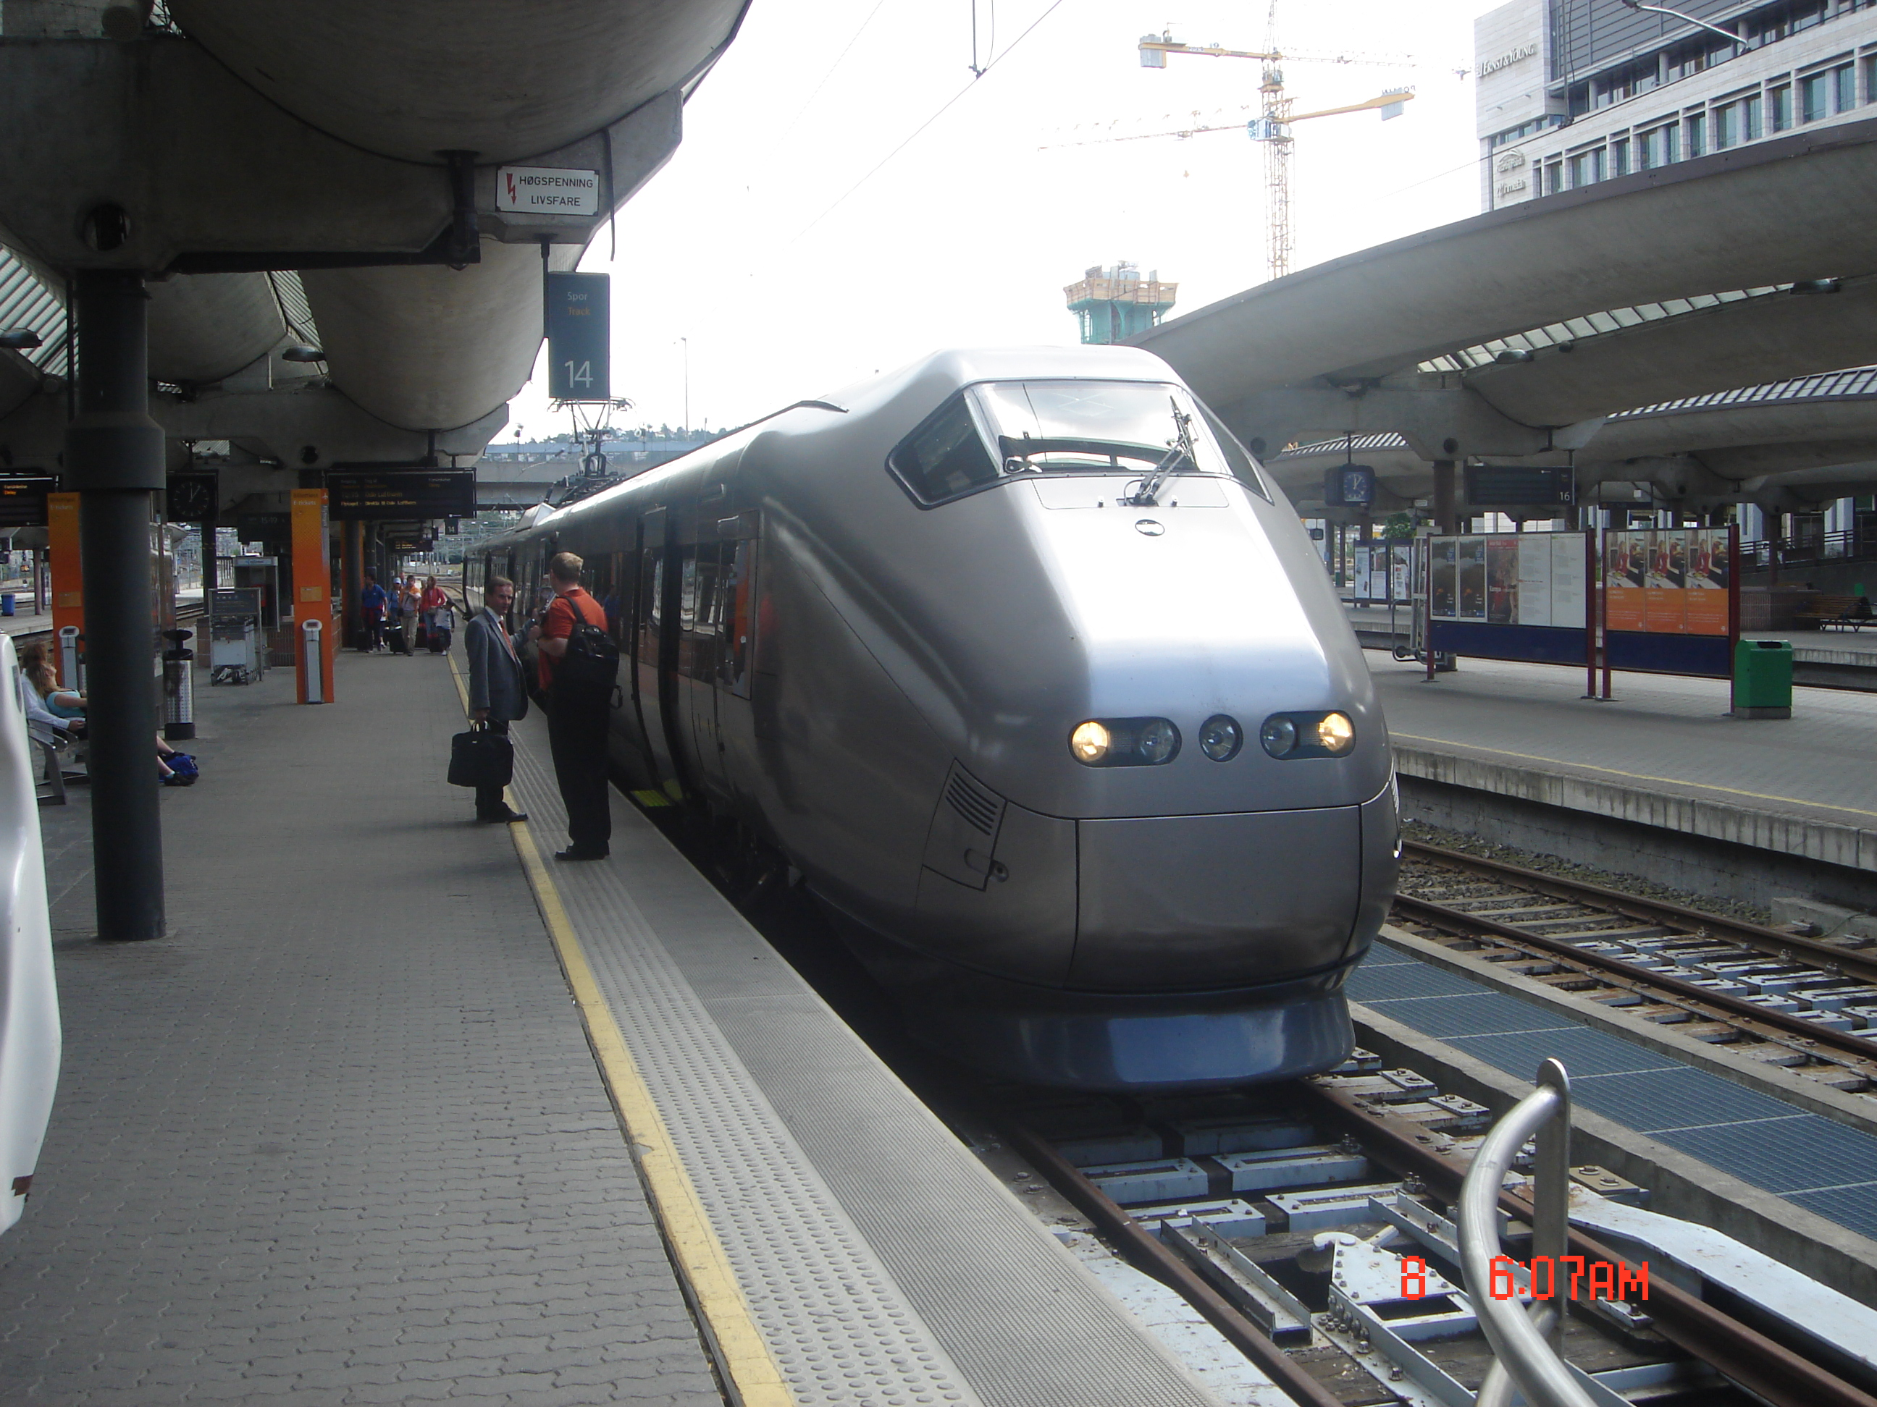
Train from Gardermoen to Oslo

A few facts for the President to remember:
There is no majority associated with a specific political party. The most popular currently is the Labor Party with 33.3%. Other parties rank no higher than 22%.The country is ruled by a coalition government, largely determined by the popularity of the numerous (8) and varied parties. These represent the spectrum from right to left, green to whatever. Conservatism, at least by Norwegian standards is on the rise currently. It is astonishing that anything gets done.
The majority of Norwegians prefer to remain outside of the European Union at this time.

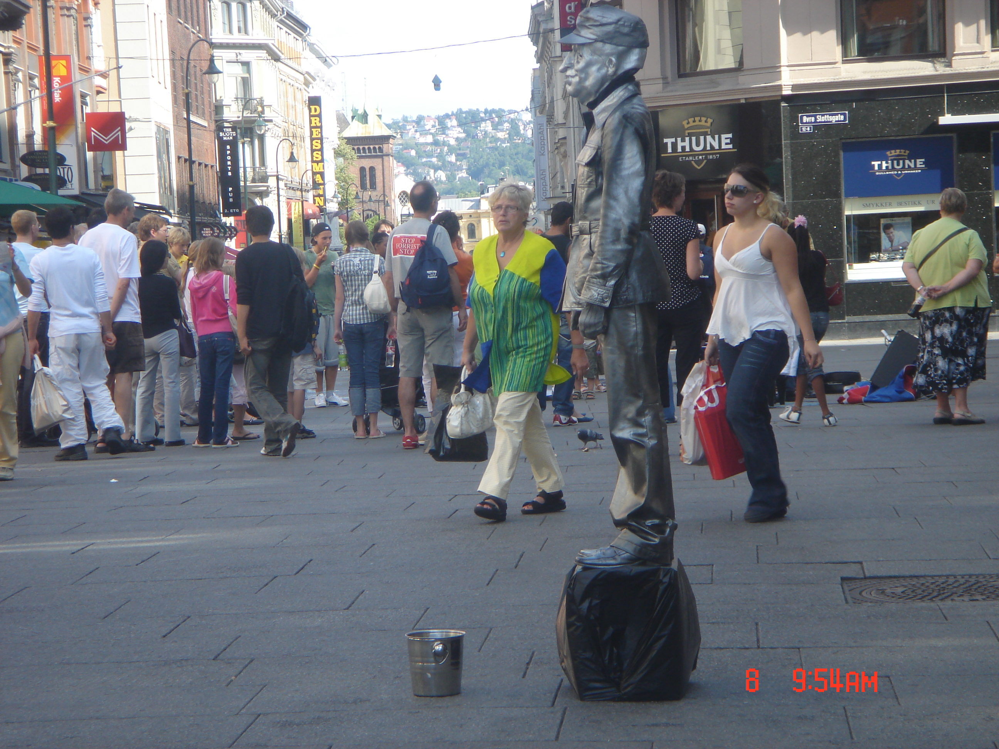
Will the President meet this iconic panhandler?

While the majority see themselves as “green”, wanting the country to be responsible for providing the next generation with the same access to a clean environment, there is little objection to drilling for gas and oil offshore. In fact the industrial infrastructure for supporting the drilling is a major employer. Oftentimes “wind parks” are voted down

by local citizens. Nuclear electric generation does not take place. A dry period means higher energy costs because hydroelectric capacity is diminished.
Norway, and its citizens do not fit any typical American stereotypes.
What may seem familiar is pizza. Norwegians eat more frozen pizza per capita than any other country, with chocolate and ice cream top favorites. Moose, whale steaks, goat cheese and reindeer maybe not so familiar. Don’t forget sardines or herring for breakfast.

Call for assistance
Channel 48 “WCET” has contacted us, in hopes that some of us may be able to answer phones during their coming membership drive. When we do this, they do announce the groups of the people helping. I will list some of the times they need help and if you can help, you can call Sharon Roehm at 381-4033, ext 323, and let her know that you are a Sons of Norway member.
  - 6 p.m.to 10 p.m.
  - 6 p.m. to 11 p.m.
  - 6 p.m. to 10 p.m.
  - 10 a.m. to 2 p.m. & 2 p.m. to 6 p.m.
  - 12 to 3 p.m. & 3 p.m.to 6 p.m.
  - 10 a.m. to 2 p.m. & 2 p.m. to 6 p.m.

Birthdays

December
Lois Evensen[5], Susan Mikaloff[7], Kari Poe[8],Carole Hanson Burge[10], Esther Charlton[12], Yvonne Iversen[12], Leah Burge Sedler[12], Nicholas Chandler[13], Ed Charlton[13], JD Elvrum[13], Richard Monson[15], Teresa Lowen[15], Neil Sorum[15], Carol Olson[16], Konrad Nelson[29], Iver Bradley[30].

January
Sissel Rasdal Unneland[1], Francis Kosobud[1], Ray Olson[1], Carolyn Hahn Mack[4], Connie Holman[10], Anna Catherine Reeder[11], Karn Erlandson[17], Adelheid Price[19], Kelly Lawson[28], Margie Mays[29], Donna Marstrander[30], Deborah Bowman[31].

February
Luke Sutphin[1], James Lee Hill, Sr[2], Tillie Elvrum[5], Arron Nelson[5], Patsy Bannick[6], J.Richard Glatfelter[6], Lee Luiso[12], Sylvia Casas[15, Robert Bowman[17], Linda Burge[17], Casssi Rice[19], Mark Kosobud[20], Helge Bjorvik[21], Jennifer Burge Reeder[26], George Bjorvik[28].

Hurtigruten News

.
The popular Norwegian coastal cruise line Hurtigruten has signed a cooperation agreement with the prestigious National Geographic Center for Sustainable Destinations, with the aim to develop Geotourism. The program will be directed at further developing Hurtigruten's unique destinations along the Norwegian coast.
Geotourism is defined as tourism that sustains or enhances the geographical character of a place—its environment, culture, aesthetics, heritage, and the well-being of its residents.
- This is an acknowledgement of the Coastal Ferry as being something unique, says Hurtigruten CEO Olav Fjell.
- Hurtigruten is unique. Travelling by their ships you are really a part of Norway and a part of the country's traditions. It is really Norwegian: The crew is Norwegian, the food is Norwegian and the experience is truly Norwegian, something you cannot always say about the more traditional cruise offers, says Director of the National Geographic Center for Sustainable Destinations Jonathan Tourtellout.
From Norway Post, by Rolliev Solnholm.

Remember to go to:
website: www.evensens.net/sons/sons.html

Officers:

President Vice-President
Jerry Elvrum Nina Downs
513-683-5826 513-608-0364
Elvrumjtj@aol.com ninatdowns@fuse.net

Secretary Treasurer
Tillie Elvrum Anders Marstrander
513-683-5826 513-398-4285
Elvrumjtj@aol.com Anders@Marstrander.com

Social Director Webmaster
Pat Nelson Schott Lois Evensen
513-490-2488 513-281-8408
jackpakpat@cinci.rr.com Lois@evensens.net

KALENDER
Saturday Dec 5th Jultrefest
Saturday January 16th Donna and Anders Home

Edvard Grieg Lodge 657 District 5
Cincinnati-Dayton, Ohio
C/O Esther Charlton
3798 Susanna Dr.
Cincinnati, OH 45251

Adopt-A-School Tubfrim
Donna Marstrander Alene Rice
513-398-4285 513-771-4378
dmarstrander@gmail.com Clocks@zoomtown.com

Membership Newsletter
Esther Charlton Per Flem
513-923-3798 513-791-8942
Esthersofn@aol.com Perflem@rectomolded.com

Publicity Foundation

Siri Timo Carol Luiso
614-389-2518 513-683-3631
Siri@Columbus.rr.com CHLuiso@aol.com

Raffle Chair Cultural Chair
Sandy Nelson Susie Mikaloff
Snel1234@fuse.net 937-748-8121
G Mikaloff@email.msn.com

